

e-Procurement

Guide for Procurement

Administrator

Version – 1.0

13th June, 2014





Prepared by:

**e- Procurement Technologies Ltd**

[www.ProcurementTiger.com](http://www.AuctionTiger.com)

Prepared by:

e- Procurement Technologies Ltd

[www.ProcurementTiger.com](http://www.ProcurementTiger.com)

**Table of Contents**

1 Introduction 4

1.1 Minimum system requirements 4

1.2 System Settings 5

2 Login 13

3 Forgot password 14

4 Administrator dashboard 15

5 Profile 16

5.1 Edit profile 16

5.2 View profile 17

5.3 Change password 18

6 Client 19

6.1 Create client 19

6.2 Manage client 22

7 Department 42

7.1 Create department 42

7.2 Manage departments 43

8 Designation 48

8.1 Create designation 49

8.2 Manage designation 50

9 User 58

9.1 Register user 58

9.2 Manage users 59

10 Bidder 69

10.1 Register bidder 69

10.2 Manage bidders 71

11 Search SSO user 86

12 Manage SSO users 86

13 Manage content 87

13.1 Create grade 89

13.2 Manage grade 91

13.3 Create category 92

13.4 Manage category 94

13.5 Create item 97

13.6 Manage item 98

13.7 Configure BOQ 100

13.8 Create marquee 107

13.9 Manage marquee 109

13.10 Manage about us 112

13.11 Manage contact us 113

13.12 Manage Meta tags 113

13.13 Manage Certificate contacts 114

13.14 Manage CRL 120

13.15 Create new field 122

13.16 Manage new field 123

13.17 Add issuer 127

13.18 Manage terms and conditions of a client: 129

13.19 Manage help pages 136

13.20 Dynamic email 139

13.21 Manage Dynamic email 143

13.22 Create Master form 143

13.23 Manage Master form 147

13.24 Create banner 156

13.25 Manage banner 159

13.26 Create link 160

13.27 Manage downloads 165

13.28 Rule engine 170

14 Logout 172

15 Do’s and Don’ts / Best practice 172

# Introduction

This is user manual for Procure Tiger; this document guides you to use Procure Tiger from an officer point of view.

The screens are given as a reference throughout the documents, for the better understanding of functionality of Procure Tiger.

This document starts with the minimum system requirements and then let you to processes of Procure Tiger related to procurement officers.

## Minimum system requirements

Before participating in an auction, you need to ensure that you have system with the following minimum requirements.

|  |  |
| --- | --- |
| System component | Requirement |
| Internet Connection | Minimum 256 kbps |
| Web browsers | IE 9 & above, Firefox , Chrome |
| Operating system | Windows XP and above |

## System Settings

### SSL – Intermediate certificate

Installation of Intermediate Certificate is mandatory. If the bidder does not install the intermediate Certificate the following warning messages will be displayed on the screen:

Warning Message in case where the browser is Internet Explorer will be as shown in Figure 2 below.

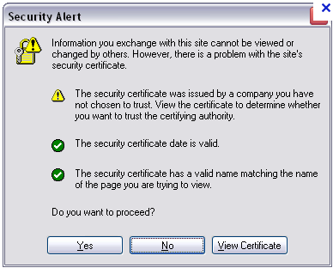

Warning Message in case where the browser is Mozilla Firefox will be as shown in Figure 3 below

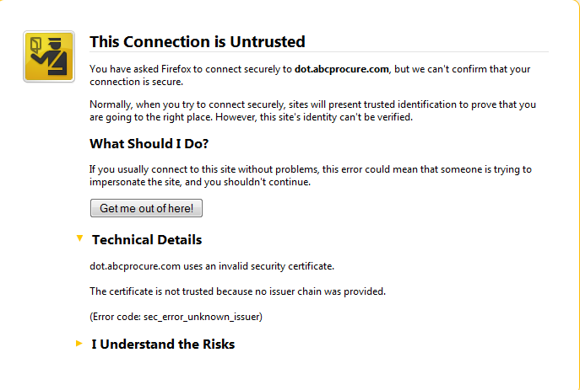

Warning Message in case where the browser is Google Chrome will be as shown in Figure 4 below.

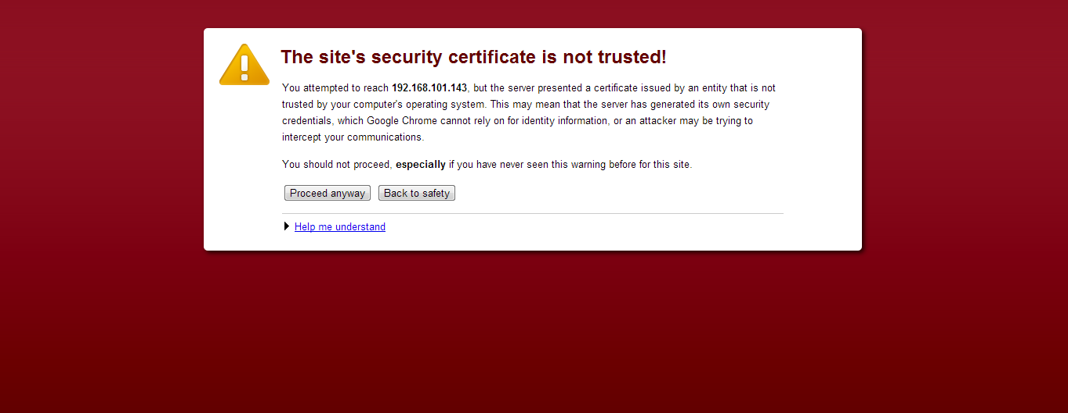

To avoid such Warning Messages, the Intermediate Certificate can be downloaded by the bidder using the steps as given below:

Step-1: Open the website

Step-2: Click on the “Intermediate Certificate” link given in the bottom gray panel as shown in below figure.

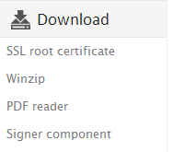

Step-3: Download the “Certificate.zip” file.

Step-4: Unzip the “Certificate.zip” file to a specific location.

Step-5: Following three certificates will be available which needs to be installed as per the steps mentioned in Step 1 to 5

e-MudhraCA2011

C3DSubCA2011

CCA2011

Bidder need to install the all the above certificates by performing below mentioned steps:

**Step 1 –Click on Open button**

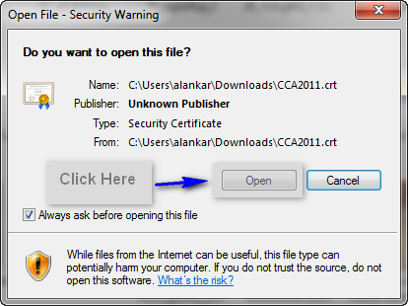

Step 2 – Click on Install Certificate button

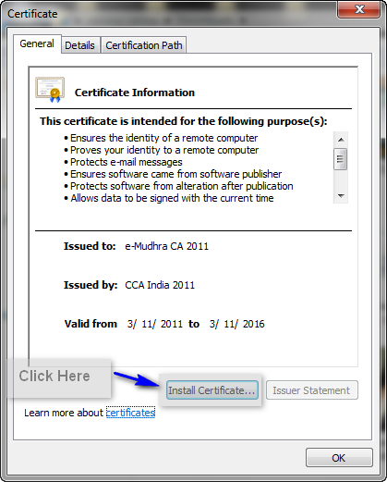

Step 3 – Click Next

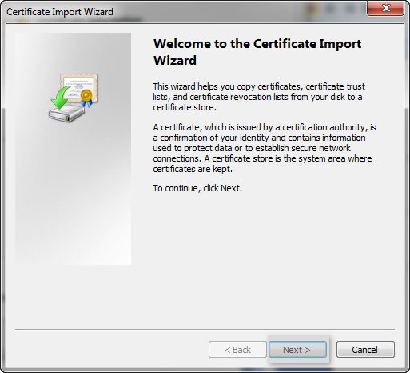

Step 4 – Click Next

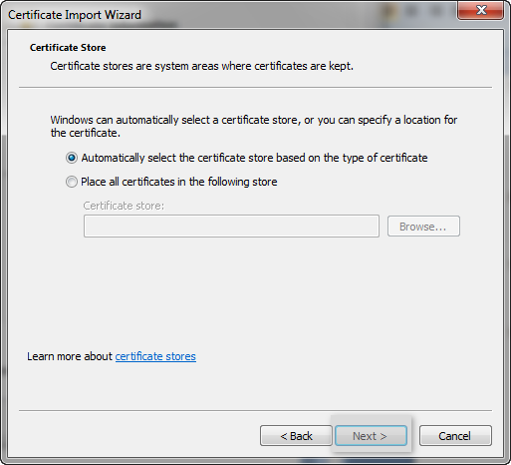

Step 5 – Click Finish

Repeat the above steps (Step 1 to 5) for installing the remaining two certificates also.

### Java Script

The following screen will come in web browser, if Java Script is disabled.

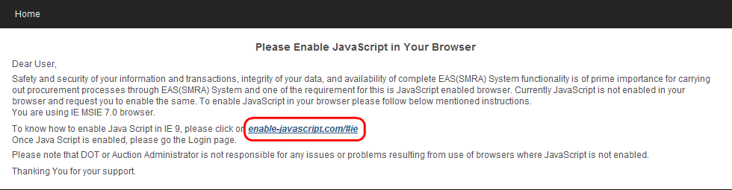

Enable Java script – Click on the highlighted link and then follow the instructions

### Toolbar / Add on / Pop up blocker

Bidders should ensure that there is no software installed on the computers which are to be used for bidding that might interfere with the normal operation of their Internet browser. The bidders have to ensure that they do not use any pop‐up blockers, such as those provided by Internet Explorer and complementary software, like for example the Google tool bar. This might, in certain cases depending on Bidders’ settings, prevent the access of the EAS application.

### Power management settings

To ensure that Bidders can view progress in the Auction without delay or difficulty it is recommended that Bidders:

* Turn off any power management features on their computer such as automatic hibernation or suspension; and
* Disable any screensavers.

# Login

To access procurement events, you need to login to the portal. You must be an approved registered user and should have a valid E-mail ID and password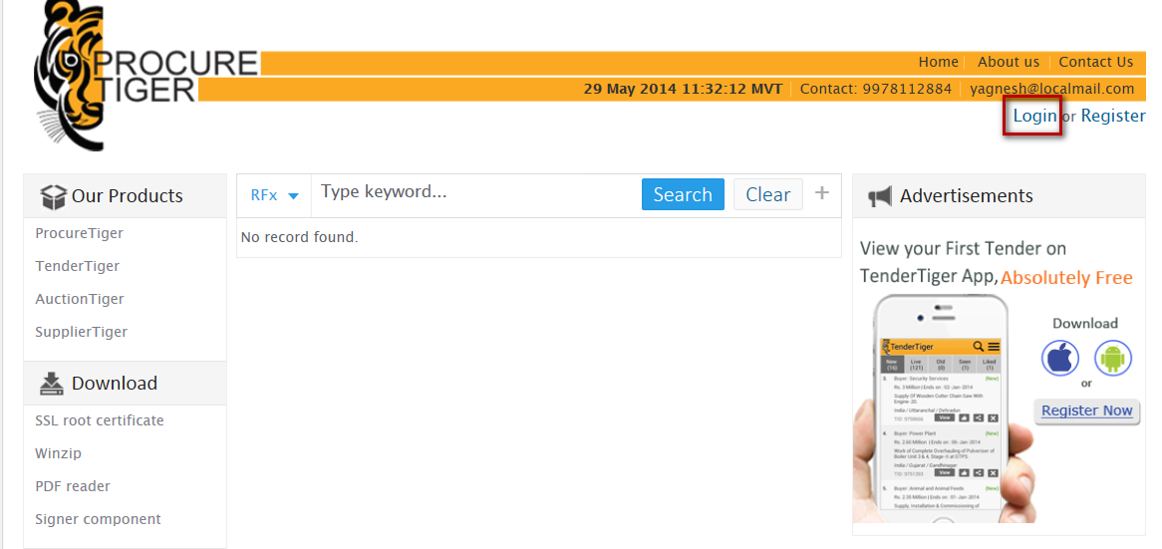

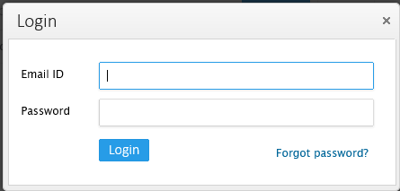

**2**

**Steps for login:**

1. Click on **Login** hyperlink as shown in the above screen shot.
2. Enter your e-mail ID and password and click on **Login** button

**Your login session can expire in 30 minutes if you have logged in and sitting idle..**

# Forgot password

In case if you have forgotten your password, you can set the new password using this functionality.

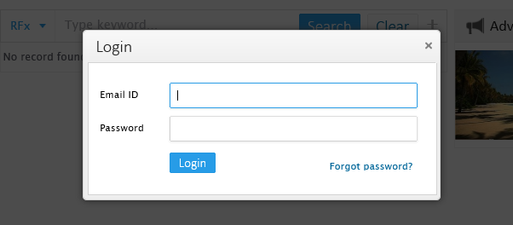

**1**

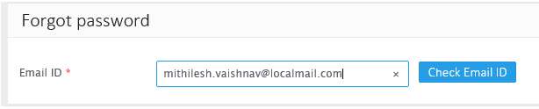

**2**

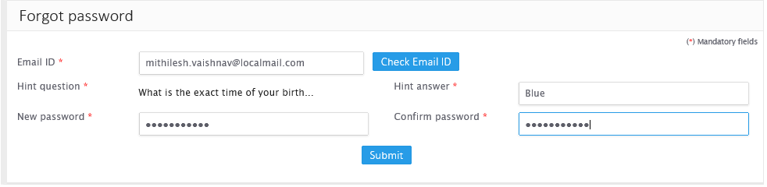

**3**

**Steps for forgot password:**

1. Click on ‘Forgot password link
2. Enter valid e-mail id and click on ‘Check Email ID’ button
3. Enter hint answer, new password and click on ‘Submit’ button

# Administrator dashboard

On login successfully to portal, you will be redirected to event dashboard where you can navigate through the menu and can perform different activities.

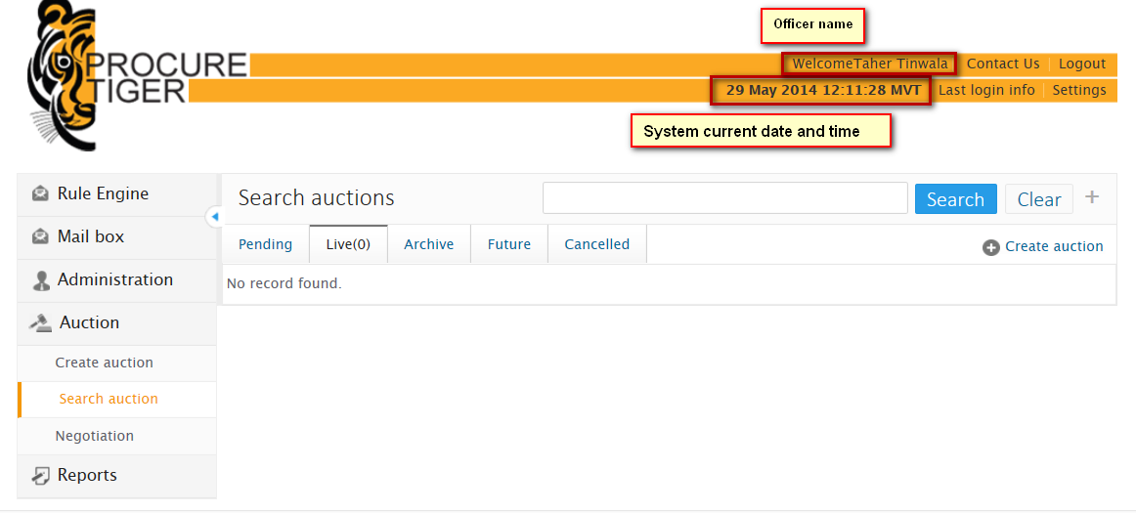

Figure

* **Administration** – You can manage portal and domain configurations through administration menu
* **Auction** – It will redirect you to the Auction listing, where you can view bid of bidders and view reports.
* **Setting: You** can view and edit Profile and can change your password from here
* **Last Login** – Shows the date and time of your last login.
* **IP address** – Shows IP address of the computer system from which you have logged in.
* Header part displays **System current Date and Time,** you need to **consider system’s current date and time while review the procurement events**
* Header part also shows **Login ID** from which you have logged in

**System’s current date and time displayed in the menu panel, will be as per the time zone selected by you during registration to portal**

# Profile

## Edit profile

Administrataor can edit their profile by following the below mentioned steps.

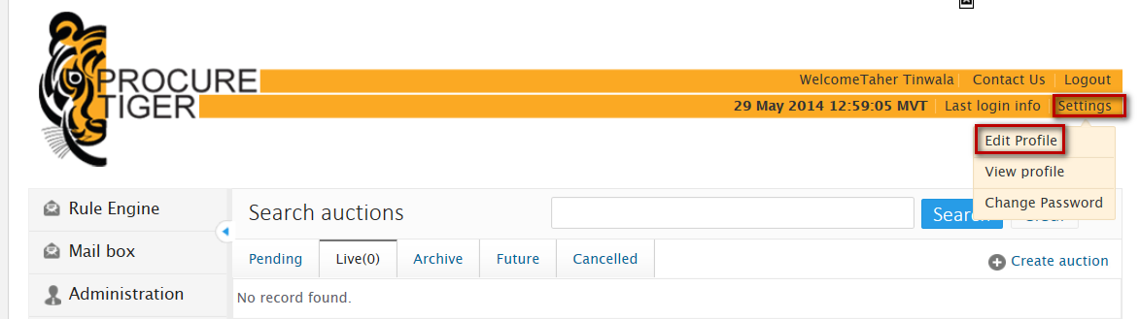

**2**

**1**

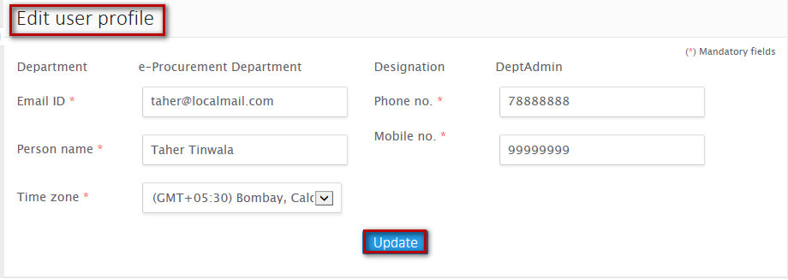

**4**

**Steps to edit profile:**

1. Click on ‘Settings’ menu
2. Click on ‘Edit profile’ sub menu
3. Edit detail as per your requirement
4. Click on **‘**Update**’** button

## View profile

Administrator can view his profile by performing below mentioned steps.

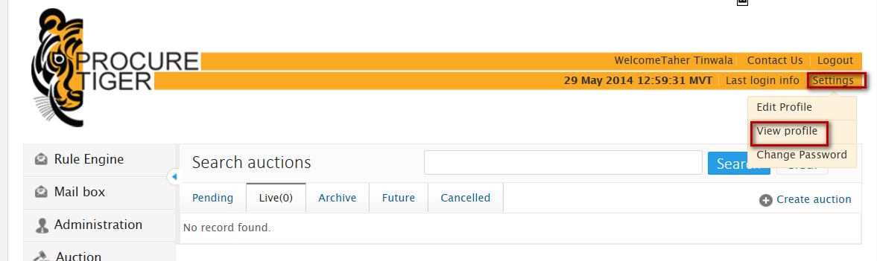

**2**

**1**

Figure

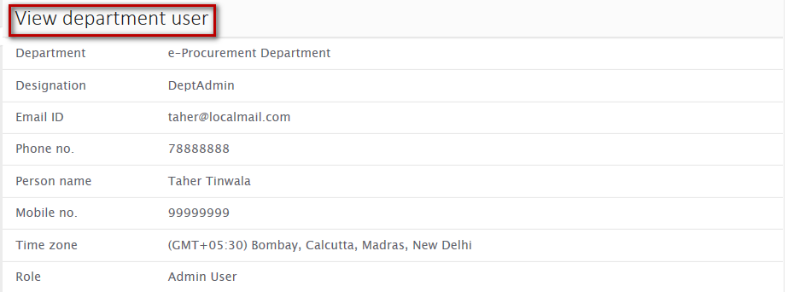

**Steps to view profile:**

1. Click on ‘Settings’ menu
2. Click on ‘Edit profile’ sub menu

## Change password

Administrator can change his password using this functionality.

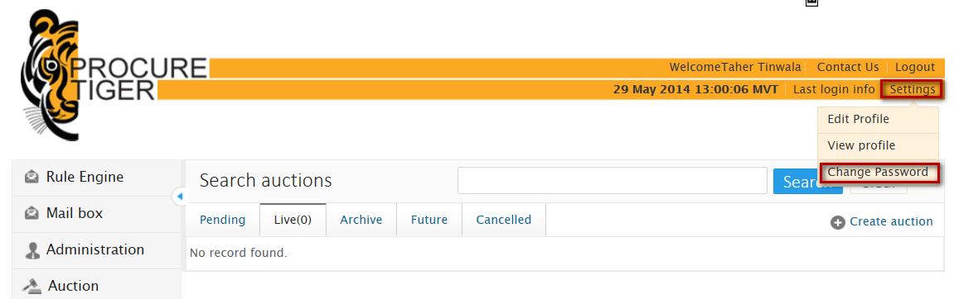

**2**

**1**

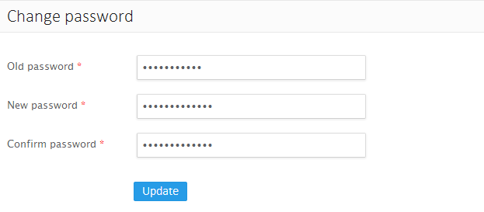

**3**

**Steps to change password:**

1. Click on **‘**setting**’** menu
2. Click on ‘Change password’

Click ‘Update’ button

# Client

Administrator can create and manage sub domains and its configurations

## Create client

Administrator can create sub domain by configuring basic details, Modules, Registration and advance configuration.

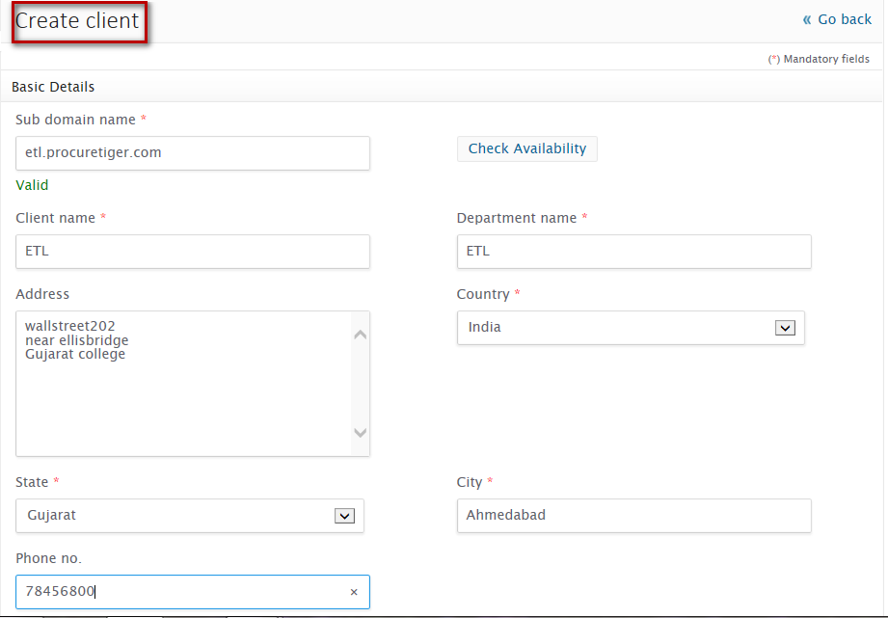

**1**

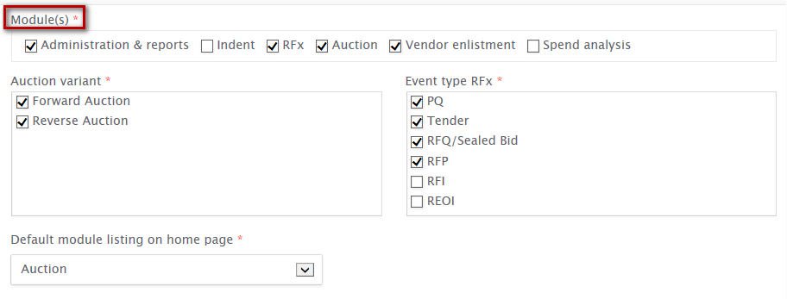

**2**

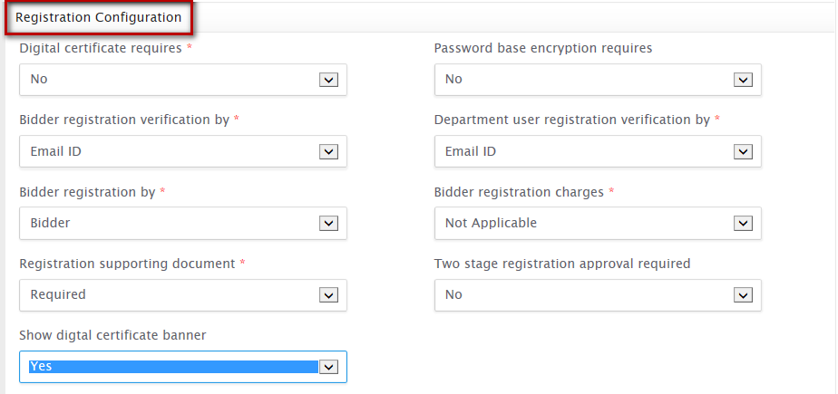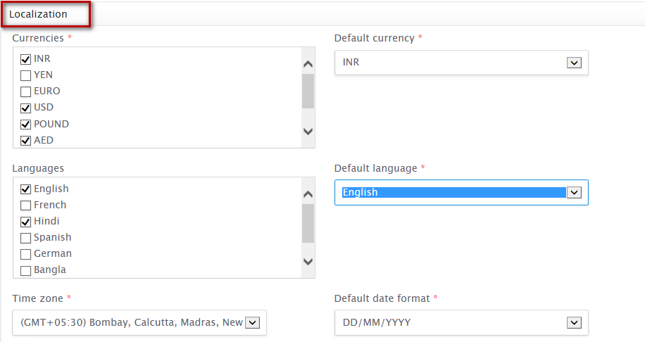

**3**

**4**

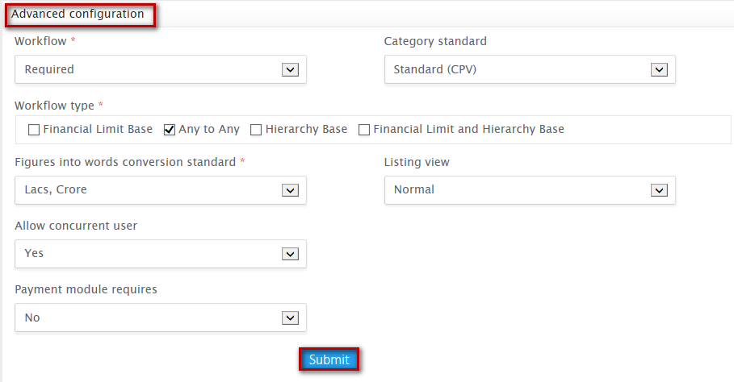

**6**

**5**

**Steps to Create Client:**

1. Configure basic details
2. Configure Modules
3. Configure registration configurations
4. Configure localization
5. Configure advance configuration
6. Click on ‘Submit’ button

On successful creation, you will be notified with a message as “**Client registered successfully**” and you will be redirected to select logo page



## Manage client

Administrator can search and manage sub domain and its configurations. Sub domains will be listed and classified into two different tabs

* **Pending** – List sub domains whose approval is pending
* **Approved** – List approved sub domains

### Search client

Provision through which you can search for sub-domain specifying search criteria’s as follows:

**Search criteria:**

* **Sub domain name** – Enter sub domain name which you would like to search
* **Department** – Enter department name to which the sub domain belongs
* **Status** – Enter status of the department whether pending or approved

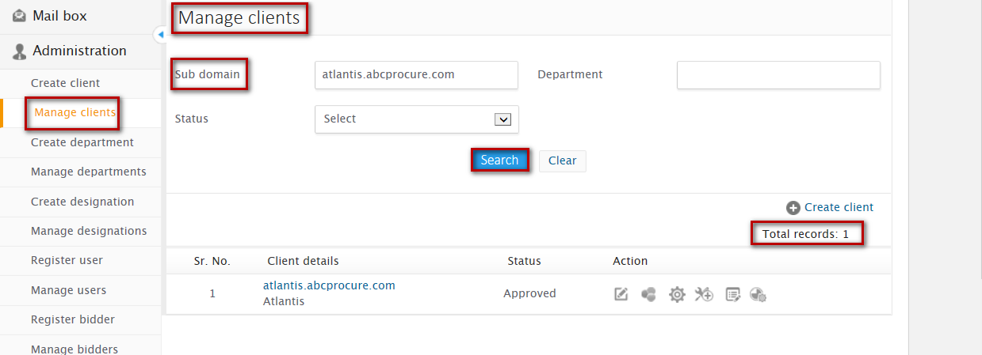

**Steps to Search Client:**

1. Enter at least one of the search criteria
2. Click on ‘Search’ button

On successful search, result will be displayed in the listing area that matches the search criteria. If no record has been found that matches the search criteria then you will find a message as “**No record found**”

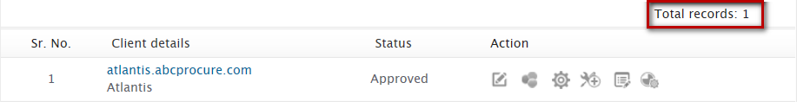



**Client listing area –** Lists Client’s created also lists client’s that matches the search criteria

* **Client details** – Shows client name and sub domain name as configured
* **Status** – Shows status of the client whether in pending state or approved
* **Actions** – Shows icons on the processing of which various actions can be performed on the client

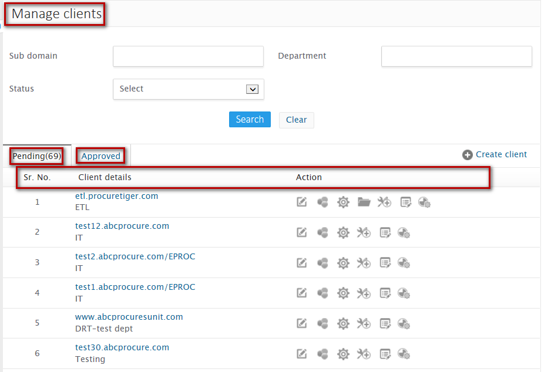

### Edit client

Administrator can edit/update configurations of sub domain. Domain configuration can be updated at any point of time. You will find all the configured details in editable mode

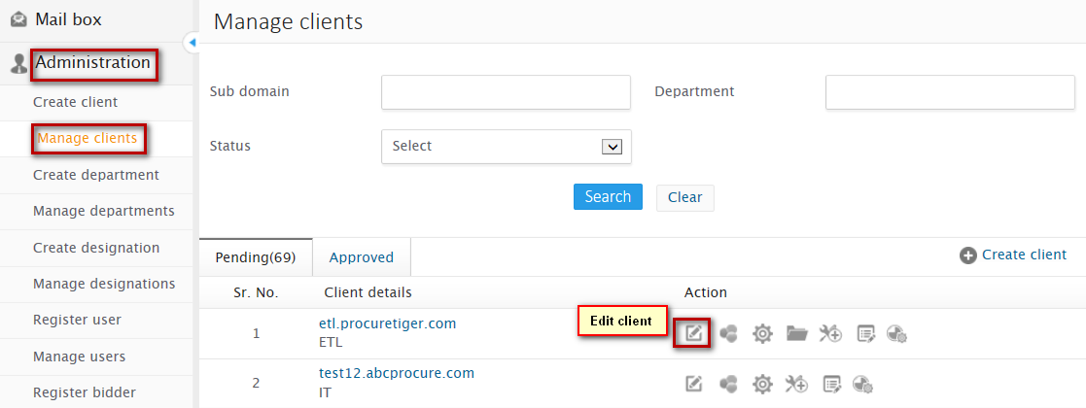

**2**

**1**

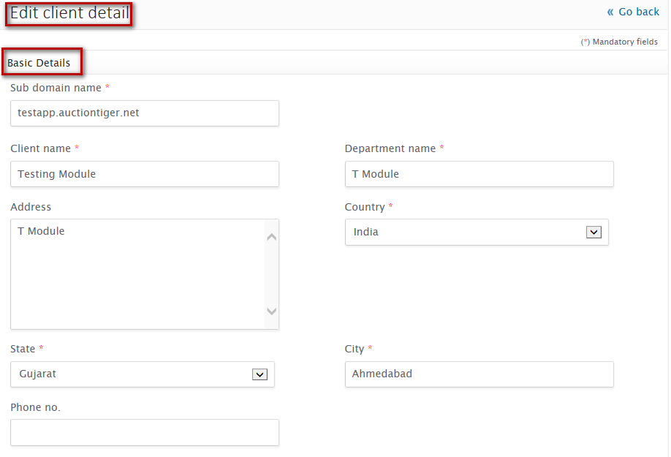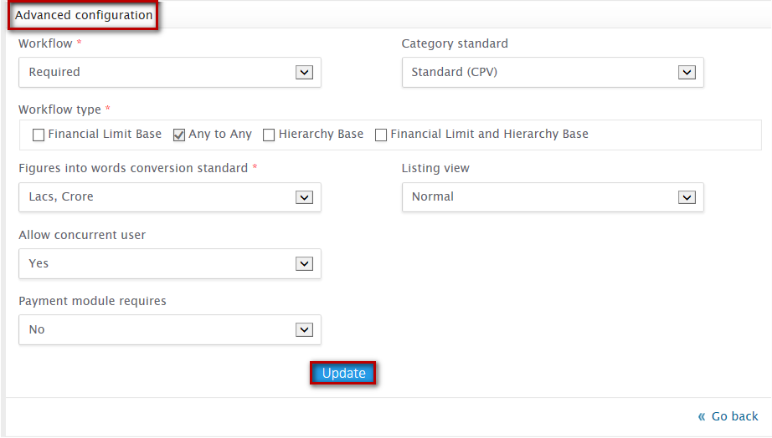 

**3**

**Steps to Edit Client:**

**4**

1. Click on Manage client from the left accordion
2. Click on edit icon, from the listing
3. Update the required details
4. Click on update button

On successful update, you will be notified with a message “**Client updated successfully**” and will be redirected to manage client listing.

### Select logo

Administrator can configure Company’s and Client’s logo to be displayed on the home page of the respective domain

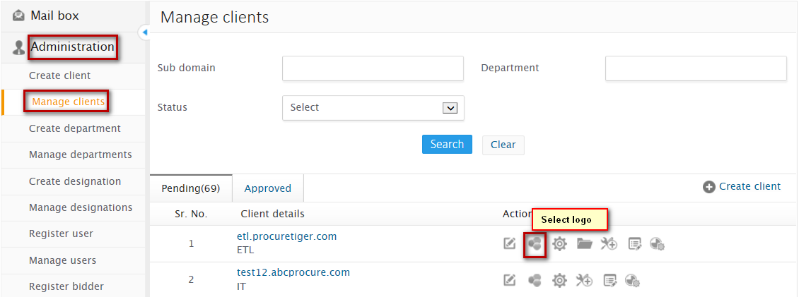

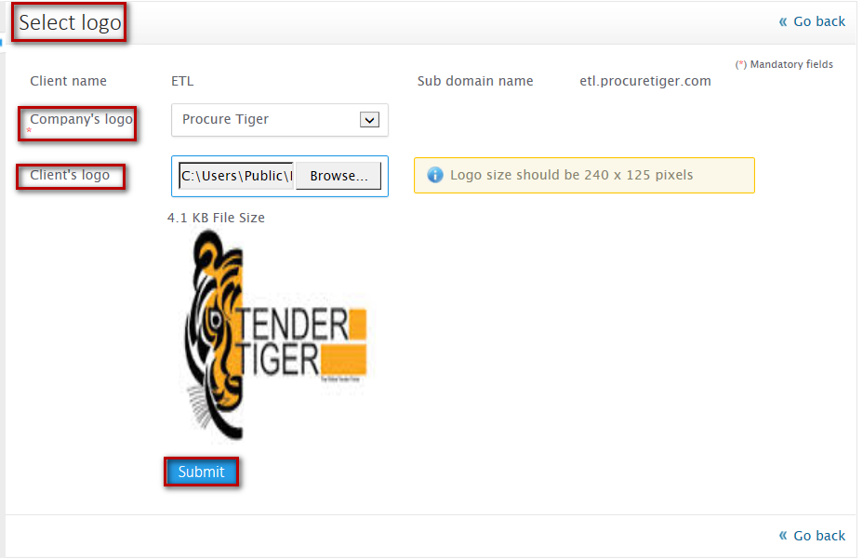

**2**

**1**

**3**

**Steps to select logo:**

1. Select Company’s logo
2. Browse and upload Client’s logo
3. Click on submit button

On successful logo submission, you will be notified with a message “**Logo updated successfully”**



Note

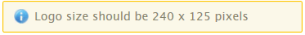

### Default configurations

Interface through which administrator can set default configuration, default field values and show/hide of fields on event notice for the modules and events configured on respective sub domain.

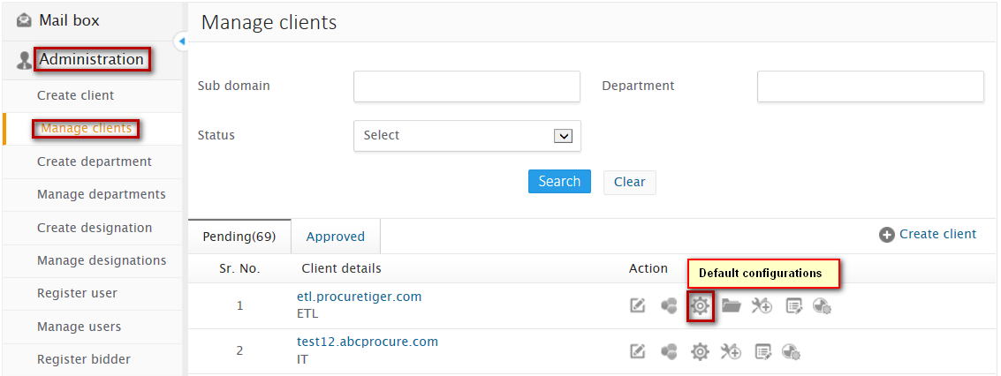

**1**

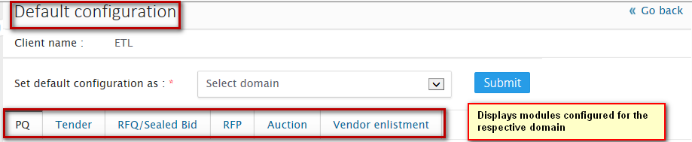

* While configuring default configuration, administrator can also dump (copy) default configuration of any sub domain to the current domain.

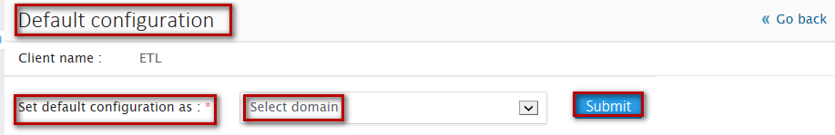

**2**

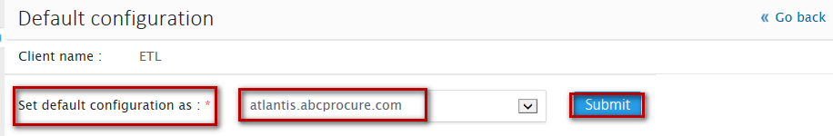

**3**

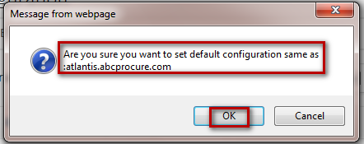

**4**



**Steps to copy default configuration of any sub-domain:**

1. From the left accordion, select Manage client
2. Click on Default configuration icon from the manage client listing
3. Select the domain, of which you would like to copy the default configuration
4. Click on Submit button
5. On confirmation, click on Ok

On successful configuration, you will be notified with a message “**Default configuration set successfully”**

* Administrator can also set default configuration and default values for each field of each modules configured

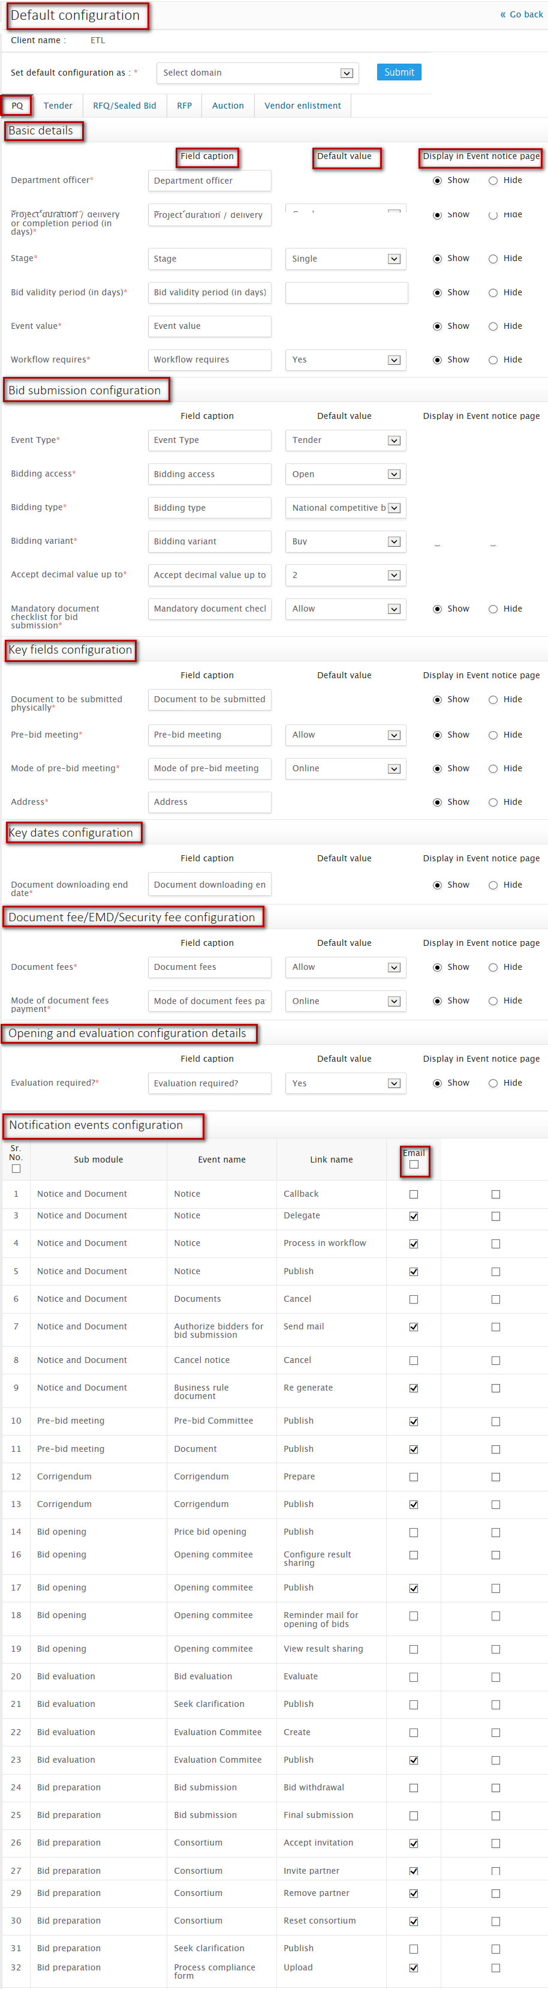

 

**Steps to configure default values for each module configured:**

1. From the left accordion under Administration, select Manage client
2. Click on Default configuration icon from the manage client listing
3. Set default values and show/hide for each field on the event notice
4. Click on Submit button

On successful configuration, you will be notified with a message “**Default configuration set successfully”**

### Registration supporting documents

Administrator can configure and manage list of documents required to be provided for successful registration

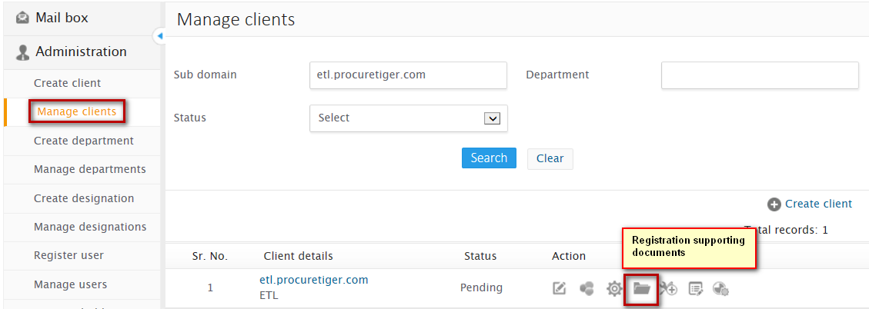

**1**

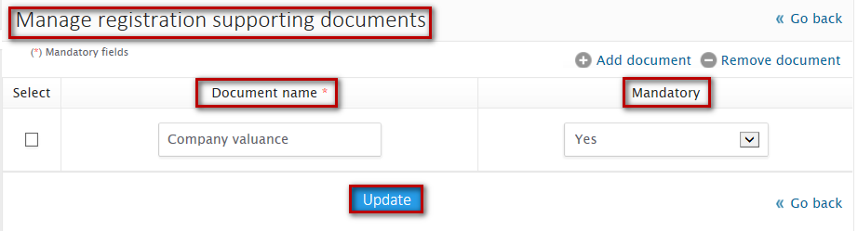

**4**

**2**

**3**



### Additional configuration

~~Interface through which you can set Add on functionalities, features and parameters for each selected module.~~

### Client’s terms and conditions

Interface through which administrator can configure terms and conditions of client for a module on the respective sub-domain.

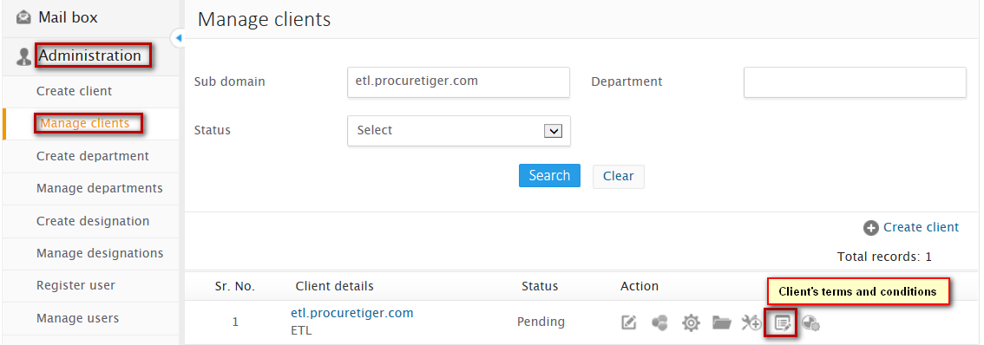

**1**

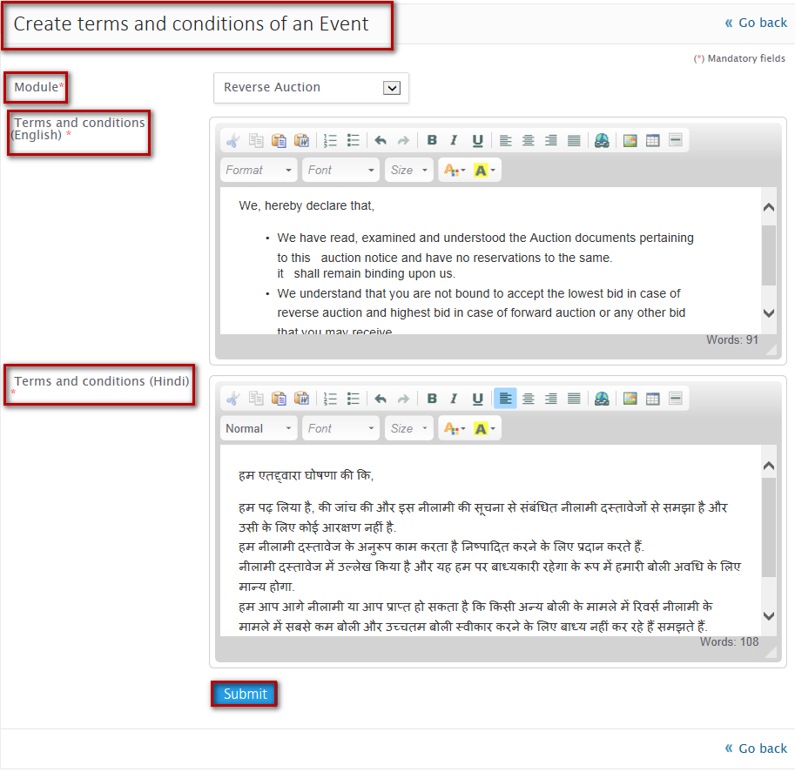

**4**

**3**

**2**

**5**



**Steps to create Client’s terms and conditions:**

1. Click on Manage client from the left accordion
2. Click on client’s terms and conditions icon, from the listing
3. Select the module for which you want to configure terms and conditions
4. Write terms and conditions in all the language configured at domain level
5. Click on submit button

On successful submit, you will be notified with a message “**Terms and conditions created successfully”** and will be redirected to Manage client’s terms and conditions listing

**Manage Client’s terms and conditions**

Administrator can manage terms and conditions created for different client. Listing displays terms and conditions created for client classified into two different tabs

* **Pending** – Lists terms and conditions for the respective client whose approval is pending
* **Approved**– Lists approved terms and conditions for the respective client

**Search client’s terms and conditions**

Provision through which administrator can search client’s terms and conditions based on the following search parameters:

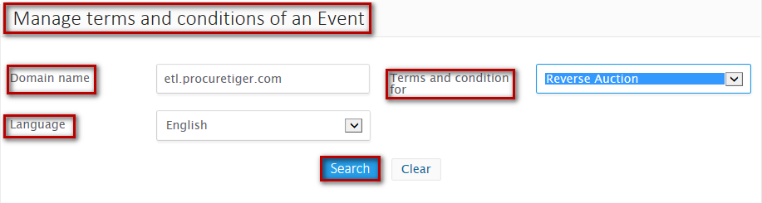

**2**

**1**

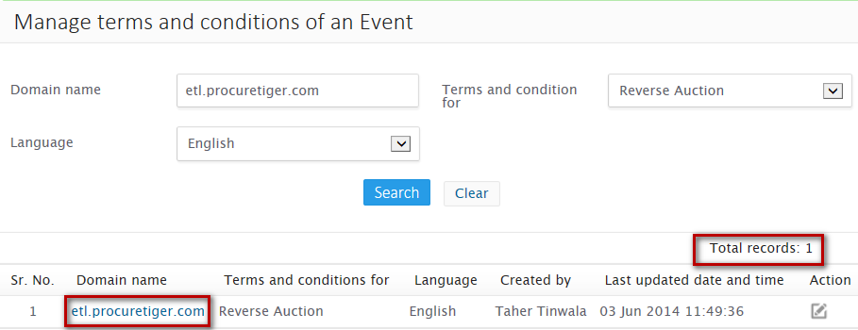

**Steps to search Client’s terms and conditions:**

1. Enter at least one of the search criteria
2. Click on the search button

On successful search, record that matches the search criteria will be displayed in the listing otherwise No record found message will be displayed

### Select vertical

Interface through which administrator can configure sector (verticals) and can classify domains sector (vertical) wise. While configuring, you will find sub domain name, department and list of verticals under that department.

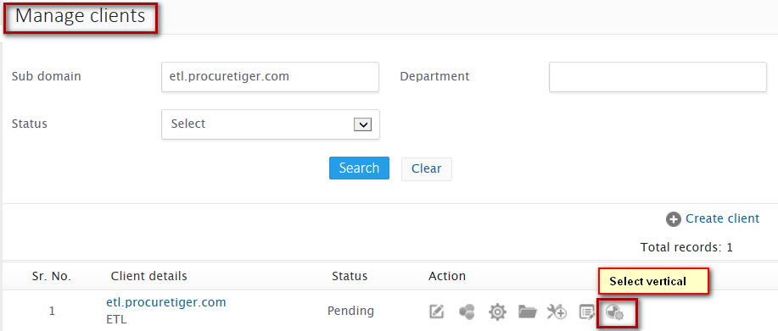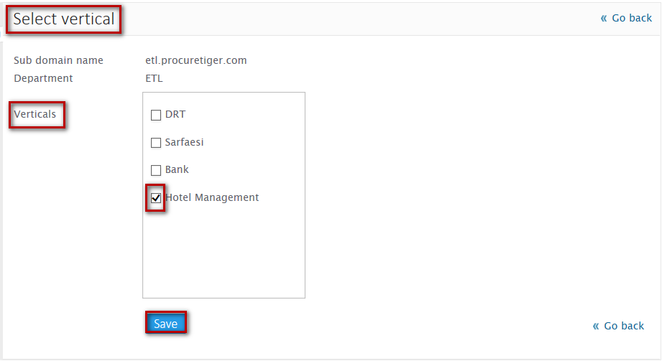

**3**

**2**

**1**

**Steps to select vertical:**

1. Click on Select vertical icon from the manage client listing
2. Select the verticals
3. Click on Submit button

On successful submit, you will be notified with a message “**Client updated successfully**” and will be redirected to Manage client listing

### Approve client

Administrator can approve client created through manage client listing.

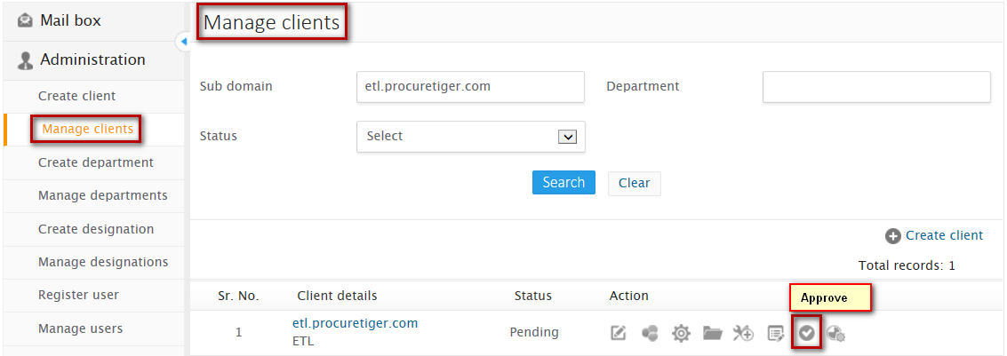

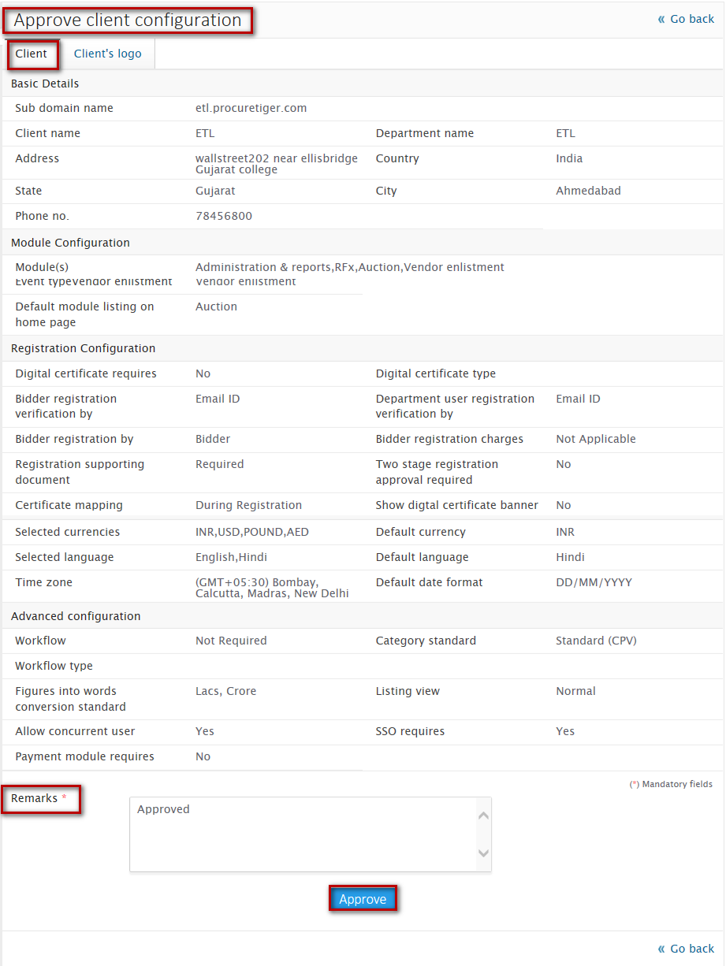



**Steps to approve client:**

1. Click on Approve icon form the manage client listing
2. View details configured
3. Enter remarks
4. Click on approve button

On successful approval, you will be notified with a message “**Client approved successfully”** and you will be redirected to manage client listing

# Department

Interface through which administrator can create, search and manage departments under parent department of respective sub domain

## Create department

Administrator can create department under parent department of respective sub domain by configuring and submitting basic details. Multiple and multilevel department under particular sub domain can be created.

**2**

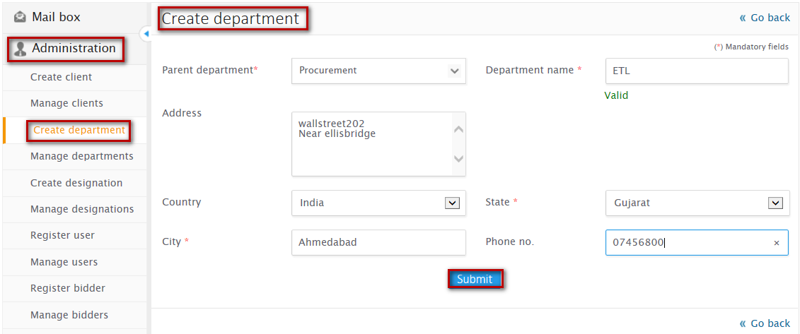

**1**

**3**



**Steps to create department:**

1. Click on Create department under administration, from the left accordion
2. Select parent department and configure all the required details
3. Click on Submit button

On successful submit, you will be notified with a message **“Department created successfully”** and you will be redirected to Manage department listing

Duplicate Department within a Sub Domain and Department Hierarchy cannot be created.

Note

## Manage departments

Administrator can search and manage departments created.

**Department listing** - Departments created can be managed through the listing that lists departments classified into different tabs:

* **Active** – Lists departments that are currently in activated mode
* **Inactive** – Lists departments that are currently in deactivated mode

**Department listing fields**

* **Department name** - Shows name of the department
* **Parent department** – Shows name of the parent department under which department has been created
* **Actions** – Lists Actions that can be performed on departments

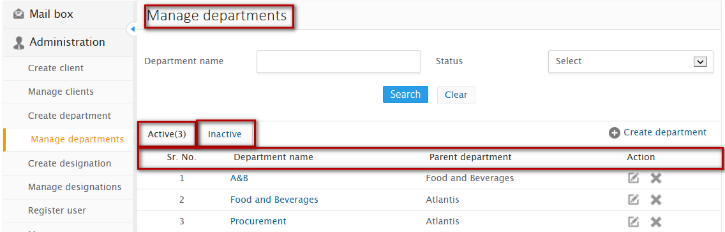

### Search department

Provision through which you can search for departments specifying search criteria’s as follows:

**Search criteria:**

* **Department name** – Enter department name
* **Status** – Enter status of the department whether active or inactive

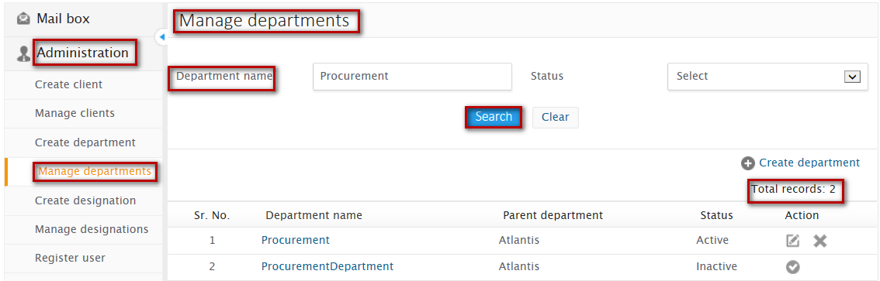

**1**

**2**

**Steps to Search department:**

1. Enter at least one of the search criteria
2. Click on ‘Search’ button

On successful search, result will be displayed in the listing area that matches the search criteria. If no record has been found that matches the search criteria then you will find a message as “**No record found**”

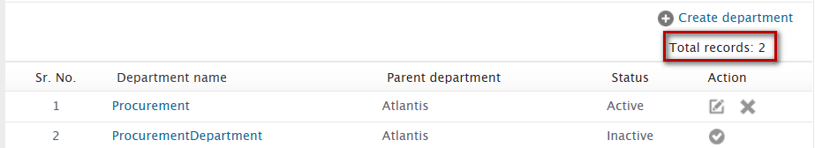

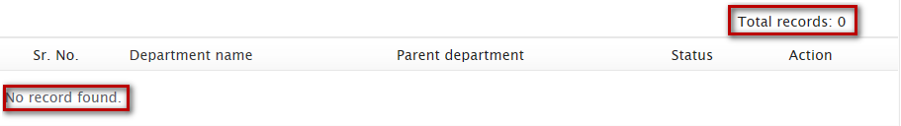

### Edit department

Administrator can edit/update details of the department created through manage department.

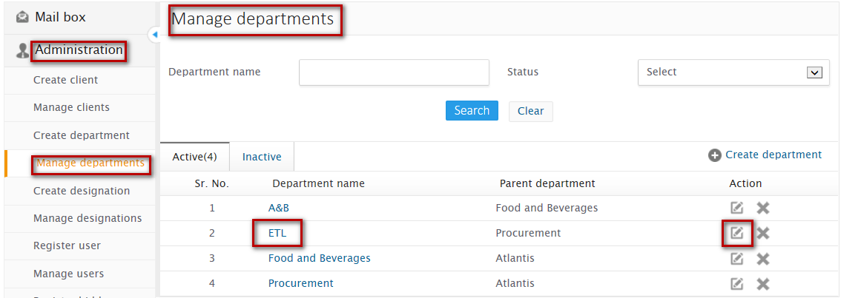

**2**

**1**

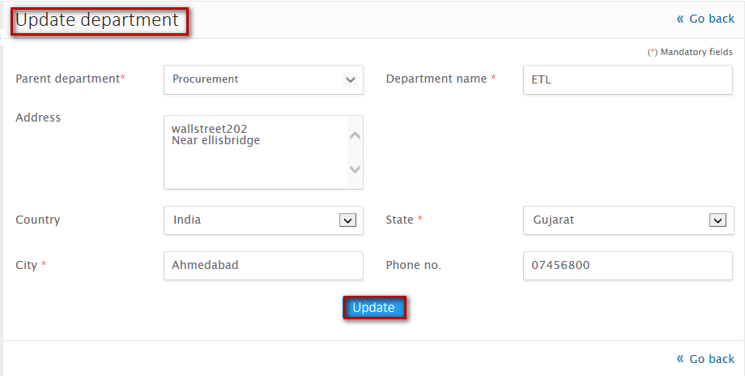

**4**

**3**



**Steps to edit department:**

1. Click on the edit icon from manage department listing
2. Update details configured as per your requirement
3. Click on update button

On successful update, you will be notified with a message **“Department updated successfully”** and you will be redirected to manage department listing

### Deactivate department

Administrator can deactivate active department through manage department listing

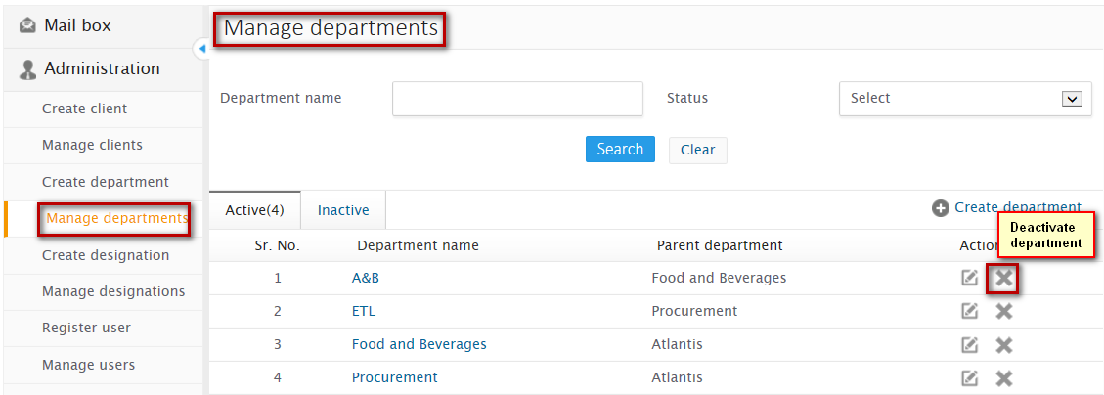

**1**

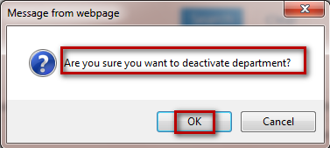

**2**



**Steps to deactivate department:**

1. Click on the cross mark against the department listing
2. On confirmation, click on Ok

On successful deactivation, you will be notified with a message as **“Department deactivated successfully”**

### Activate department

Administrator can activate deactivated department through manage department listing

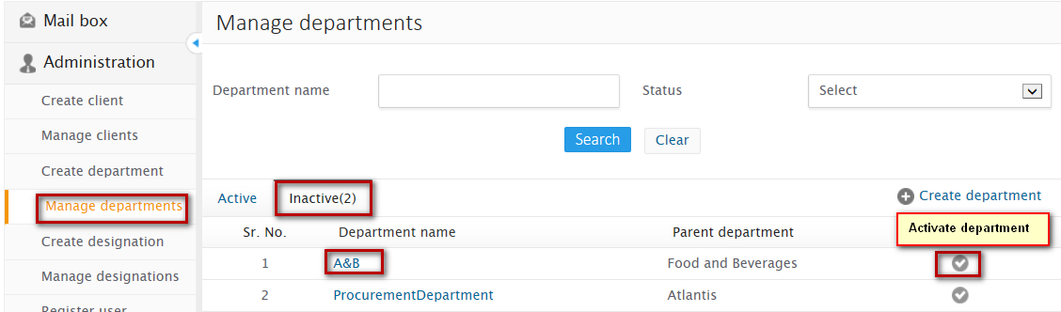

**1**

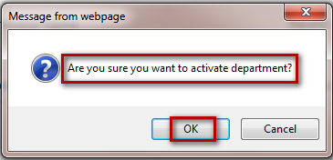

**2**



**Steps to deactivate department:**

1. Click on the cross mark against the department listing
2. On confirmation, click on Ok

On successful deactivation, you will be notified with a message as “**Department deactivated successfully”**

# Designation

Interface through which administrator can create, search and manage designations under department

## Create designation

Interface through which administrator can create designation under parent department. Multiple and multilevel designations can be created under parent department and parent designation

**1**

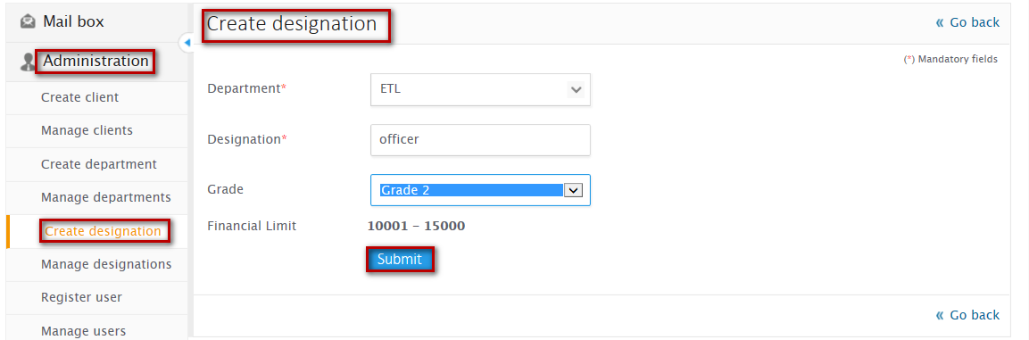

**3**

**1**



**Steps to create designation:**

1. Click on the create designation under administration from the left accordion
2. Configure all the required details
3. Click on submit button

On successful creation, you will be notified with a message as “**Designation created successfully**” and you will be redirected to manage designation listing.

Note

* Parent designation displays all the approved designations of a selected department
* Parent designation field will be hidden, if no approved designation is created
* Grade functionality will be displayed only if workflow type is selected as Financial or Hierarchy and Financial.
* Designation name must be unique within a department.
* It is mandatory to generate Authorized User Sign at the time of Designation Approval

## Manage designation

Administrator can search and manage configurations of designations

**Designation listing** - Departments created can be managed through the listing that lists departments classified into different tabs:

* Pending – Lists designations whose approval is pending
* Approved – Lists approved designations

**Designation listing fields**

* Designation - Shows name of the designation
* Parent designation – Shows name of the parent designation under which designation has been created
* Department – Shows name of the department under which designation has been created
* Actions – Lists Actions that can be performed on designations

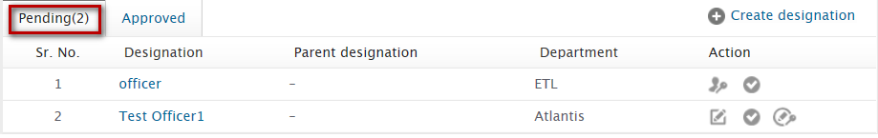

### Search designation

Provision through which you can search for designation specifying search criteria’s as follows:

**Search criteria:**

* Department name – Enter department name
* Designation – Enter designation name
* Status – Enter status of the designation whether pending or approved

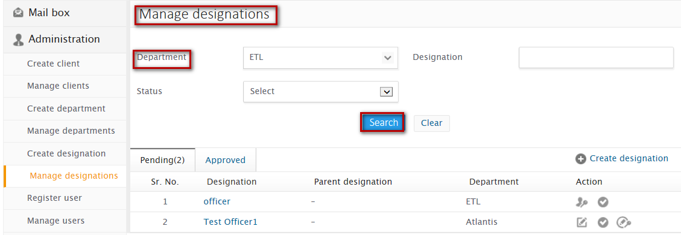

**3**

**2**

**1**

**1**

**Steps to Search designation:**

1. Enter at least one of the search criteria
2. Click on ‘Search’ button

On successful search, result will be displayed in the listing area that matches the search criteria. If no record has been found that matches the search criteria then you will find a message as “No record found”





### Assign rights

Administrator can assign rights to designations for the events in sub modules and modules configured. While assigning rights, list of modules and sub modules with the events listed and links that defines roles that has to be configured on the basis of which user with respective designation will only be able to perform roles as per rights assigned

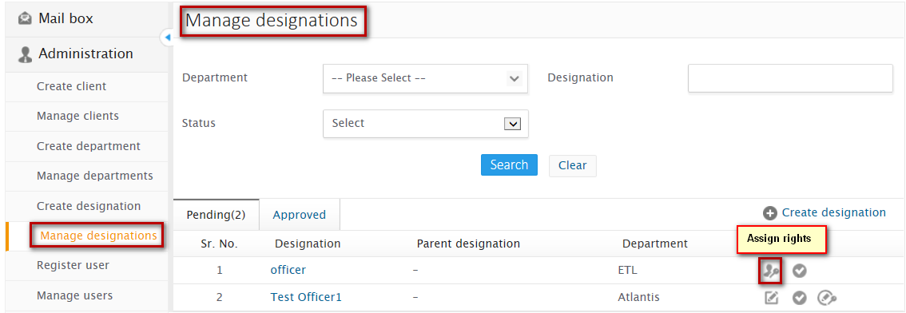

**1**

**1**

* While assigning rights, administrator can also dump (copy) rights of any other approved designation

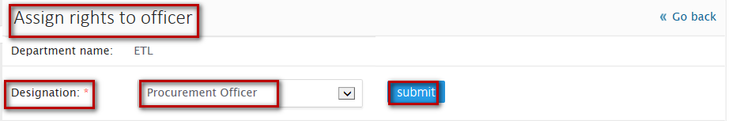

**4**

**3**



**Steps to copy rights of any other designation:**

1. Click on Assign rights icon from the manage client listing
2. Select the designation, of which you would like to copy the default configuration
3. Click on Submit button

On successful configuration, you will be notified with a message “Rights updated successfully”

* Administrator can also assign rights of each link for each events on sub modules for modules configured



**3**

**2**

**1**

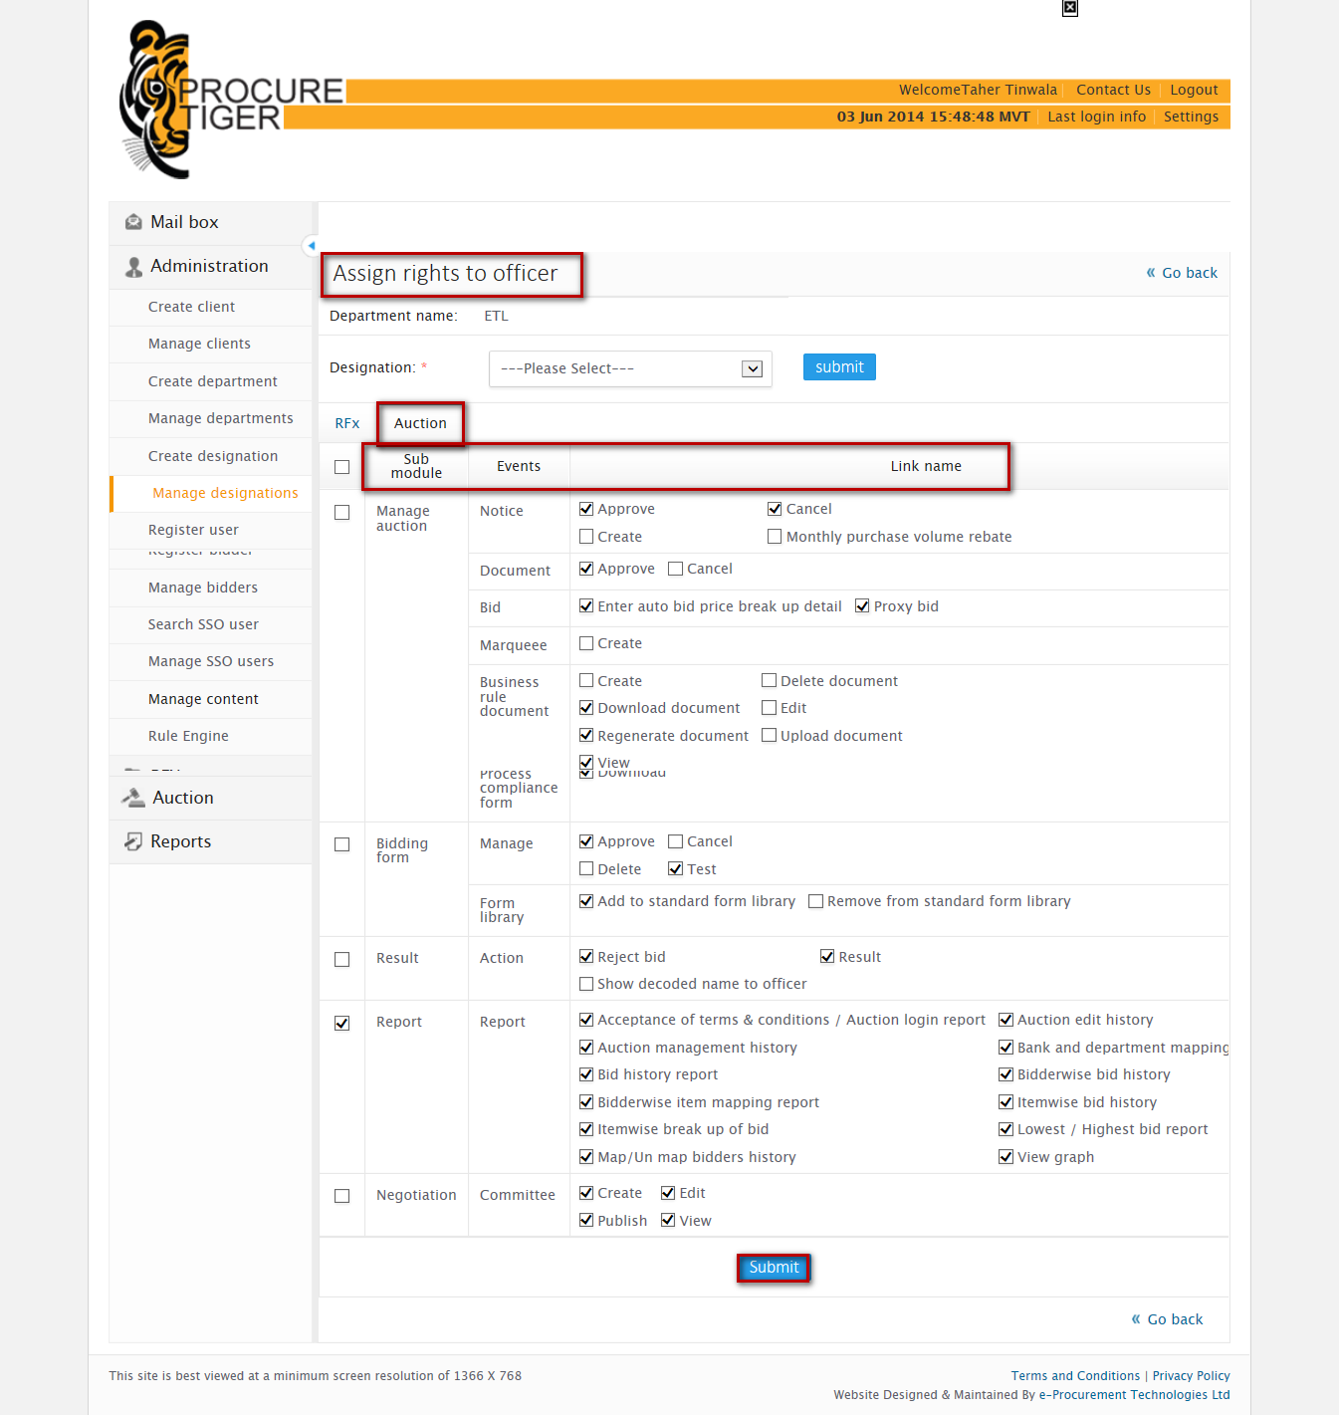

**4**



**Steps to assign rights to designations:**

1. Click on Assign rights icon from the manage client listing
2. Select the link against the event and sub modules as per your requirement
3. Click on Submit button

On successful configuration, you will be notified with a message “Rights updated successfully”

### Approve

Administrator can approve the designation created

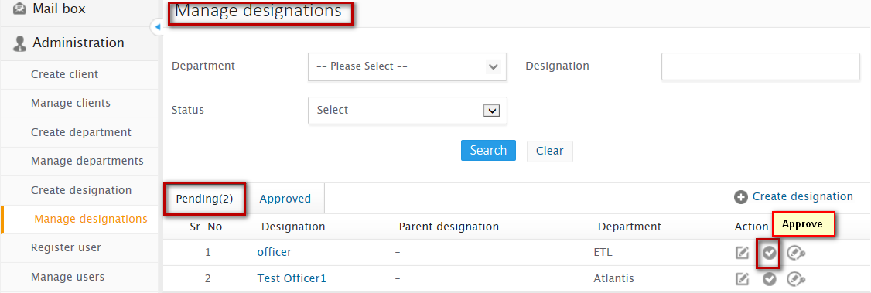

**1**

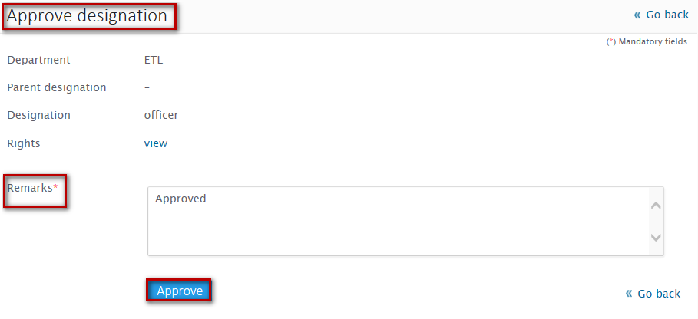 

**3**

**2**

**Steps to approve designation:**

1. Click on the approve icon from the manage designation listing
2. Give remarks for approval
3. Click on Approve button

On successful submission, you will be notified with a message “**Designation approved successfully”** and you will be redirected to manage designation listing.

### Edit

Administrator can edit designation details configured

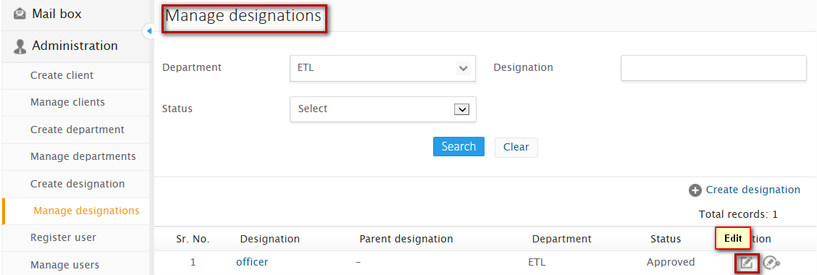

**1**

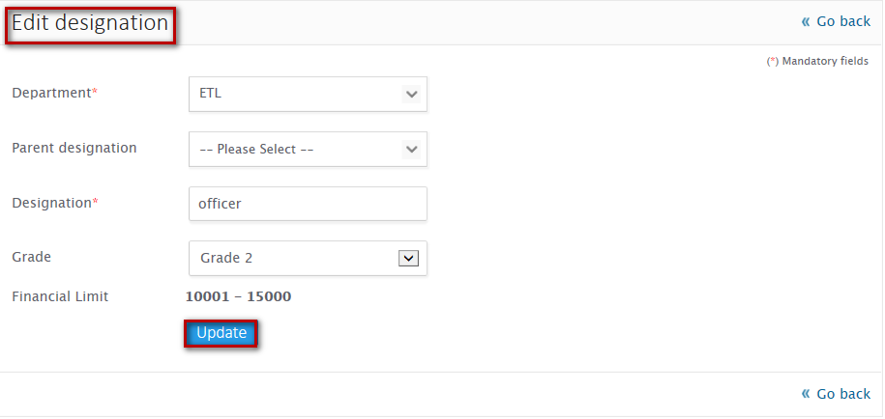

**3**

**2**

**Steps to edit designation:**

1. Click on the Edit icon from the manage designation link
2. Update details as per your requirement
3. Click on Update button

On successful update, you will be notified with a message “**Designation updated successfully**” and you will be redirected to manage designation listing

### Edit rights

Administrator can edit rights assigned for events to designations created

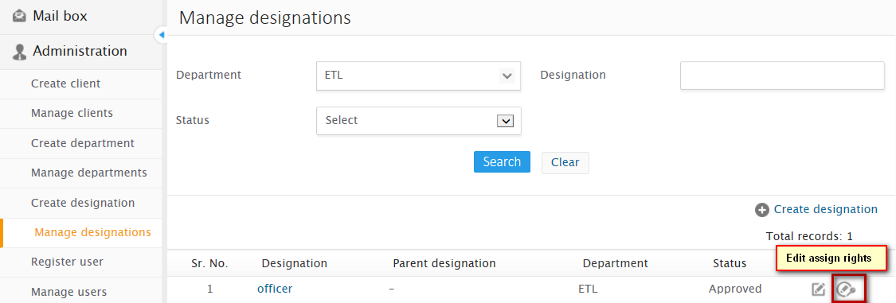

**1**



**2**

**3**



**Steps to edit assign rights:**

1. Click on the edit assign rights icon from the manage designation listing
2. Update rights assigned as per your requirement
3. Click on update button

On successful update, you will be notified with a message “**Rights assigned successfully”**

# User

Administrator can register, search and manage department user

## Register user

Administrator can register/create department user. While registering user, administrator has to map department, designation and fill up all the required basic details. Also administrator has provision to select role to be assigned to the registered user to be Admin user or department user

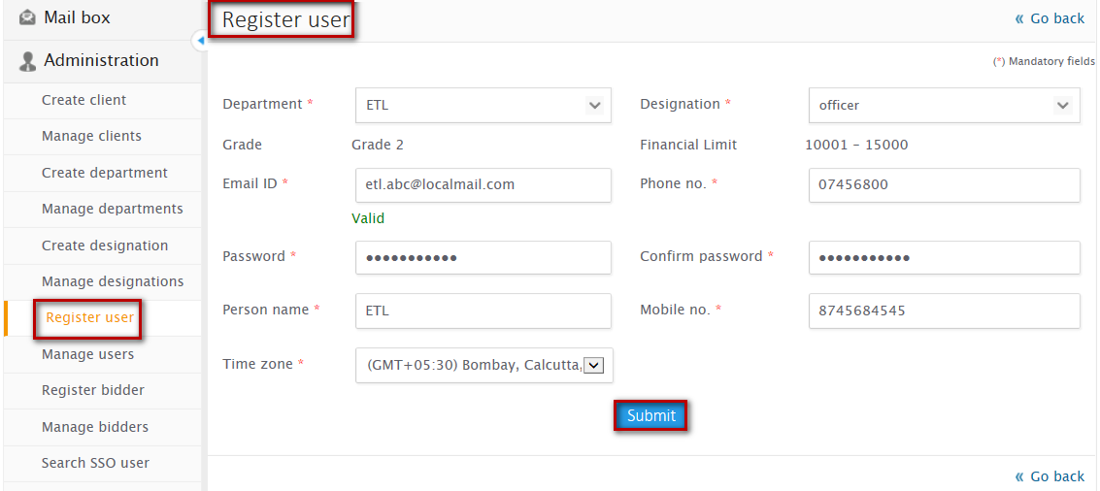

**3**

**2**

**1**



Steps to register user:

1. Click on Register user under Administration, from left accordion
2. Configure all the registration details
3. Click on Submit button

On successful registration, you will be notified with a message as User registered successfully and you will be redirected to manage user listing

1. Email Id should be unique

Note

1. It is mandatory to configure all the fields
2. User registered as a bidder cannot be registered as an auctioneer
3. Only super admin can create Admin users, Department users cannot create admin users
4. It is mandatory to generate Authorized User Sign on Resend Registration Mail and Verification Link

## Manage users

Administrator can search and manage users from the listing by performing various actions

### Search user

Provision through which department user registered can be searched by administrator by specifying search criteria.

**Search criteria:**

* Email id – Enter email id of the department user registered
* Designation – Enter designation of the registered user
* Person name – Enter person name of the registered user
* Department – Enter department to which the user belongs
* Status – Enter status of user

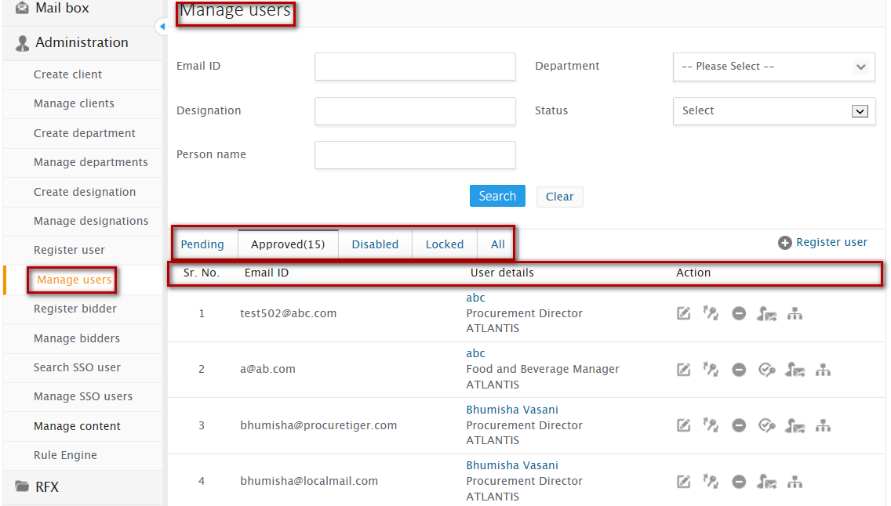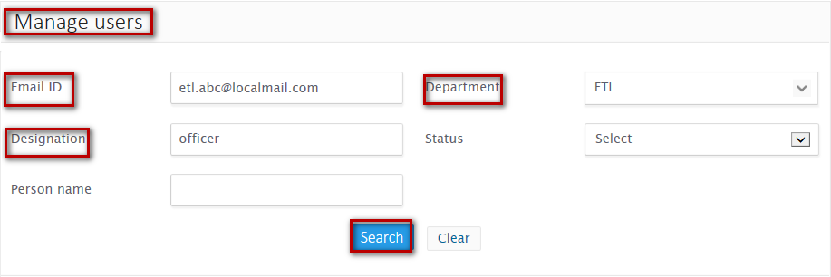

**Steps to Search user:**

1. Enter at least one of the search criteria
2. Click on ‘Search’ button

On successful search, result will be displayed in the listing area that matches the search criteria. If no record has been found that matches the search criteria then you will find a message as “No record found”

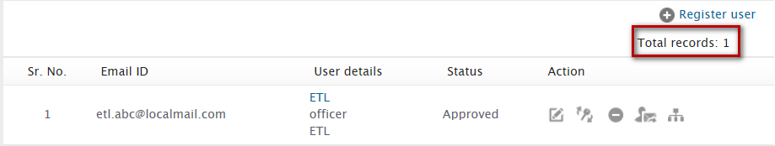



**Manage user listing –** Lists department users that have been registered by classifying into different tabs as follows:

* Pending – Lists users whose registration approval is pending
* Approved – Lists approved registered department users
* Disabled – Lists users whose login id has been disabled
* Locked – Lists users whose login has been locked due to three consecutive wrong login attempts
* All – Lists department users with all the above described status

**Listing fields:**

* Email Id – lists email id of the department user
* User details – List department user department name, designation and client name
* Actions – lists actions to be performed on registered users



### Edit user

Administrator can edit details of registered department user

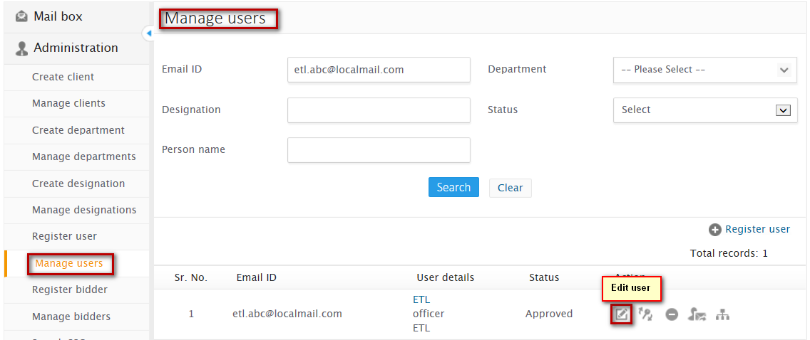

**1**

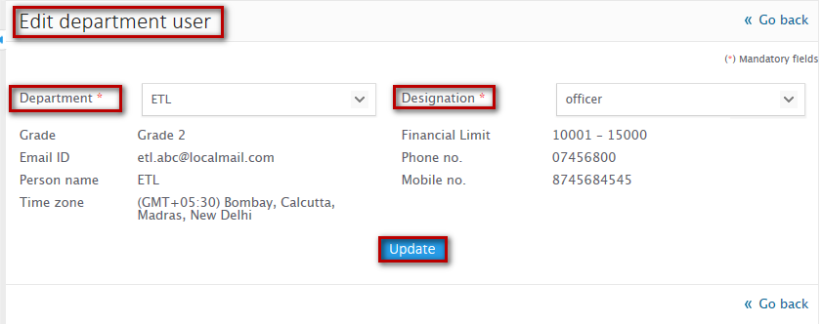

**3**

**2**

**Steps to edit user:**

1. Click on edit icon from the Manage user listing
2. Edit details as per your requirement
3. Click on update button

On successful update, you will be notified with a message **“User profile updated successfully”** and you will be redirected to manage user listing

Note

Only department and designation of department user can be edited

### Reset password

Administrator can reset password in case department user has forgotten password

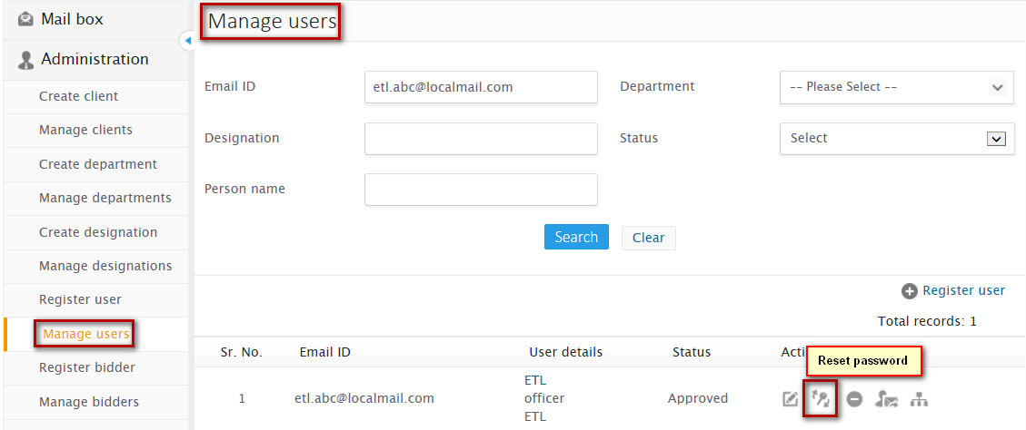

**1**

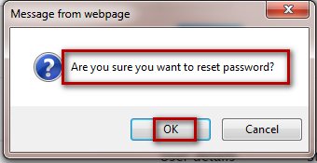

**2**

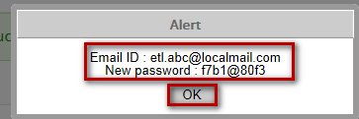

**3**



**Steps to reset password:**

1. Click on Reset password icon from the Manage user listing
2. On confirmation click on ok

On successful reset, you will receive an alert message that notifies your Email id and new password set, Click on ok and you will be notified with a message as **“Password reset successfully”**

### Disable

Administrator can disable approved user through manage user listing that lists user name, department and designation to which the user belongs

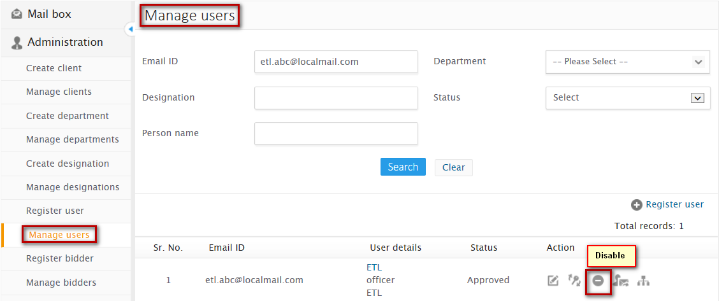

**1**

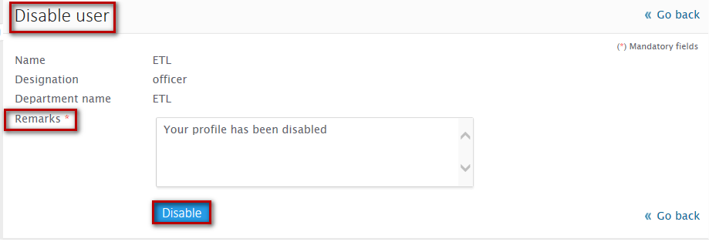 

**3**

**2**

**Steps to disable user:**

1. Click on the disable icon from the manage user listing
2. Enter remarks to disable user
3. Click on Disable button

On successful user disable, you will be notified with a message **“Department user disabled successfully”**

### Enable

Administrator can enable disabled user through manage user listing that lists user name, department and designation to which the user belongs

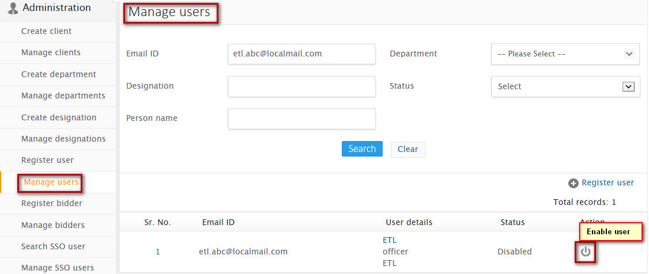

**1**

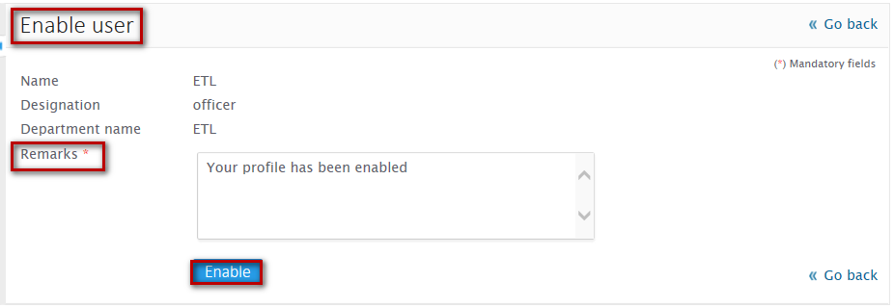

**3**

**2**



**Steps to enable user:**

1. Click on the enable icon from the manage user listing
2. Enter remarks to enable user
3. Click on Enable button

On successful user enable, you will be notified with a message **“Department user enabled successfully”**

### Send registration detail

Administrator can send registration detail of department user

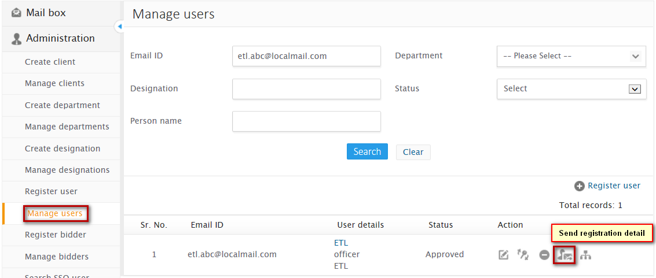

**1**

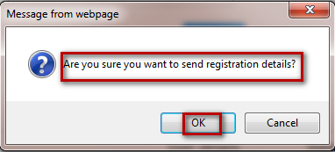

**2**



**Steps to send registration detail to department user:**

1. Click on the send registration detail icon from the manage user listing
2. On confirmation click on Ok

On successful sending of registration detail, you will be notified with a message as “**Registration details sent successfully”**

### Map to another department

Administrator can map department user from one department to another department

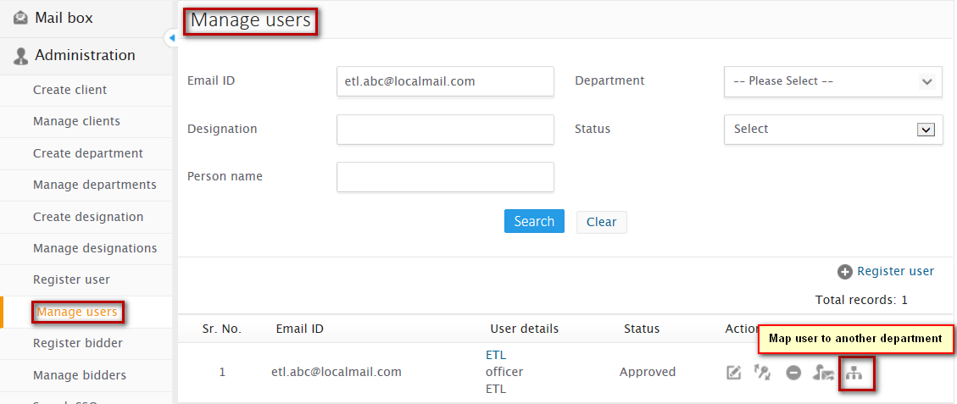

**1**

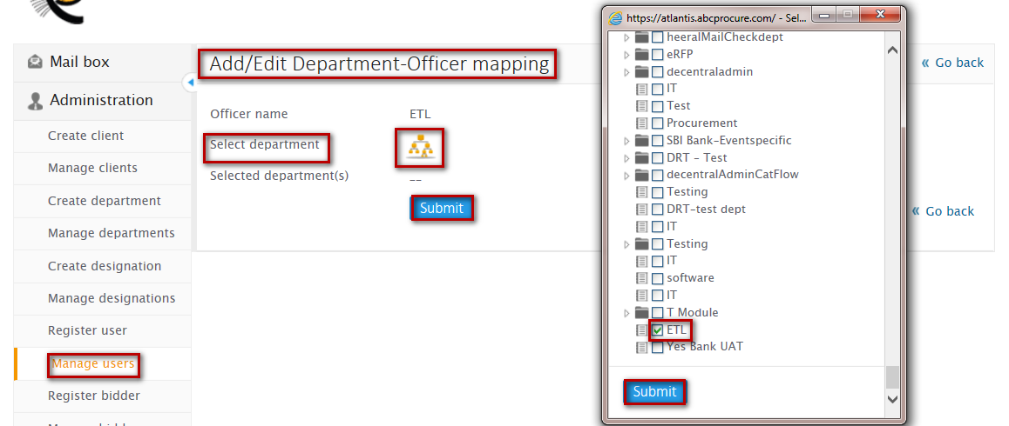

**5**

**4**

**3**

**2**

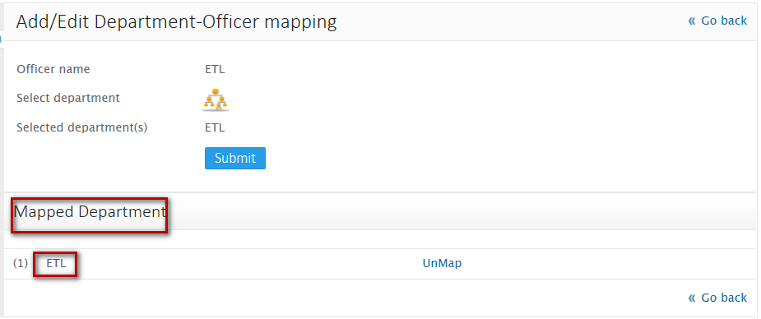



**Steps to map/unmap user to another department:**

1. Click on map user to another department from the manage user listing
2. Click on select department icon
3. Select department and submit
4. Submit mapped department

On successful mapping user to another department, you will be notified with a message as “**Officer-department mapping successfully**” and you will be redirected to manage user listing.

# Bidder

Administrator can register, search and manage bidders on the respective domain

## Register bidder

Administrator can register bidder on the respective sub domain if during domain creation Bidder registration is configured to be from officer

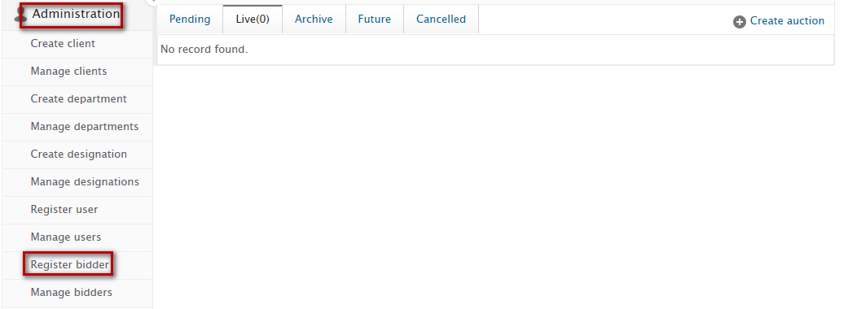

**2**

**1**

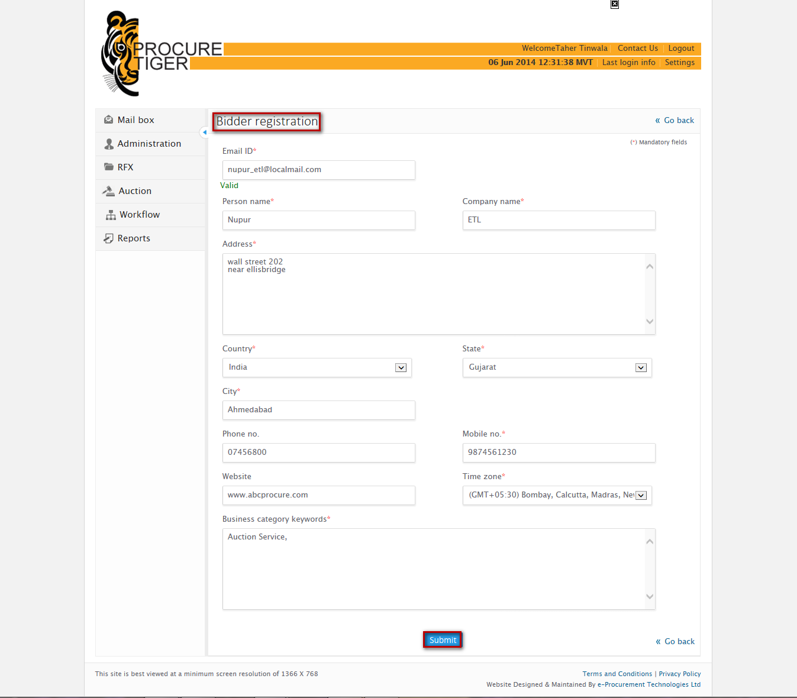

**3**



Steps to register bidder:

1. Click on Register bidder from the administration panel
2. Configure all the required details
3. Click on Submit button

On successful registration, you will be notified with a message as **“Registration step-1 completed successfully**” and you will be redirected to Manage bidder’s listing.

## Manage bidders

Administrator can search and manage bidder configurations

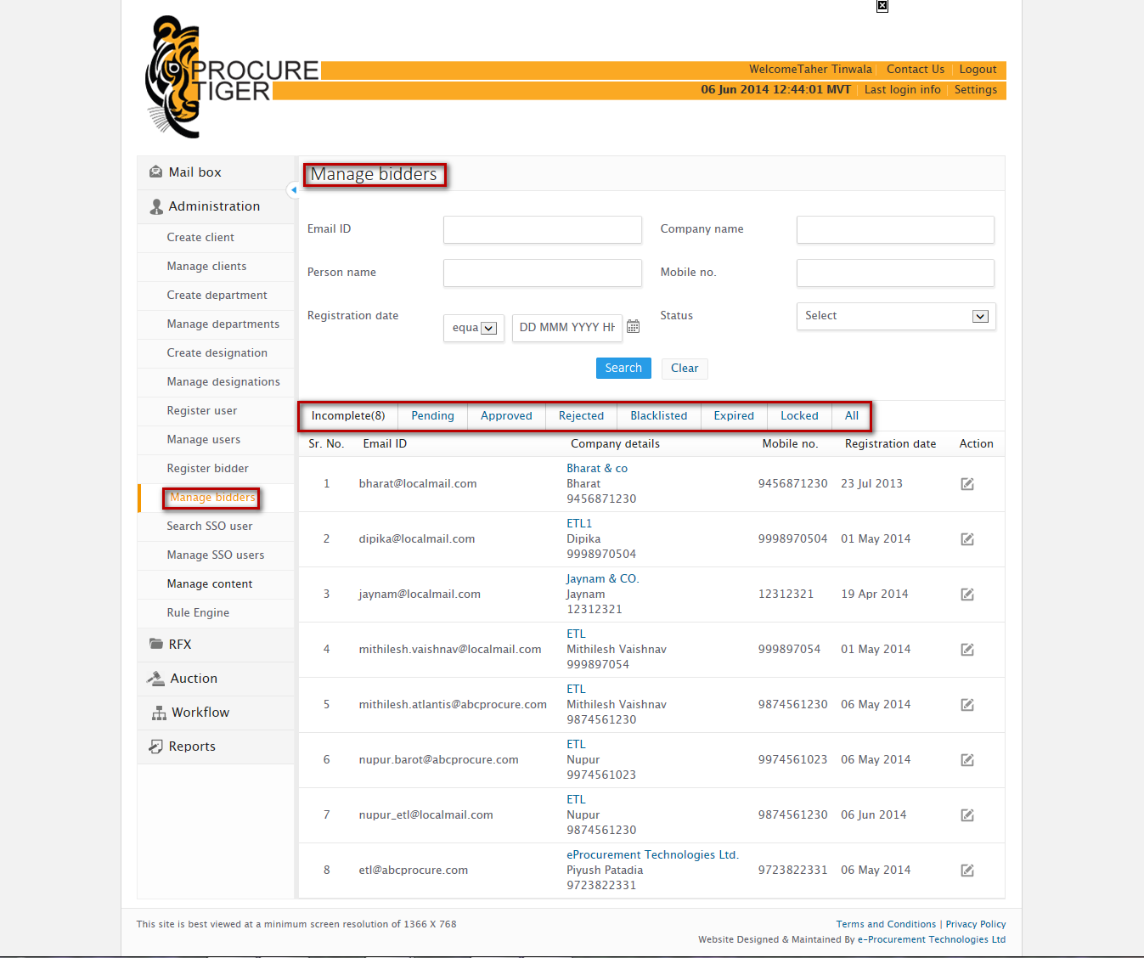

### Search bidder

Provision through which you can search bidder specifying search criteria’s

**Search criteria’s:**

* Email id – Enter email id of the bidder
* Company name – Enter company name of bidder
* Person name – Enter bidder’s name
* Mobile no – Enter registered mobile no of bidder
* Registration date – Enter date on which bidder was registered
* Status – Specify status of the bidder

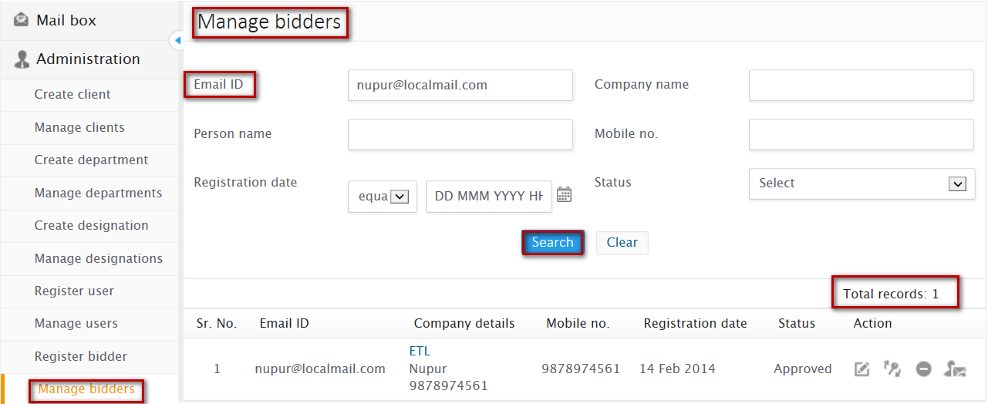

**Steps to Search user:**

1. Enter at least one of the search criteria
2. Click on ‘Search’ button

On successful search, result will be displayed in the listing area that matches the search criteria. If no record has been found that matches the search criteria then you will find a message as **“No record found”**

**Manage bidder listing** – Lists bidder’s registered classifying them into different tabs as follows:

* Incomplete – Lists bidder’s whose registration process is incomplete
* Pending – Lists bidder’s whose registration profile is pending for approval
* Approved – Lists approved bidder’s
* Rejected – Lists bidder’s whose registration has been rejected
* Blacklisted – Lists bidder’s whose profile has been blacklisted
* Expired – Lists bidder’s whose registration validity has been expired
* Locked – Lists bidder’s whose profile has been locked
* All – List bidder’s with all the above status



### Edit bidder

Administrator can edit bidder’s profile

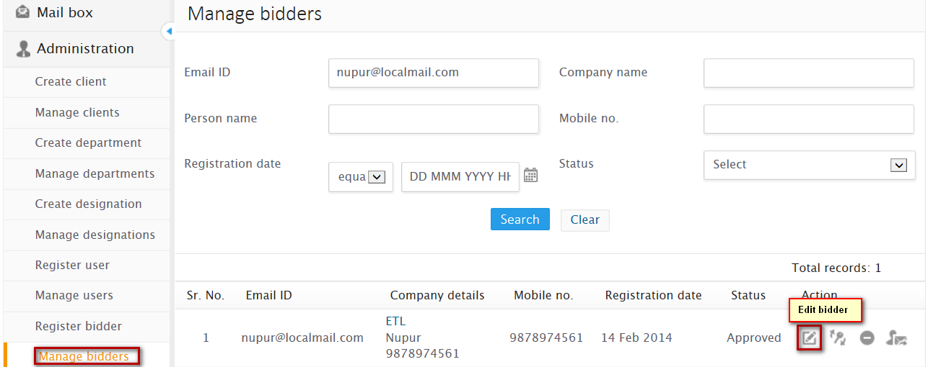

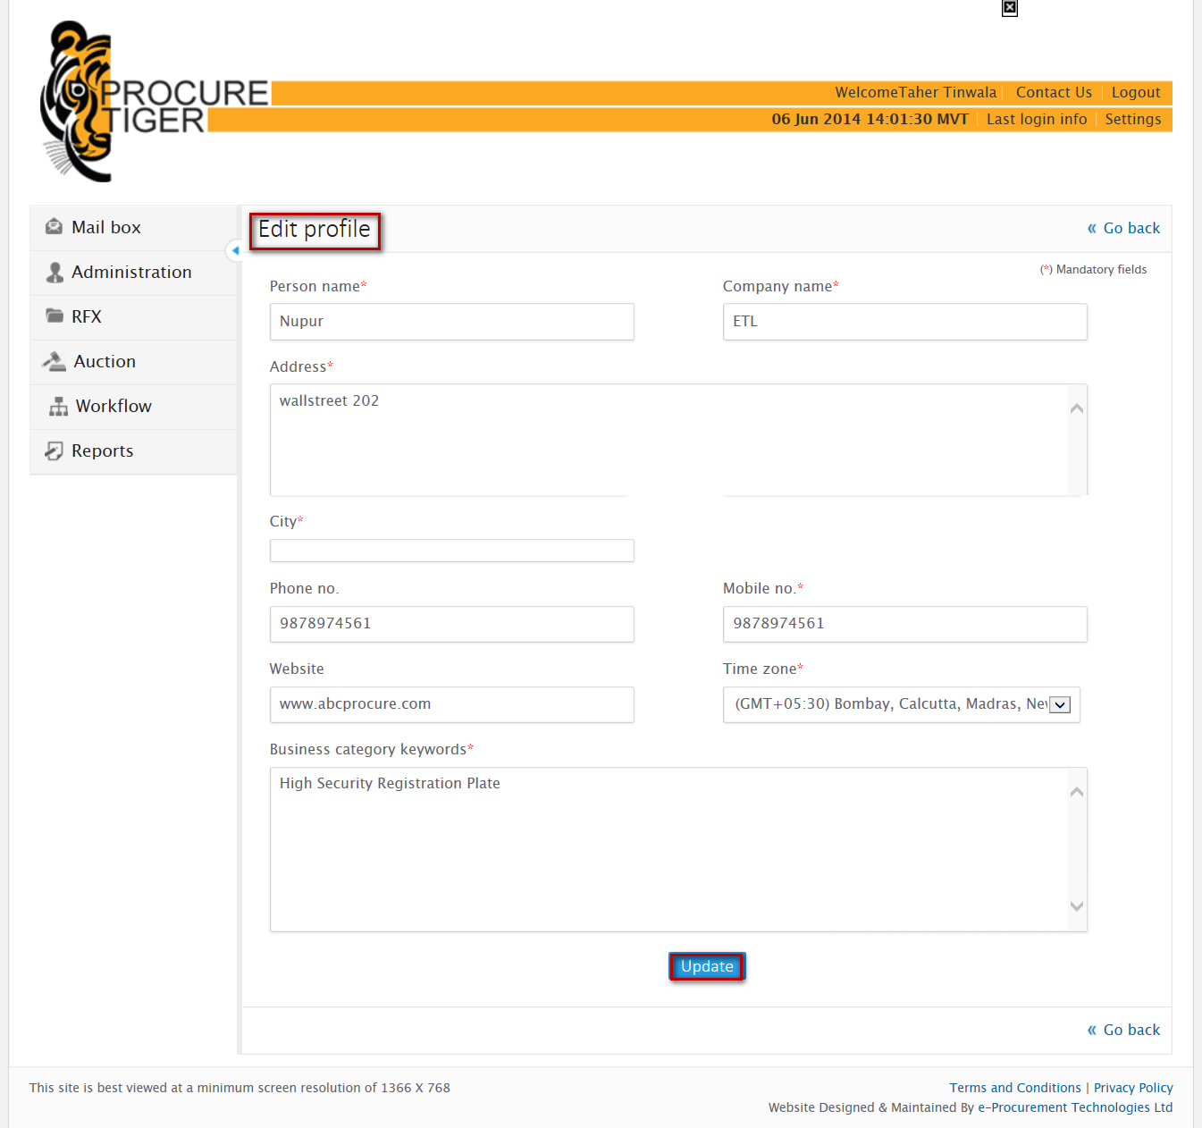



**Steps to edit bidder’s profile**:

1. Click on Edit icon, from the manage bidder listing
2. Update the details as per your requirement
3. Click on update button

On successful update, you will be notified with a message “**User profile updated successfully”** and you will be redirected to Manage bidder’s listing

### Reset password

Administrator can reset password in case department bidder has forgotten password

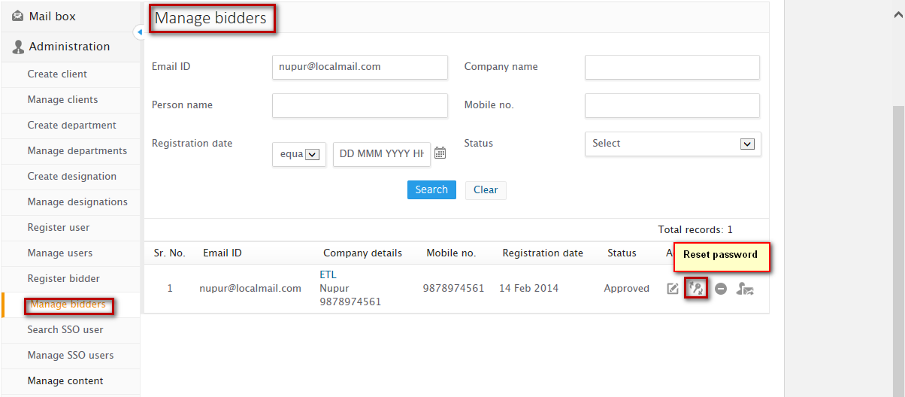

**1**



**2**



**3**



**Steps to reset password:**

1. Click on Reset password icon from the Manage user listing
2. On confirmation click on ok

On successful reset, you will receive an alert message that notifies your Email id and new password set, Click on ok and you will be notified with a message as **“Password reset successfully”**

### Approve bidder

Administrator can approve bidder’s registration profile

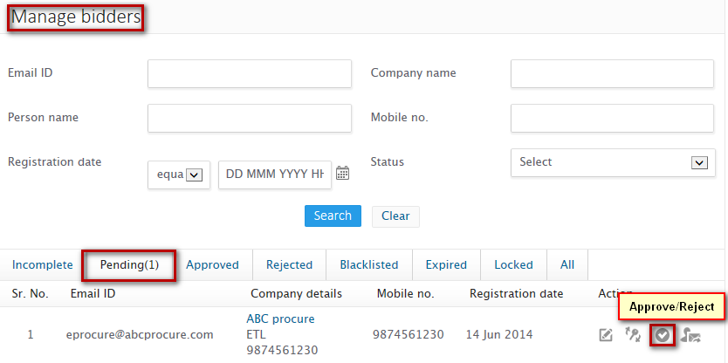

**1**

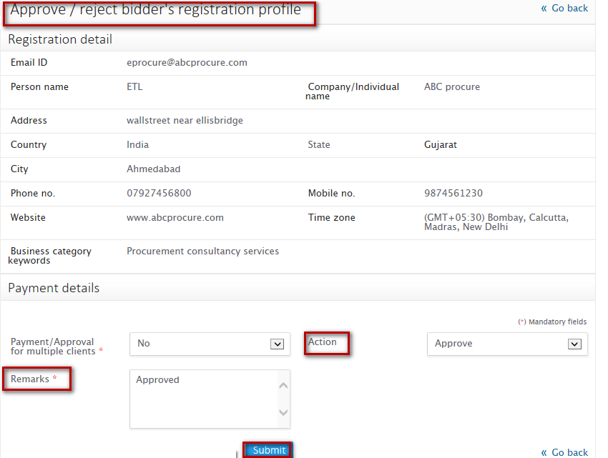

**3**

**5**

**43**

**2**



**Steps to approve bidder:**

* 1. Click on Manage bidder from the administration menu
  2. Go to Pending tab from manage bidder listing
  3. Click on the Approve/Reject icon
  4. Configure payment details
  5. Perform action as approve
  6. Specify remarks on approval
  7. Click on Submit button

On successful approval, you will be notified with a message as “**Profile approved successfully”** and you will be redirected to Manage bidder’s listing

### Reject bidder

Administrator can approve bidder’s registration profile



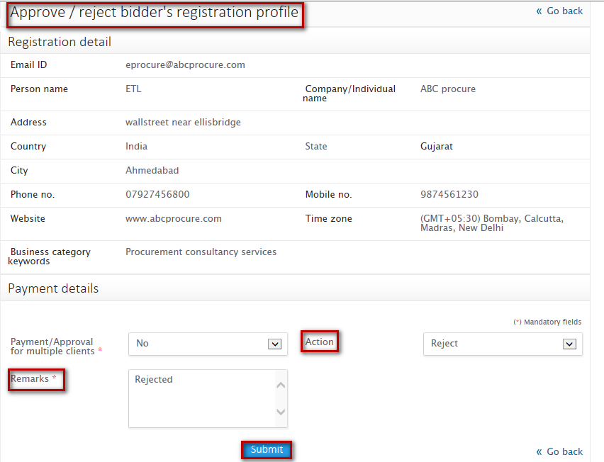

**Steps to reject bidder:**

1. Click on Manage bidder from the administration menu
2. Go to Pending tab from manage bidder listing
3. Click on the Approve/Reject icon
4. Configure payment details
5. Perform action as Rejected
6. Specify remarks on rejection
7. Click on Submit button

On successful approval, you will be notified with a message as “**Profile rejected successfully”** and you will be redirected to Manage bidder’s listing

### Unlock bidder

On three consecutive unsuccessful login attempts, bidder’s profile gets locked. Administrator can unlock bidder’s profile else bidder’s profile will automatically get unlocked after 30 minutes

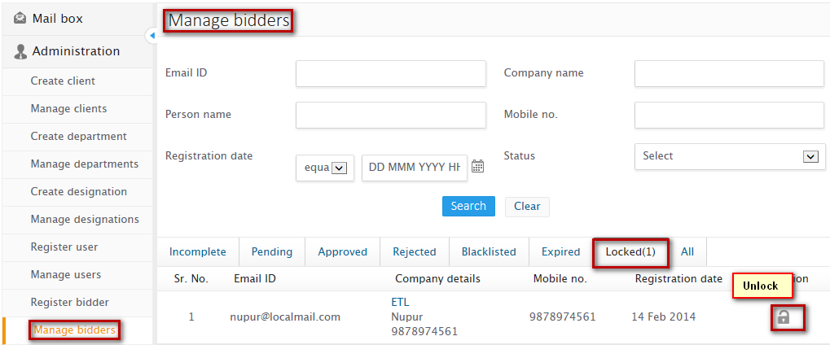



**Steps to unlock bidder’s profile**:

1. Search the bidder from the locked tab
2. Click on the unlock icon from the manage bidder listing

On successful unlock, you will be notified with a message as **“User unlocked successfully”** and you will be redirected to manage bidder’s listing.

When bidder’s profile is unlocked and after unlock when bidder tries to login the following alert will come

Note

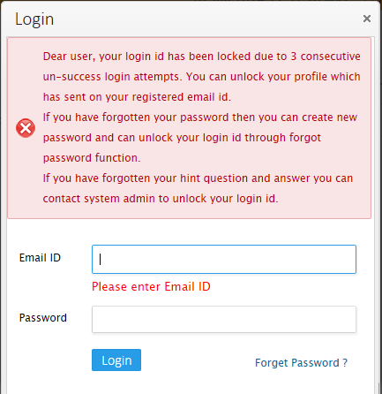

### Blacklist bidder

Administrator can blacklist bidder temporary or permanent. Once blacklisted, bidder can also be removed from blacklist else if bidder has been blacklisted temporary by configuring from date and to date then bidder will automatically get removed from the blacklist once the to date has been lapsed

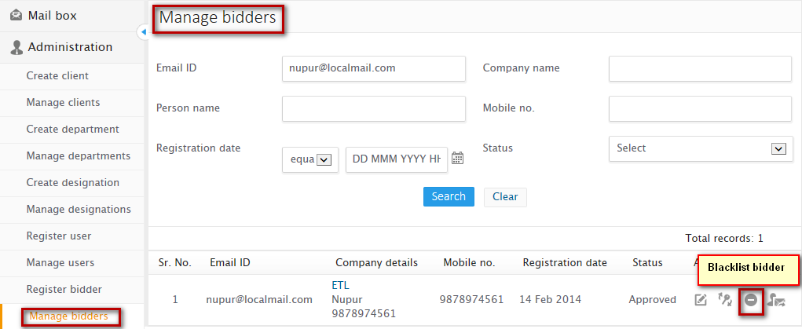

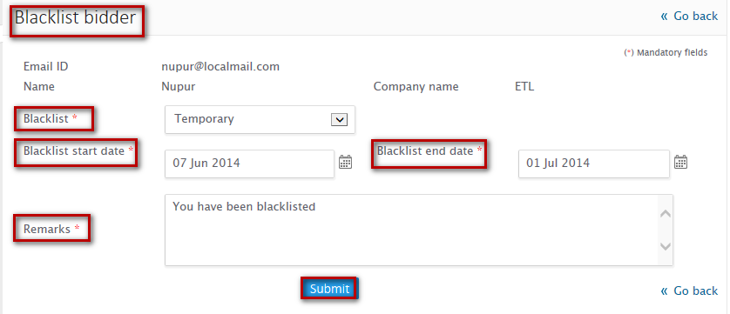



**Steps to blacklist bidder:**

1. Click on the blacklist icon from the manage bidder’s listing
2. Configure whether you want to blacklist the bidder temporary or permanent
3. If temporary, configure start date and end date
4. Click on Submit button

On successful blacklist, you will be notified with a **message “<Bidder name> blacklisted successfully”** and you will be redirected to manage bidder listing page.

### Remove bidder from blacklist

Once the bidder has been blacklisted, administrator can remove bidder from blacklist

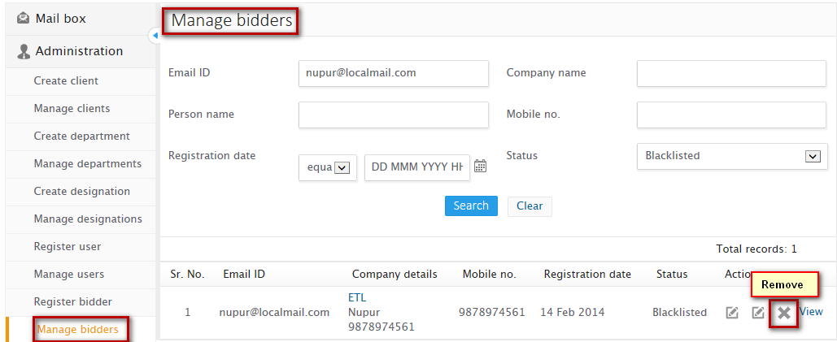



**Steps to remove bidder from blacklist:**

1. From the manage bidder listing, go to blacklisted tab
2. Click on the remove icon against the bidder

On successful removal, you will be notified with a message **“User removed from blacklisting successfully**” and you will be redirected to manage bidder listing

### Send registration detail

Administrator can send bidder’s registration detail to respective bidder

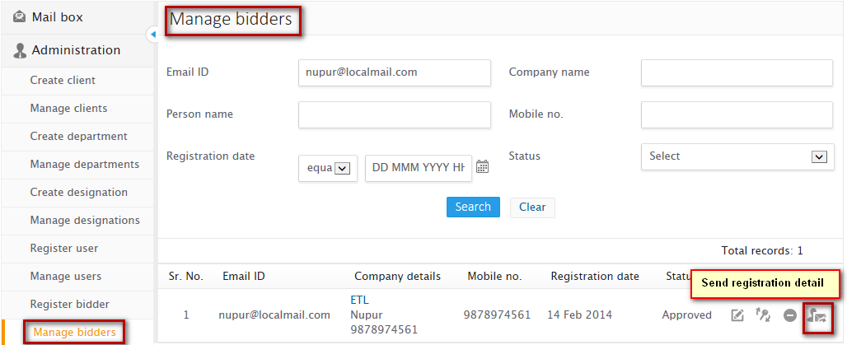

**1**



**2**



**Steps to send registration detail to department user:**

1. Click on the send registration detail icon from the manage user listing
2. On confirmation click on Ok

On successful sending of registration detail, you will be notified with a message as “**Registration details sent successfully”** and you will be redirected to manage bidder listing

### Unmap digital certificate

Administrator can unmap bidder’s mapped digital certificate if bidder has been registered on PKI domain

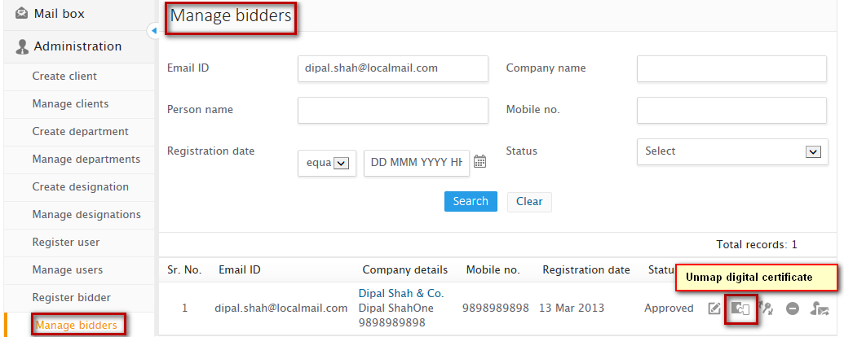

**1**

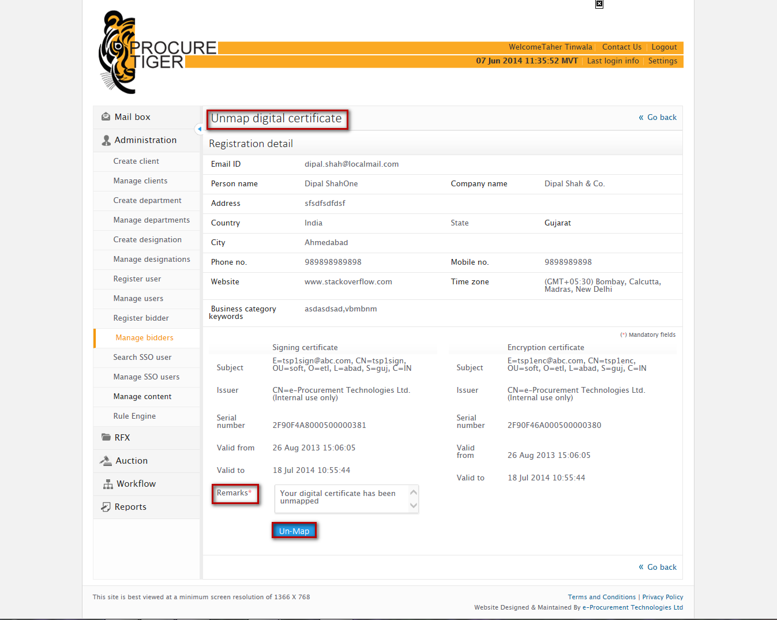

**3**

**2**

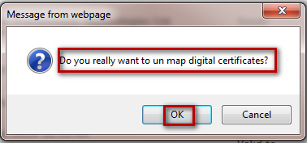

**4**



**Steps to unmap bidder’s digital certificate:**

1. Search the bidder
2. From the manage bidder listing, click on Unmap digital certificate icon
3. Enter remarks
4. Click on submit button
5. On confirmation, click on Ok

On successful unmapping, you will be notified with a message as “**Certificate un-mapped successfully”** and you will be redirected to manage bidder listing.

# Search SSO user

Administrator can search SSO user on any domain by specifying email id of the user

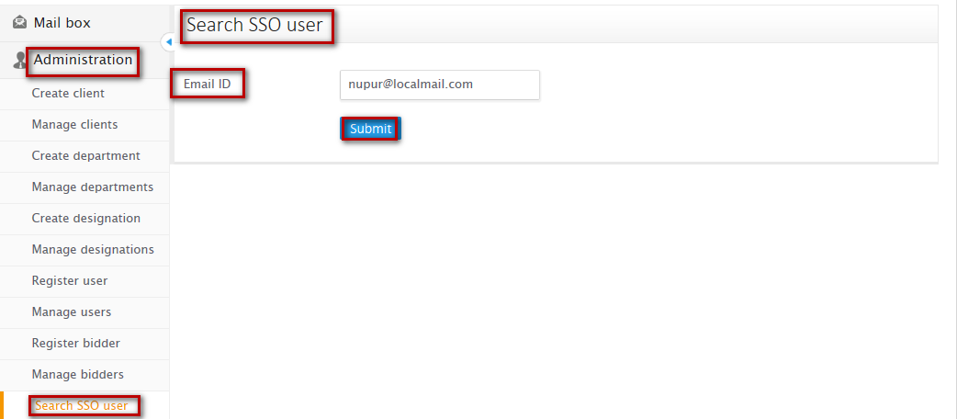

**2**

**3**

**1**

**Steps to search SSO user:**

1. From the administration panel on left accordion, click on search SSO user
2. Enter email id of the user which you want to check to be an SSO user
3. Click on Submit

On successful submit, you will find the listing of SSO user

# Manage SSO users

Administrator can search and manage SSO users

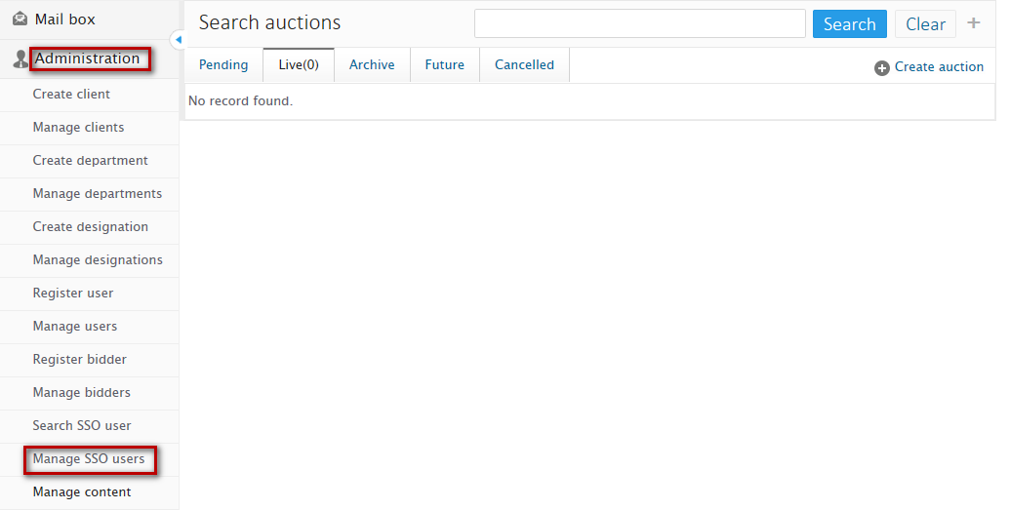

**1**

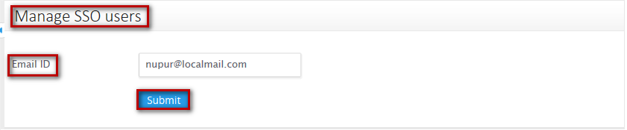

**3**

**2**

# Manage content

Administrator can search, create and manage all the master content through manage content

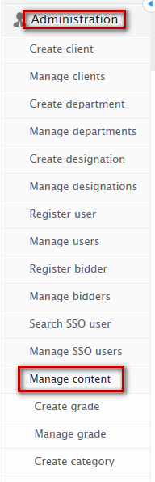

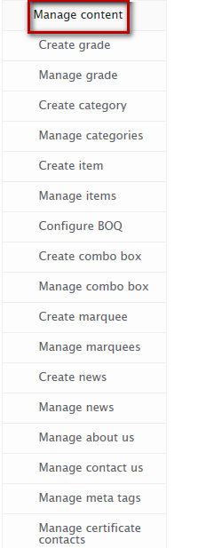

## Create grade

Administrator can create master data for grades that can be assigned to different designations created

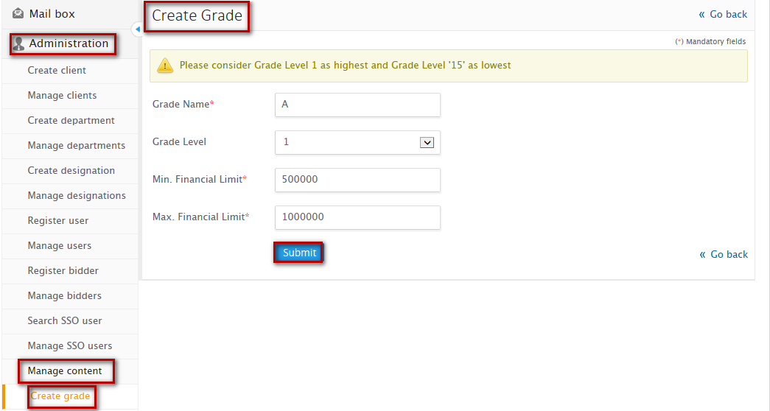

**2**

**3**

**4**

**1**



**Steps to create grade:**

1. From the left accordion administration panel, Click on manage content
2. Click on create grade
3. Configure all the required details required to create grade
4. Click on submit button

On successful grade creation, you will be notified with a message as **“Grade added successfully”** and you will be redirected to manage grade listing

**2**

## Manage grade

Administrator can manage grades created and can perform actions on it

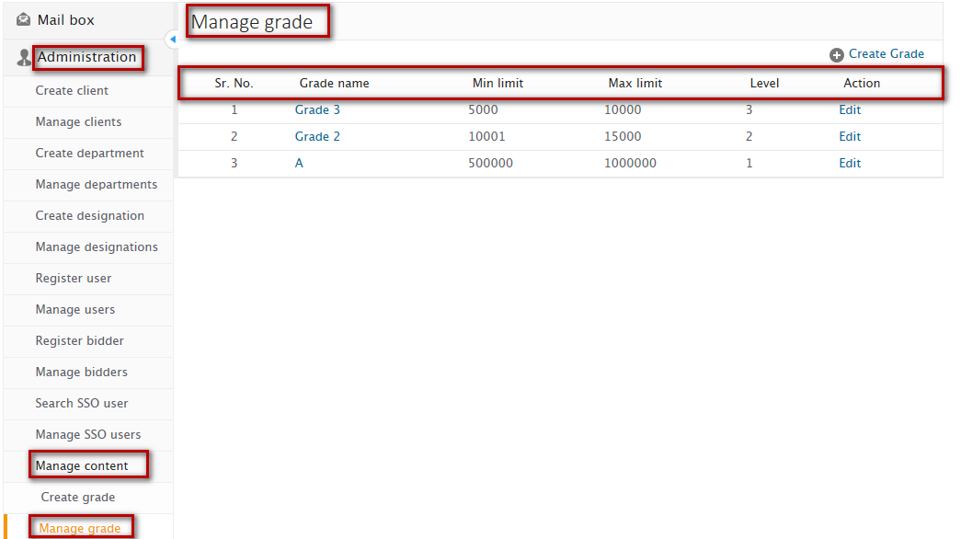

**2**

**1**

**3**

**Manage grade listing:**

* Grade name – Shows name of the grade
* Minimum limit – Shows minimum limit configured for grade
* Maximum limit - Shows maximum limit configured for grade
* Level – Shows grade level
* Action – Lists actions that can be performed on grades created

### Edit grade

Administrator can edit grade details configured

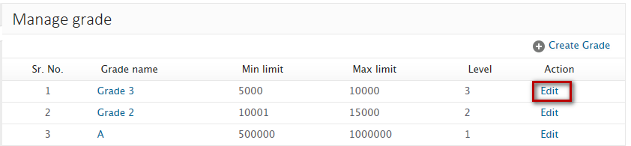

**1**

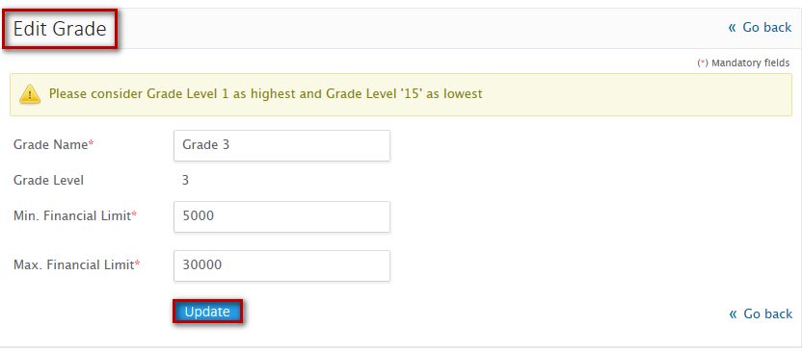

**3**

**2**

Steps to edit grade:

1. Click on edit icon against the grade from the manage grade listing
2. Update the details as per your requirement
3. Click on Update button

On successful update, you will be notified with a message as **“Grade updated successfully”** and you will be redirected to manage grade listing.

## Create category

Administrator can create category that can be mapped to items

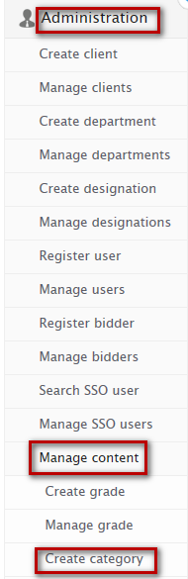

**2**

**1**

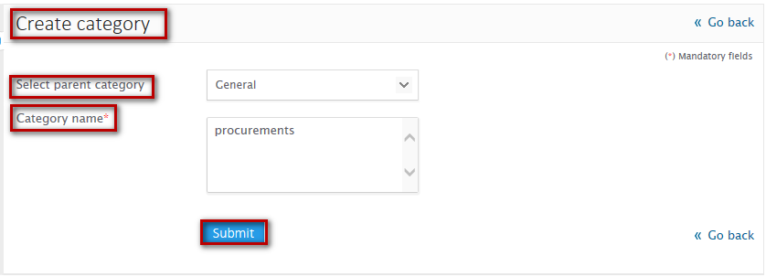

**5**

**4**

**3**



**Steps to create category:**

* 1. Form the administration panel, click on Manage content
  2. Click on create category
  3. Select parent category
  4. Enter category name
  5. Click on Submit button

On successful creation, you will be notified with a message as “**Category created successfully”** and you will be redirected to manage category listing.

## Manage category

Administrator can search and manage categories created

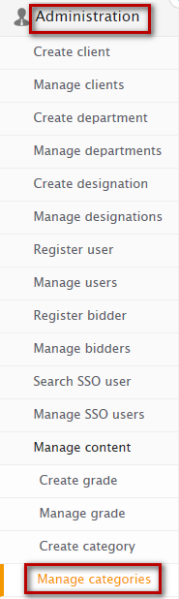

### Search category

Administrator can search for category created by specifying search parameter of category name and parent category

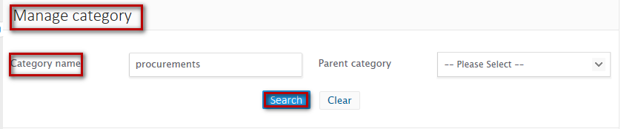

**1**

**2**

**Steps to Search category:**

1. Enter at least one of the search criteria
2. Click on ‘Search’ button

On successful search, result will be displayed in the listing area that matches the search criteria. If no record has been found that matches the search criteria then you will find a message as **“No record found”**

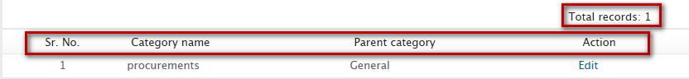  
**Category listing** – Lists categories created by listing the following

* **Category name** – Shows name of the category created
* **Parent category** – Shows parent category to which the category has been mapped
* **Action** – Shows actions that can be performed on categories created.

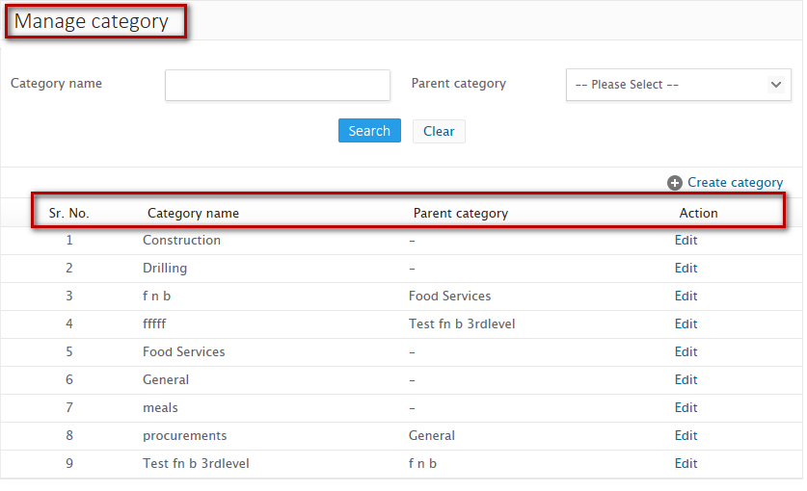

### Edit category

Administrator can edit category details configured

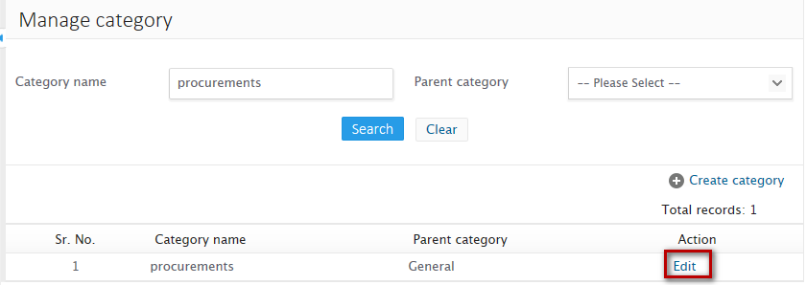

**1**

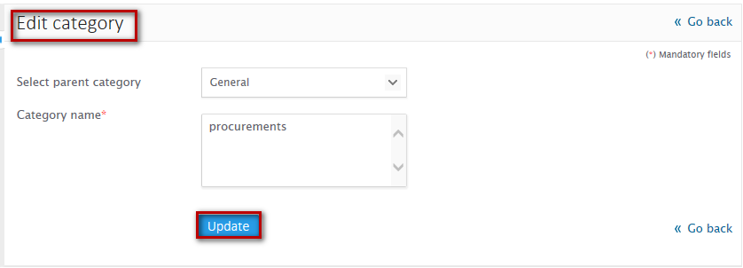

**3**

**2**

**Steps to edit category:**

1. Click on the edit icon from the category listing
2. Edit the details as per your requirement
3. Click on update button

On successful update, you will be notified with a message **“Category/sub-category updated successfully”** and you will be redirected to manage category listing

## Create item

Administrator can create item master mapping items their respective category. It is mandatory to map items to a category

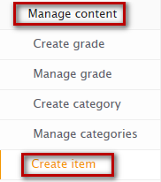

**2**

**1**

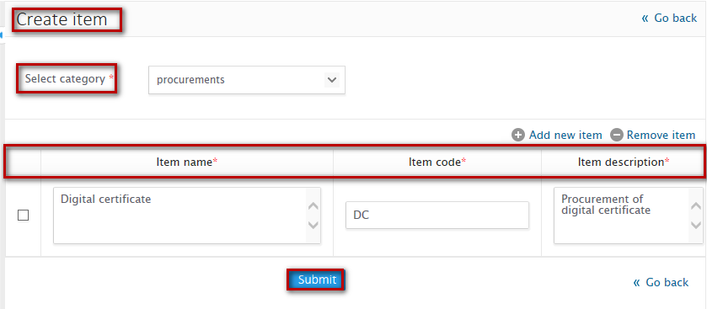

**4**

**5**

**6**

**7**

**3**



**Steps to create item:**

1. Click on Manage content from administration panel left accordion
2. Click on Create item
3. Select category
4. Enter item name, code and description
5. Add more record or delete record if required
6. Click on submit button

On successful item creation, you will be notified with a message as “**Item created successfully”** and you will be redirected to manage item listing page

## Manage item

Administrator can search, and edit items created

### Search

Administrator can search for item created by specifying search parameter of item name, item code and category name

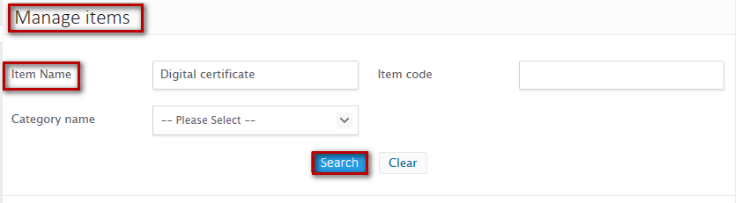

**2**

**1**

**Steps to Search item:**

1. Enter at least one of the search criteria
2. Click on ‘Search’ button

On successful search, result will be displayed in the listing area that matches the search criteria. If no record has been found that matches the search criteria then you will find a message as **“No record found”**

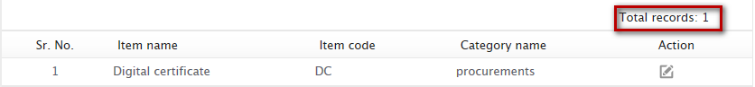

### Edit item

Administrator can edit details of item created.

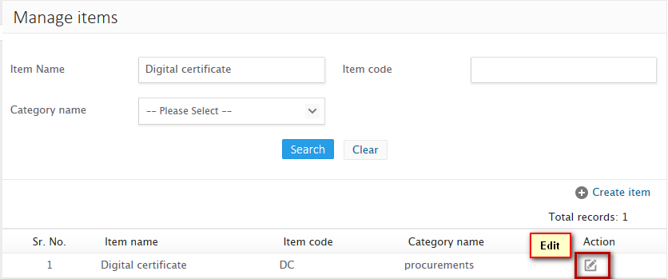

**1**

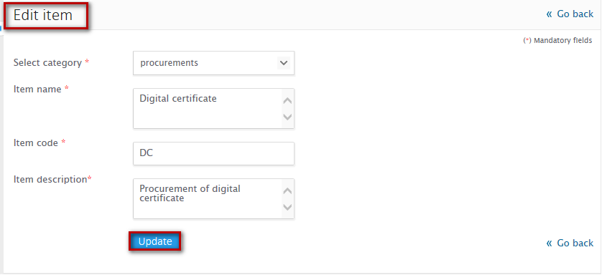

**3**

**2**



**Steps to edit item:**

1. Click on the edit icon against the item from the manage item listing
2. Edit the details configured as per your requirement
3. Click on Update button

On successful update, you will be notified with a message as “**Item updated successfully”** and you will be redirected to manage item listing page

## Configure BOQ

Administrator can configure and map BOQ columns and can create a standard BOQ format that can be used as bidding forms for events

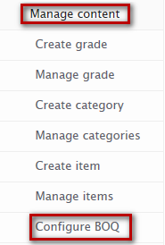

**2**

**1**

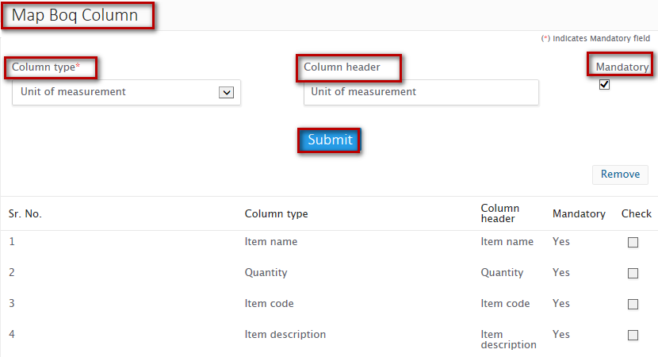

**3**

**4**



**Steps to configure BOQ**

1. Click on manage content from administration panel
2. Click on configure BOQ
3. Select column type, column header and set mandatory or not
4. Click on submit

On successful submit, you will be notified with a message as **“BOQ format configured successfully”** and you will be able to see BOQ columns listing where you can find recently mapped column

* **Remove BOQ column**

Configure BOQ shows the listing of columns mapped, from the listing you can remove any of the column

**Steps to remove BOQ column:**

1. Check on the checkbox against the column which you want to remove
2. Click on remove button

On successful remove you will find the column removed from the BOQ column listing

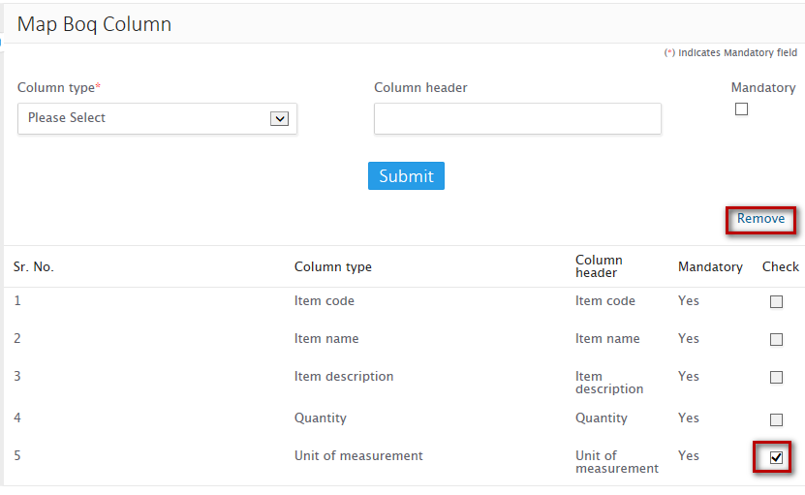

**2**

**1**

### Create combo box/list box

Administrator can create combo box/list box master that can be assigned as a control to any of the field

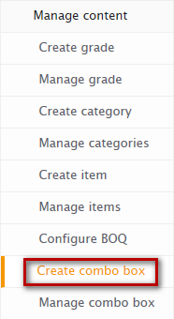

**1**

* **Combo box**

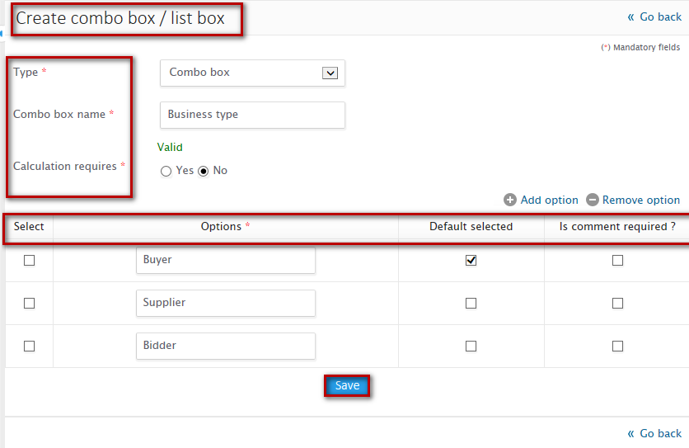

**3**

**2**

**4**



**Steps to create combo box:**

1. From the manage content, click on create combo box
2. Select type as combo box, name and calculation requires as per your requirement
3. Specify options to be displayed under combo box also select the default value and comments if required
4. Click on Save button

On successful creation, you will be notified with a message as “Combo box/list box created successfully” and you will be redirected to manage combo box/list box page

* **List box**



**1**

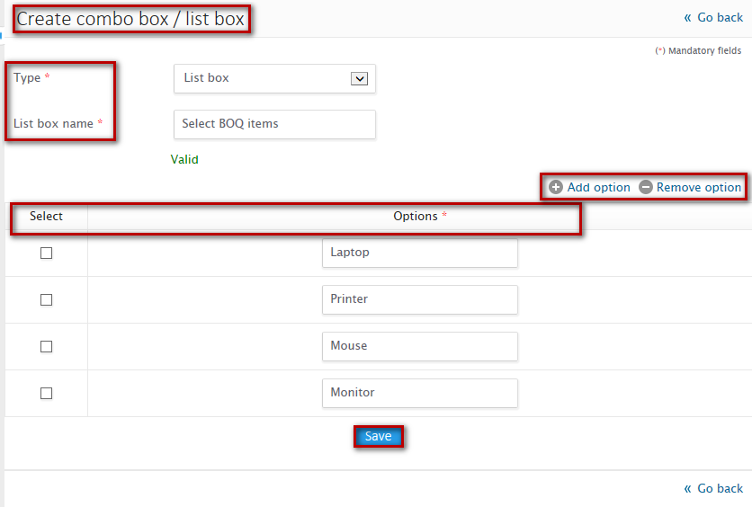

**4**

**3**

**2**



**Steps create list box:**

1. From the manage content, click on create combo box
2. Select type as list box, give list box name as per your requirement
3. Specify options to be displayed under list box
4. Click on Save button

On successful creation, you will be notified with a message as “**Combo box/list ox created successfully”** and you will be redirected to manage combo box/list box page

### Manage combo box/list box

Administrator can search and manage combo box/list box created

**Search combo box/list box:**

Administrator can search for combo box/list box created by specifying search parameters of combo box/list box name and status

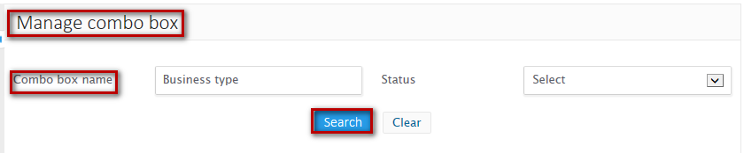

**Steps to search combo box/list box:**

1. Enter at least one of the search criteria
2. Click on ‘Search’ button

On successful search, result will be displayed in the listing area that matches the search criteria. If no record has been found that matches the search criteria then you will find a message as **“No record found”**

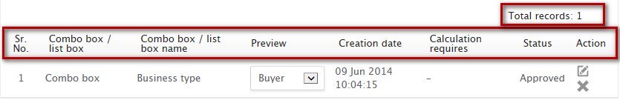

* **Combo box/List box listing**

Listing displays combo box/list box created classifying them into two different tabs of Approved and cancelled

* **Approved** – Displays all the approved combo box/list box
* **Cancelled** – Displays cancelled combo box/list box

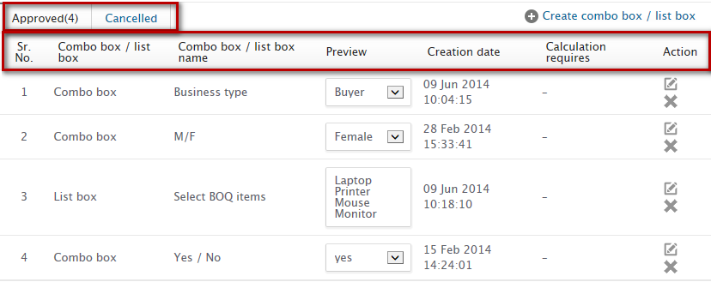

**Listing fields:**

* **Combo box/list box** – Displays type of box whether combo box or list box
* **Combo box/list box Name** – Displays name of the combo box/list box created
* **Preview** – Display preview of combo box/ list box
* **Creation date** – Displays date of creation on which combo box/list box created
* **Calculation requires** – Displays calculation requires configuration as yes/no
* **Actions** – Displays icons through which actions can be performed\

## Create marquee

Administrator can create marquee that floats marquee text as per time configured on the domain selected

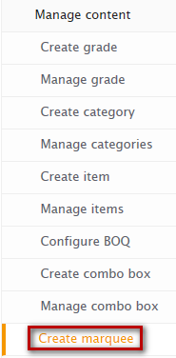

**1**

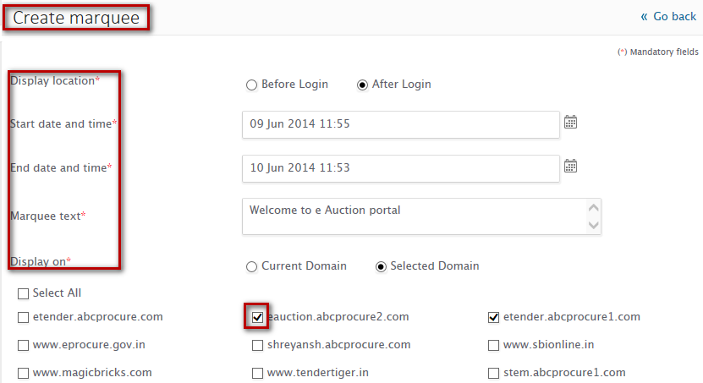

**3**

**5**

**4**

**2**

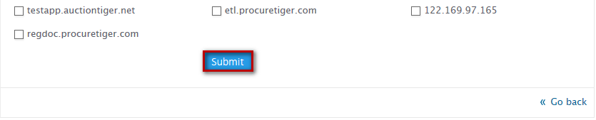

**6**



**Steps to create marquee:**

1. Click on create marquee, from manage content from the left accordion under administration menu
2. Configure marquee location
3. Configure Marquee start date and time and end date and time
4. Specify marquee text to be floated
5. Configure domain on which you want marquee to be floated

On successful creation, you will be notified with a message as **“Marquee created successfully”** and you will be redirected to Manage marquees page

## Manage marquee

Administrator can search and manage marquees created

### Search marquee

Administrator can search marquee by specifying at least one of the search parameter of Marquee text and status of marquee

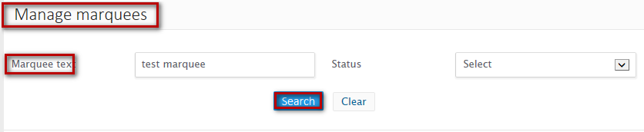

**2**

**1**

**Steps to Search marquee:**

1. Enter at least one of the search criteria
2. Click on ‘Search’ button

On successful search, result will be displayed in the listing area that matches the search criteria. If no record has been found that matches the search criteria then you will find a message as **“No record found”**

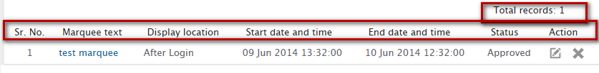

**Marquee listing:**

Lists details of marquees created

**Listing fields:**

* **Marquee text** – Displays marquee text configured
* **Displays location** – Displays location of the marquee configured
* **Start date and time** – Displays marquees configured start date and time
* **End date and time** – Displays marquees configured end date and time
* **Status** – Displays status of marquee to be approved or cancelled
* **Actions** – Lists icons through which actions can be performed on marquee created

### Edit marquee

Administrator can update marquee details configured

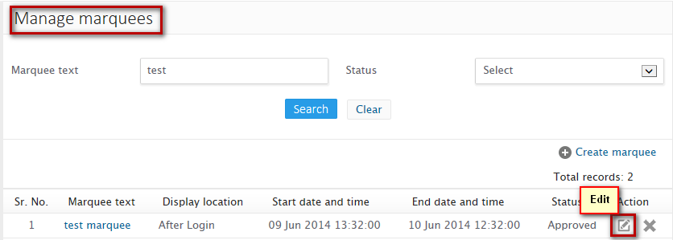

**1**

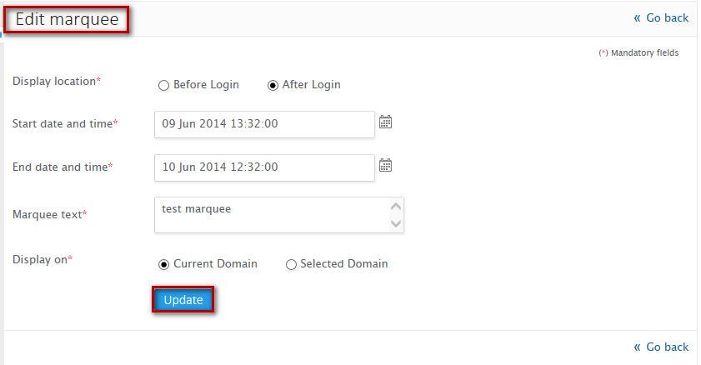

**3**

**2**

**Steps to edit marquee:**

1. Click on manage marquee, from manage content under administration panel from left accordion
2. Update details configured as per your requirement
3. Click on Update button

On successful update, you will be notified with a message “**Content updated successfully”** and you will be redirected to manage marquee page

### Cancel marquee

Administrator can cancel marquee configured

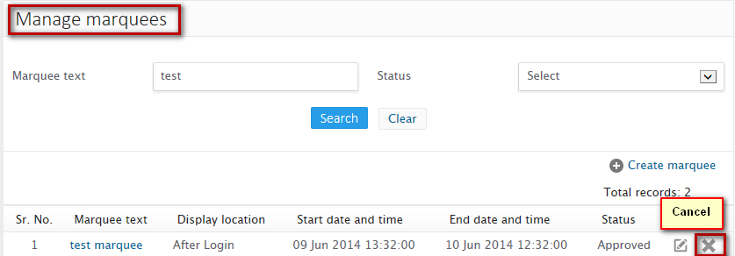

**1**

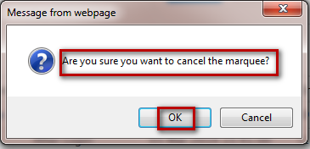

**2**



**Steps to cancel marquee:**

1. Click on the Cancel icon from the manage marquee listing
2. On confirmation click on Ok

On successful cancellation, you will be notified with a message as “**Marquee cancelled successfully”** and you will be redirected to manage marquee listing

## Manage about us

Client can edit/update about us content

## Manage contact us

## Manage Meta tags

Administrator can create Meta tags for respective domain

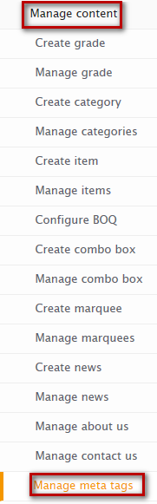

**1**

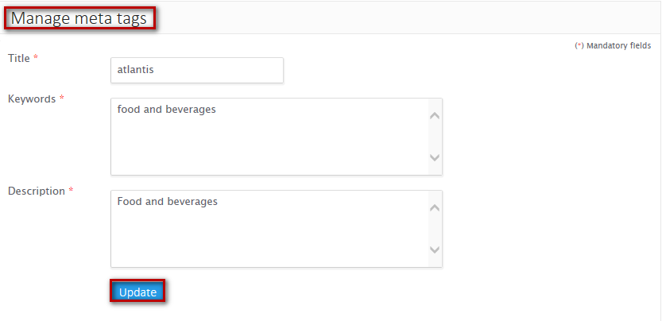

**3**

**2**



**Steps to manage Meta tags:**

1. Click on manage meta tags, from manage content under administration panel from left accordion
2. Configure title, keywords and description
3. Click on Update button

On successfully update, you will be notified with a message as “**Content updated successfully”**

## Manage Certificate contacts

Administrator can manage and create contacts for digital certificate on the respective domain

* **Manage certificate contact listing**

Lists certificate contacts created

**Listing fields:**

* **Contact person name** – Displays name of the contact person
* **Actions** – Lists icons through which actions can be performed on certificate contacts created

### Add a new contact

Administrator can add a new contact in the digital certificate contact list

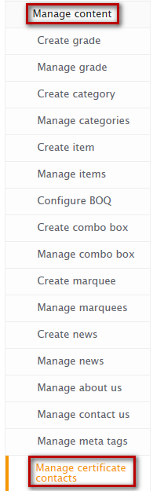

**1**

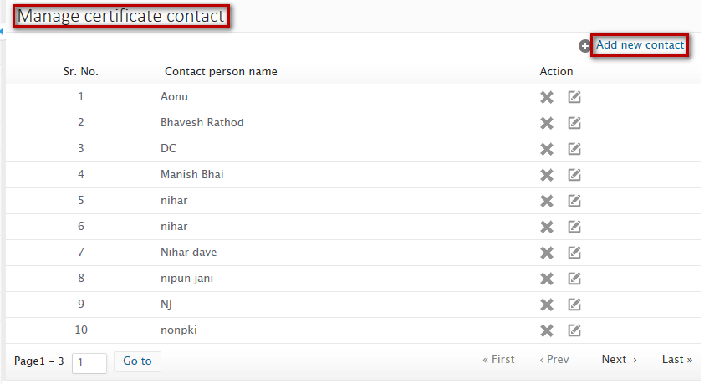

**2**

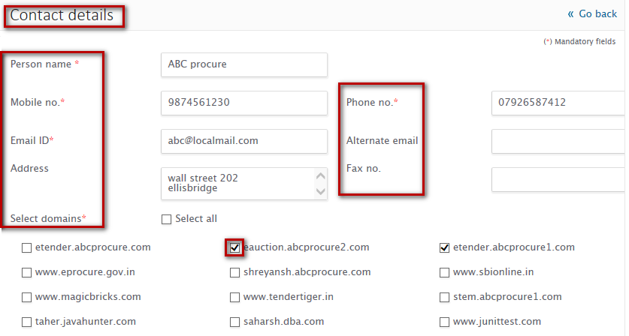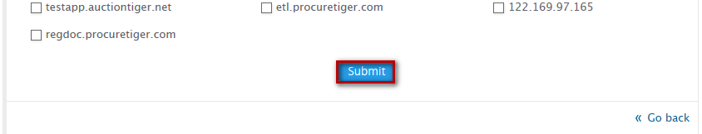

**4**

**3**



**Steps to add new certificate contact:**

1. Click on Manage certificate contact, from manage content under administration menu from left accordion
2. Click on Add a new contact link
3. Configure all the details of contact person as per your requirement
4. Click on Submit button

On successful submission, you will be notified with a message as **“Certificate contacts added successfully”** and you will be redirected to manage certificate contact listing

### Edit certificate contacts

Administrator can edit contact details of respective contact person



**1**

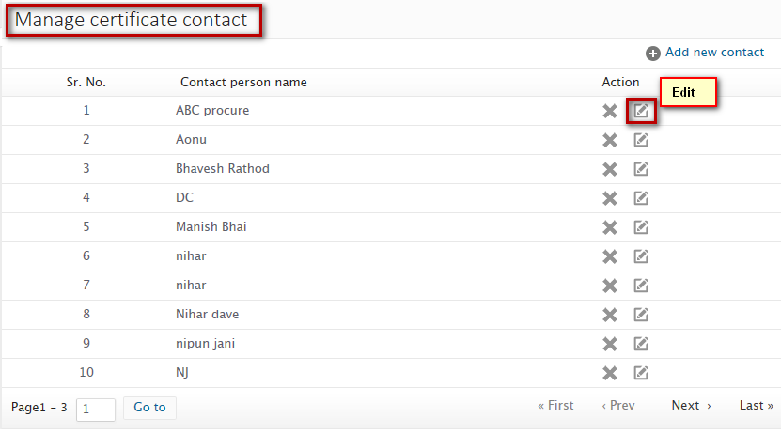

**2**

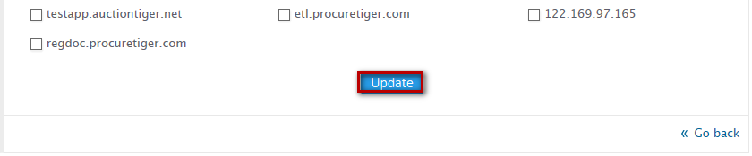

**3**

**4**



**Steps to edit certificate contact:**

1. Click on Manage certificate contact, from manage content under administration menu from left accordion
2. Click on edit icon against the contact you need to update
3. Update the details as per your requirement
4. Click on Update button

On successful update, you will be notified with a message as “**Certificate contacts updated successfully”** and you will be redirected to manage certificate contact listing

### Remove contact

Administrator can remove any of the certificate contact from manage certificate contact listing

**Steps to remove contact:**

1. Click on the Remove icon from the listing
2. On confirmation click on Ok

On successful removal, you will be notified with a message as “Certificate contact removed successfully” and you will be redirected to manage certificate contact listing

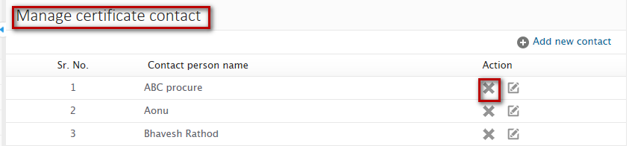

**1**

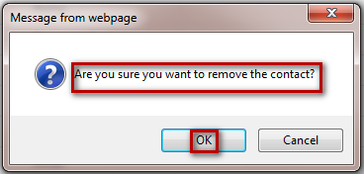

**2**

## Manage CRL

Administrator can select and upload CRL files. Manage CRL, lists CRL files uploaded with following fields

* **Certifying authority** – Displays certifying authority
* **Last updated** – Displays date on which CRL file was last updated

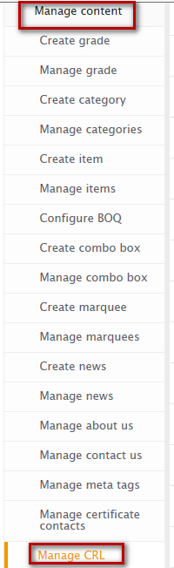

**1**

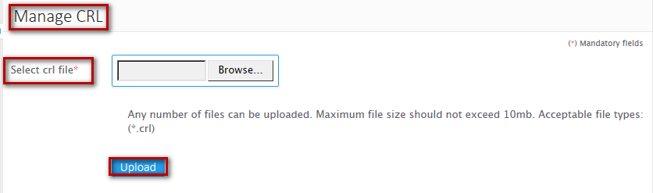

**3**

**2**

**Steps to upload CRL files:**

1. Click on Manage CRL, from manage content under administration panel from left accordion
2. Browse and select CRL file
3. Click on Upload button

On successful upload, you will be able to see the listing that lists all the CRL files uploaded

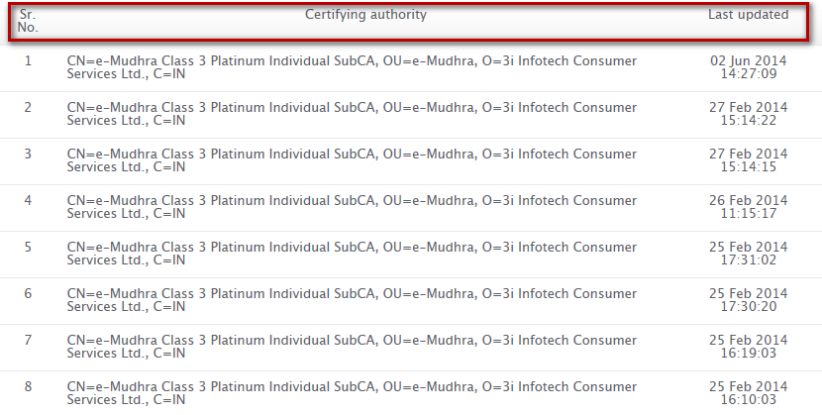

## Create new field

Administrator can create new field for a particular event on the respective sub module and module

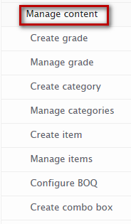

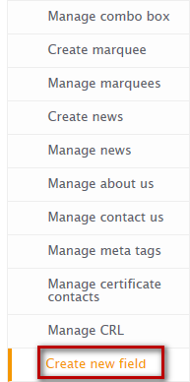

**1**

 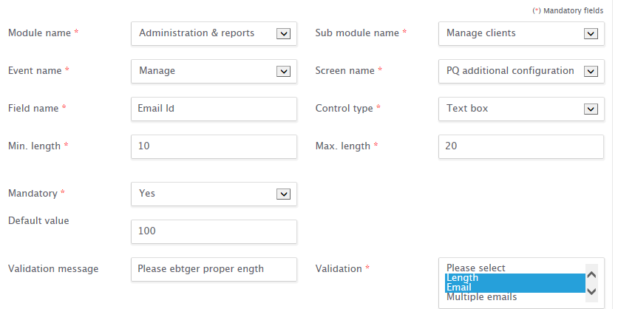 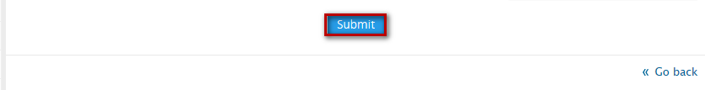

**2**

**Steps to create new field:**

**3**

1. Click on Create new field from Manage content, under administration panel from left accordion
2. Configure all the required details to create new field
3. Click on Submit button

On successful submit, you will be notified with a message as “**New field created successfully”** and you will be redirected to manage fields page

## Manage new field

Administrator can search and manage new fields created.

**Manage field listing**

Lists new fields created classifying them into two different tabs

* **Approved** – lists fields that are approved
* **Cancelled** – Lists fields that got canceled

**Listing fields:**

* **Screen name** – Displays name of the screen for which new field has been created
* **Field name** – Displays name of the newly created field
* **Status** – Displays status of the field as approved or cancelled
* **Actions** – Displays icons through which actions can be performed on fields created

### Search

Administrator can search for new field created by specifying search parameters Field name, screen name and status of the field

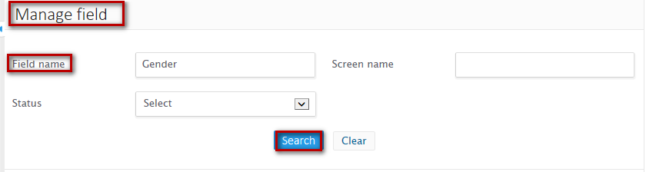

**2**

**1**

**Steps to Search new field:**

1. Enter at least one of the search criteria
2. Click on ‘Search’ button

On successful search, result will be displayed in the listing area that matches the search criteria. If no record has been found that matches the search criteria then you will find a message as **“No record found”**

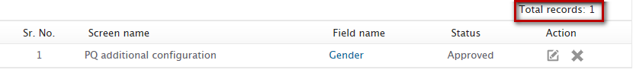

### Edit new field

Administrator can edit details of new field created

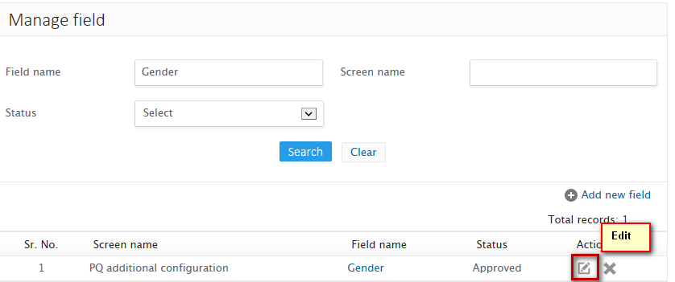

**2**

**1**

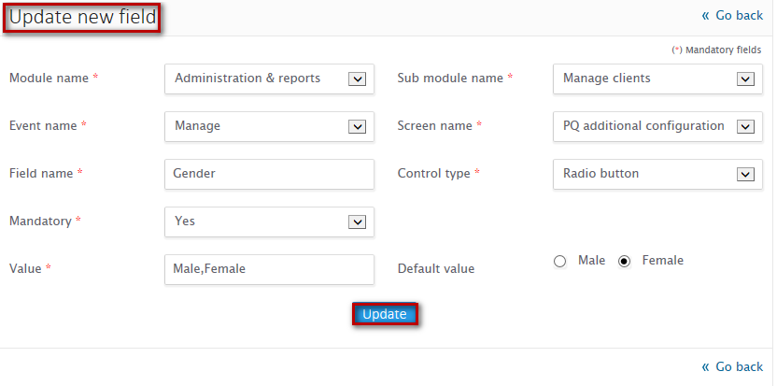

**3**

**Steps to edit new field:**

1. Click on Manage new fields from manage content under administration panel from left accordion
2. Click on the edit icon against the icon from the manage new field listing
3. Update the details as per your requirement
4. Click on Update button

On successful update, you will be notified with a message as “**New field updated successfully”** and you will be redirected to manage new fields listing

### Cancel field

Administrator can cancel the approved newly created field from manage new fields listing page

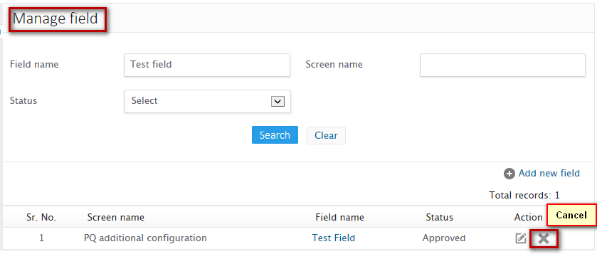

**1**

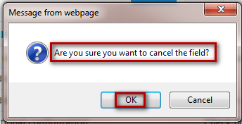

**2**



**Steps to cancel field:**

1. Click on Cross mark from the manage new field listing
2. On confirmation click on “Ok”

On successful cancellation, you will be notified with a message as “New field cancelled successfully” and you will be redirected to Manage new field listing

## Add issuer

Administrator can add issuer details

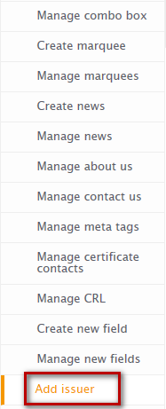

**1**

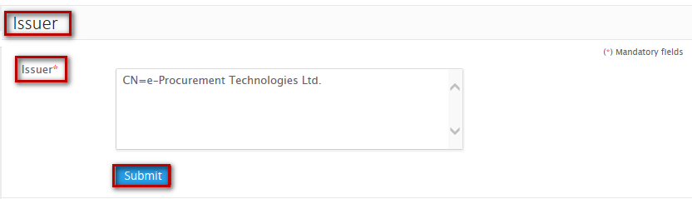 

**3**

**2**

**Steps to add issuer:**

1. Click on add issuer from manage content under administration menu
2. Add issuer string
3. Click on Submit button

On successful submit, you will be notified with a message as “**Issuer added successfully”** and you will be able to see the listing of issuer being added

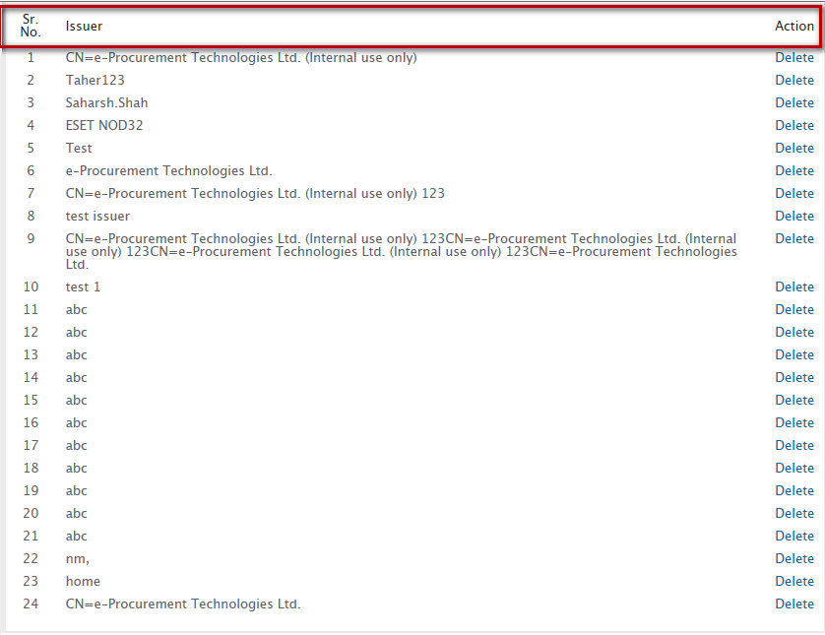

**Issuer listing fields**

* **Issuer** – Displays issuer string being added
* **Action** – Shows links through which actions can be performed on issuer added

### Delete issuer

Administrator can delete issuer being added through the listing

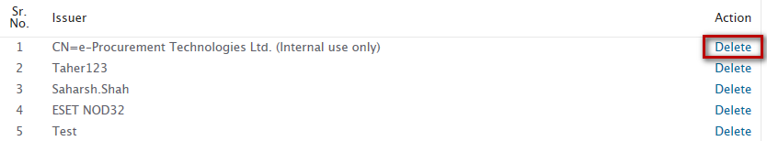

**1**

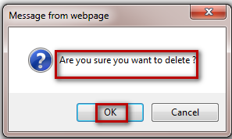

**2**



**Steps to delete issuer:**

1. Click on delete link against the issuer from the listing
2. On confirmation, click on Ok

On successful delete, you will be notified with a message as “**Issuer deleted successfully”**

## Manage terms and conditions of a client:

Administrator can search, add and update terms and conditions of client

### Search terms and conditions

Administrator can search for terms and conditions configured for any client by specifying parameters as follows:

* **Domain name** – Enter domain name for which you have configured terms and conditions
* **Terms and conditions for** – Select module for which you have configured terms and conditions
* **Language** – Select language in which you have configured terms and conditions

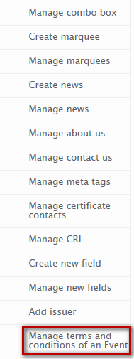

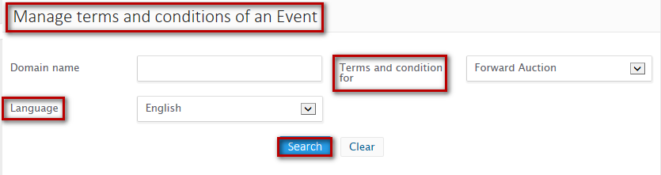

**2**

**1**

**Steps to search for terms and conditions:**

1. Enter at least one of the search criteria
2. Click on Search button

On successful search, result will be displayed in the listing area that matches the search criteria. If no record has been found that matches the search criteria then you will find a message as **“No record found”**

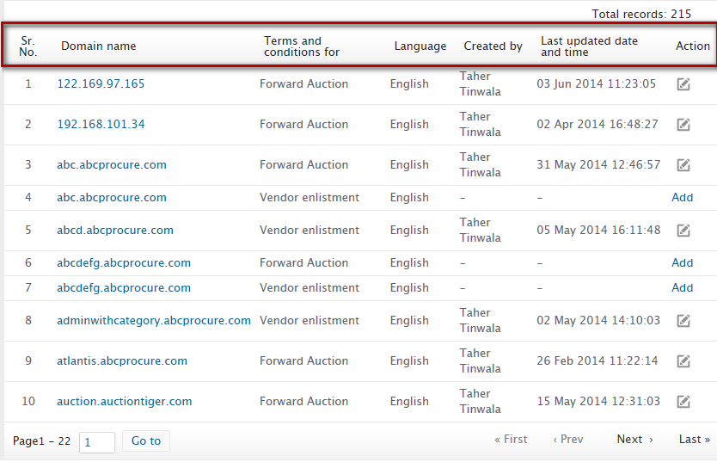

**Terms and conditions listing fields:**

* **Domain name** – Displays name of the domain for which terms and conditions have been configured
* **Terms and conditions for** – Displays name of the module for which terms and conditions have been configured
* **Language** – Displays language name in which terms and conditions have been configured
* **Created by** – Displays name of the user who created respective terms and conditions
* **Last updated date and time** – Displays date and time on which respective terms and conditions was last updated
* **Action** - List icons through which actions can be performed on terms and conditions being created

### Add terms and conditions

Administrator can add terms and conditions through manage terms and conditions listing



**1**

**2**

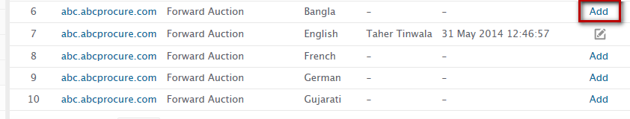

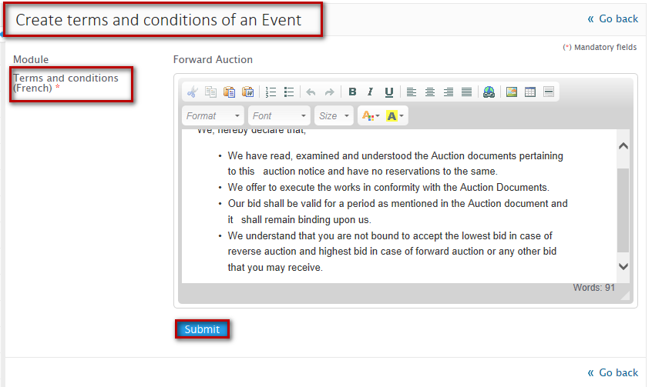

**4**

**3**



**Steps to add terms and conditions:**

1. Click on manage terms and conditions form manage content under administration panel from left accordion
2. Click on Add link from manage terms and conditions listing
3. Add terms and conditions
4. Click on Submit

On successful submit, you will be notified with a message as **“Terms and conditions added successfully”** and you will be redirected to terms and conditions listing

### Edit terms and conditions

Administrator can edit terms and conditions terms and conditions details configured for a client



**1**

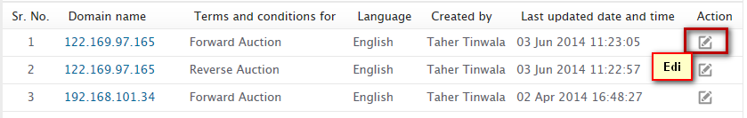

**2**

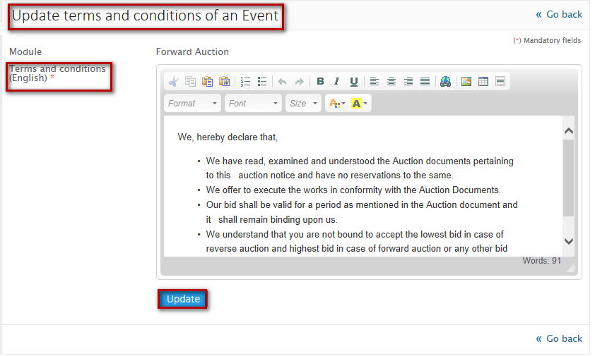

**4**

**3**



**Steps to edit terms and conditions:**

1. Click on manage terms and conditions form manage content under administration panel from left accordion
2. Click on Edit icon from manage terms and conditions listing
3. Update the details as per your requirement
4. Click on Update button

On successful update, you will be notified with a message as **“Terms and conditions updated successfully”** and you will be redirected to terms and conditions listing

## Manage help pages

Administrator can search and edit help pages

### Search help pages

Administrator can search for help pages by specifying search criteria as follows:

* **Page name** – Enter page name
* **Module name** – Enter name of the module for which help page has been created
* **Language** – Enter language in which help page has been created

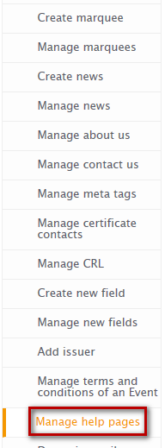

**1**

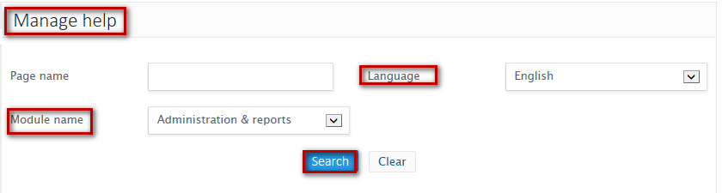

**3**

**2**

**Steps to search help pages:**

1. Click on manage terms and conditions form manage content under administration panel from left accordion
2. Enter at least one of the search criteria
3. Click on search button

On successful search, result will be displayed in the listing area that matches the search criteria. If no record has been found that matches the search criteria then you will find a message as **“No record found”**

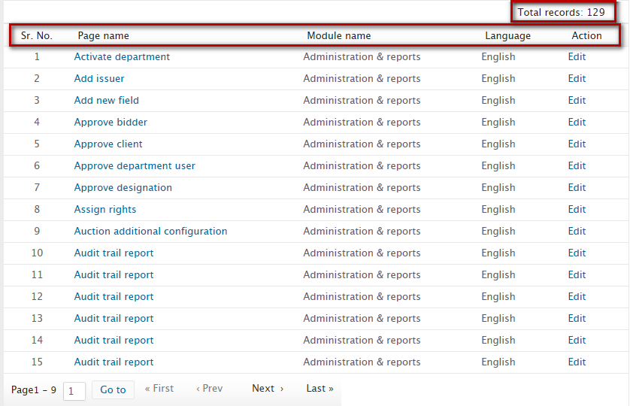

**Help page listing fields:**

* **Page name** – Displays name of the Page
* **Module** – Displays name of the module for which help page has been created
* **Language** – Displays language name in which help page has been created
* **Actions** – Displays links through which actions can be performed on help page

### Edit help pages



**1**

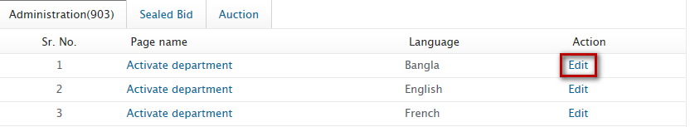

**2**

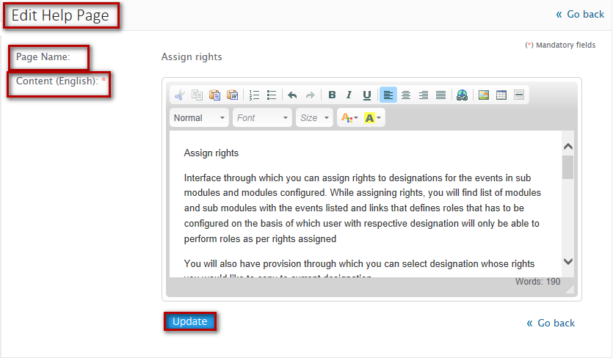

**4**

**3**



**Steps to edit help pages:**

1. Click on manage help pages form manage content under administration panel from left accordion
2. Click on Edit icon from manage help pages listing
3. Update the details as per your requirement
4. Click on Update button

On successful update, you will be notified with a message as **“Help page content updated successfully”** and you will be redirected to help page listing

## Dynamic email

Administrator can create email content for events and modules through Dynamic email

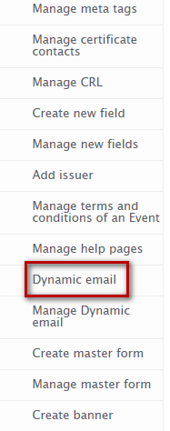

**1**

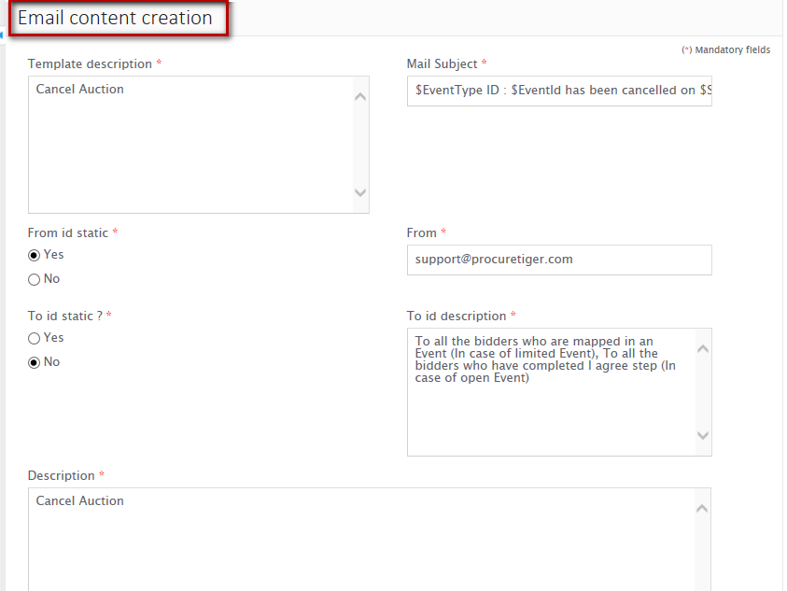

**2**

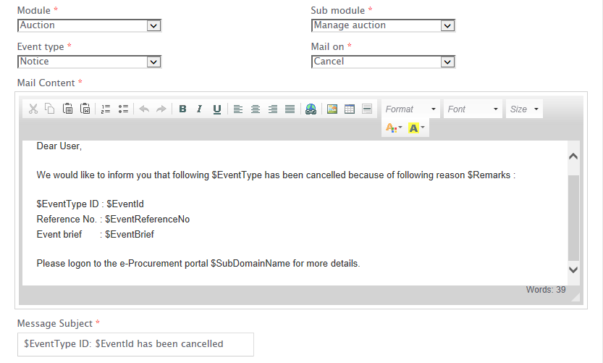

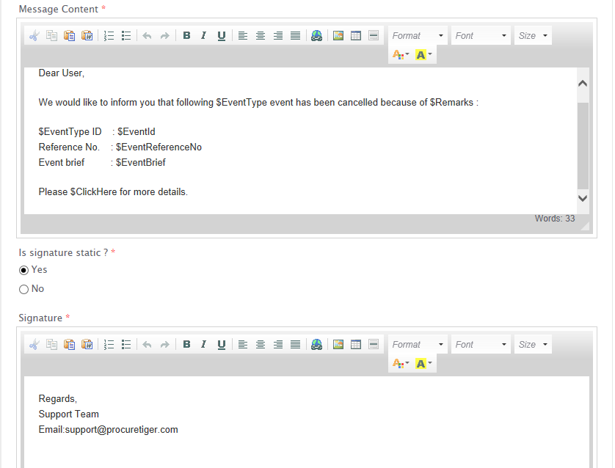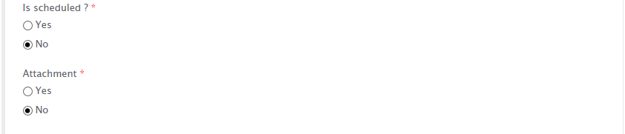

**3**



**Steps to create Dynamic email:**

* 1. Click on Dynamic email from Manage content under administration menu from left accordion
  2. Configure email content as per your requirement
  3. Click on Submit button

On successful email creation, you will be notified with a message as “**Email template added successfully”** and you will be redirected to Manage Dynamic email page

## Manage Dynamic email

## Create Master form

Administrator can create master form library for bidding forms

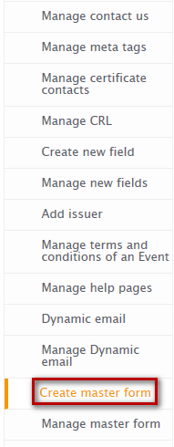

**1**

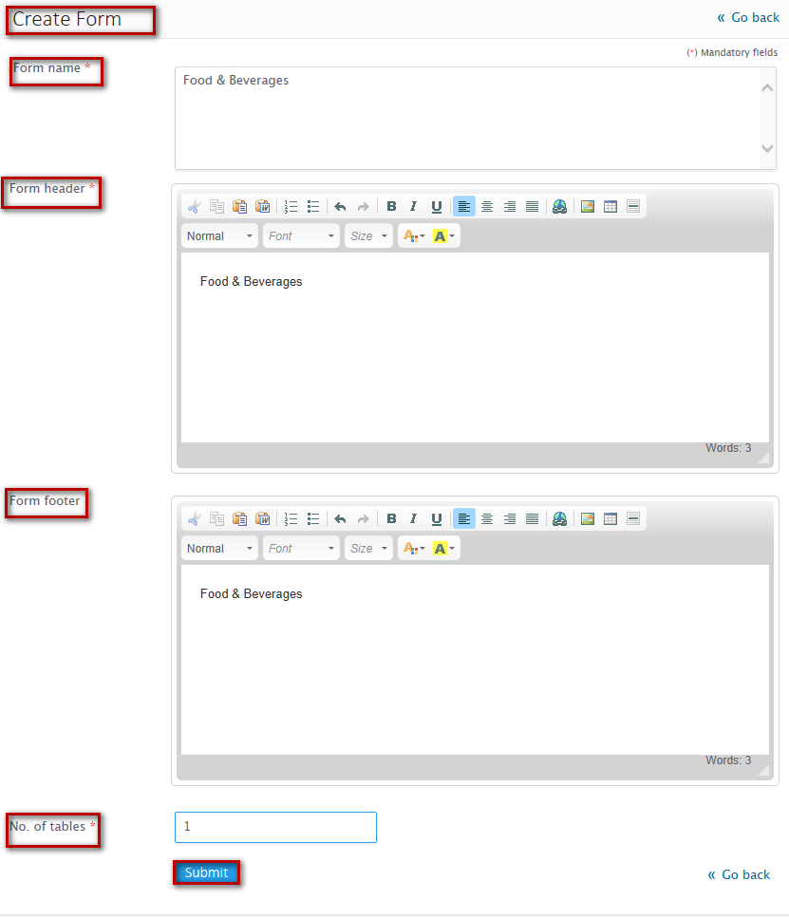

**3**

**2**

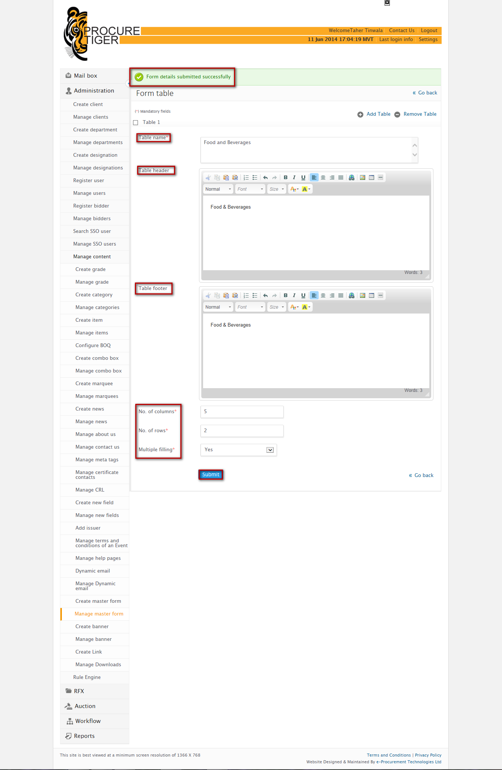

**5**

**4**

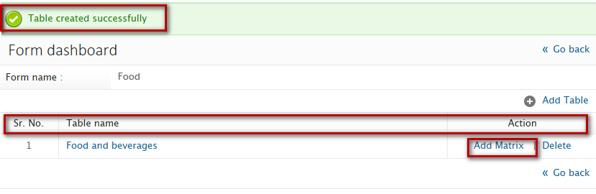

**6**

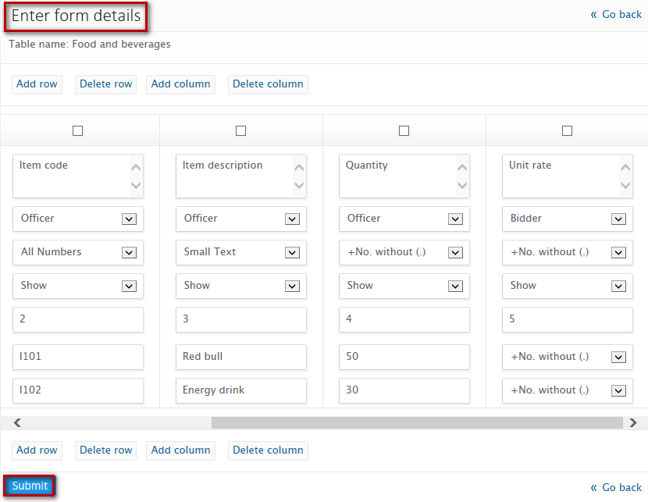

**8**

**7**

**Steps to create form, table and table matrix:**

1. Click on “Create master form” from manage content under administration panel from left accordion
2. Configure form details
3. Click on submit
4. Create tale and configure details
5. Click on Submit
6. Add table matrix
7. Configure matrix details
8. Click on Submit

On successful form creation you will be notified with a message as “**Form details submitted successfully**” and you will be redirected to create table

On successful table creation you will be notified with a message as “**Table created successfully**” and you will be redirected to create table matrix

On successful creation of table matrix you will be notified with a message “**Form created successfully”** and you will be redirected to Manage master form dashboard

## Manage Master form

Administrator can search and manage master form created

### Form dashboard

Administrator can add, edit and delete table matrix through form dashboard

* Edit master form

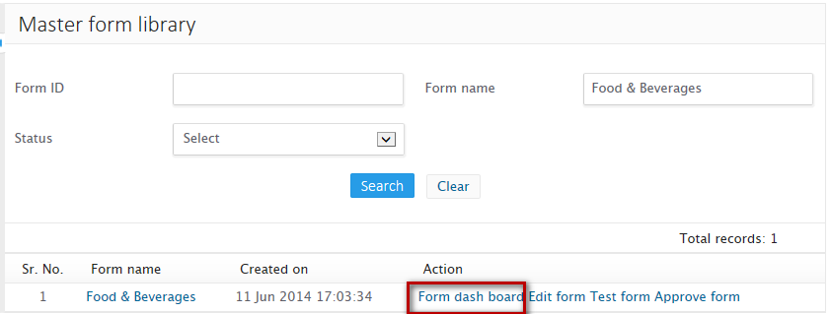

**1**

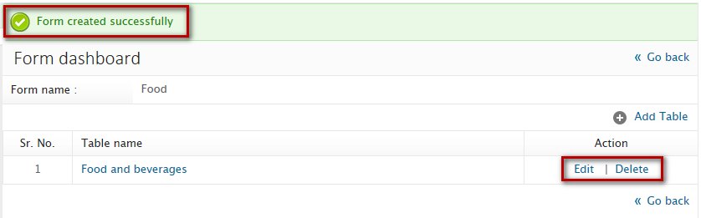

**3**

**23**

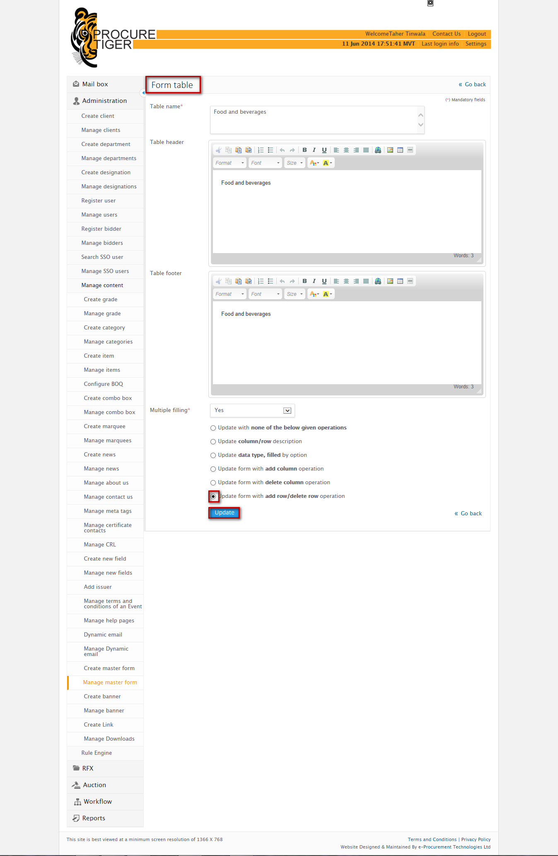

**5**

**4**

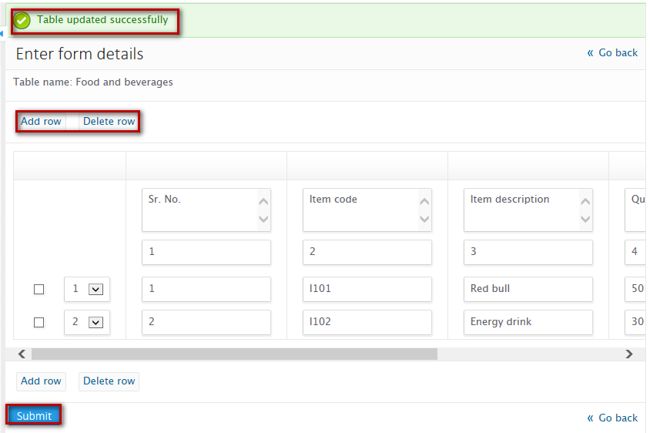

**7**

**6**



**Steps to edit table matrix:**

1. Click on form dashboard
2. Click on edit link against the form name
3. Edit form name, header and footer and select operation to be performed
4. Click on Update
5. Edit details as per your requirement
6. Click on Update button

On successful update, you will be notified with a message as “**Form updated successfully”** and you will be redirected to the dashboard

* Delete master form



**1**

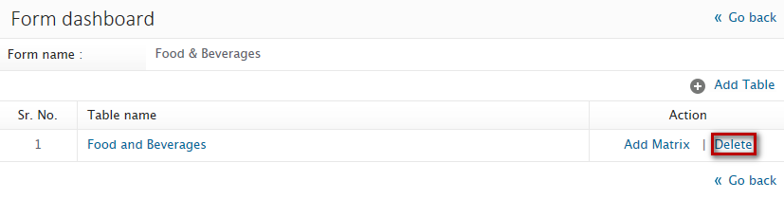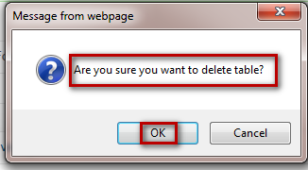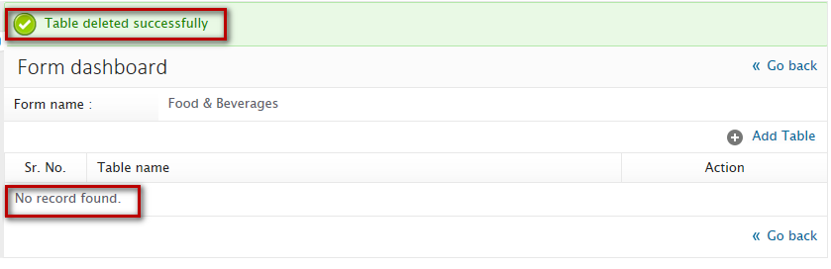

**3**

**2**

**Steps to delete master form:**

1. Click on form dashboard
2. Click on delete link against the form name from the listing
3. On confirmation, click on Ok

On successful deletion, you will be notified with a message as “**Table deleted successfully”**

### Edit form

Administrator can edit form details as per their requirement

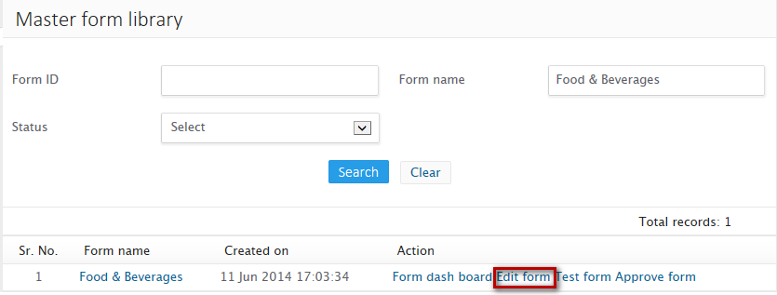

**1**

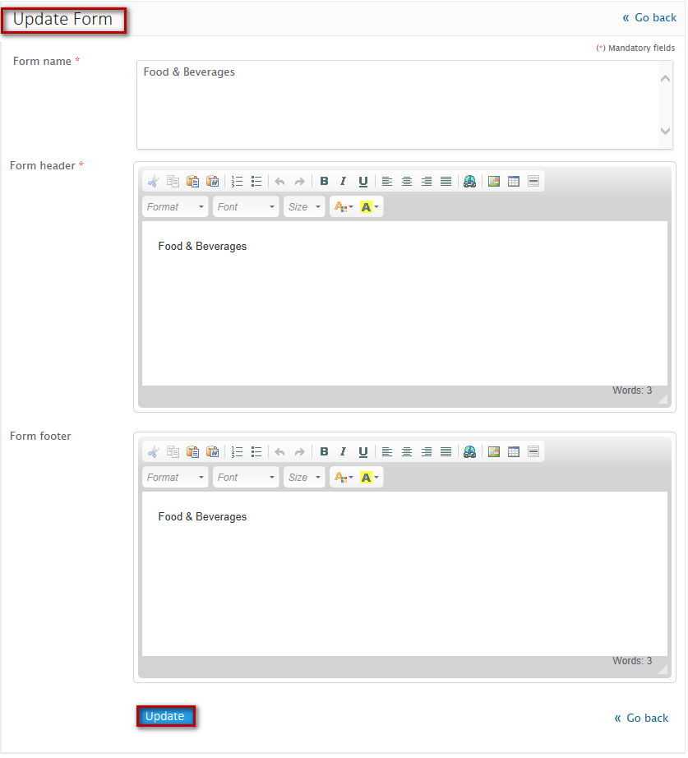

**3**

**2**



**Steps to edit form:**

1. Click on Manage master form from manage content under administration menu from left accordion
2. Click on Edit form link
3. Edit the details as per your requirement
4. Click on Update button

On successful update, you will be notified with a message as “**Form details updated successfully”**

### Test form

Administrator can test master form created

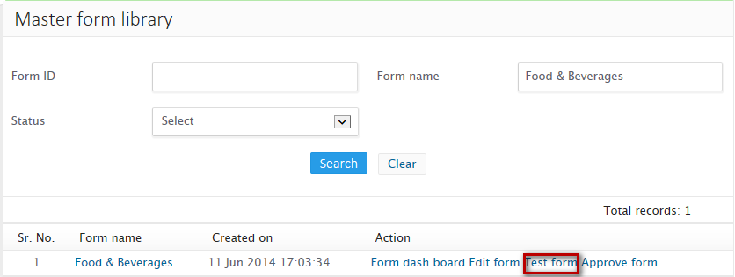

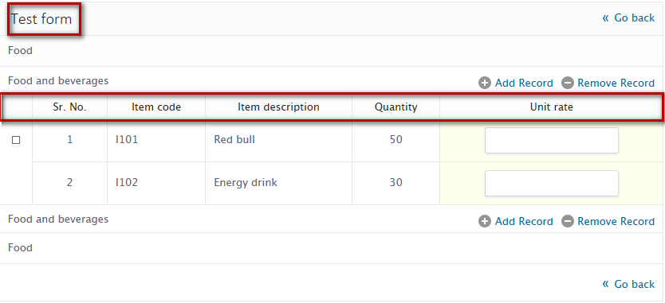

### Approve form

Administrator can approve master form created

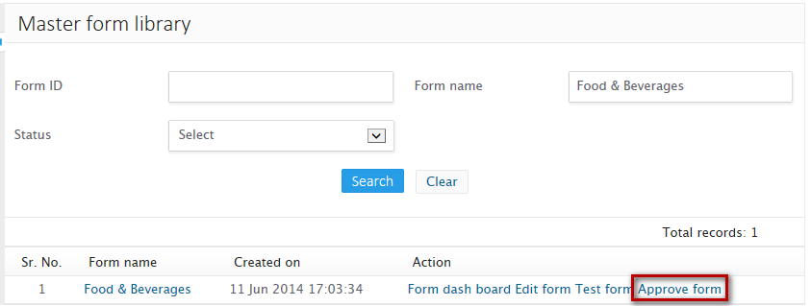

**1**

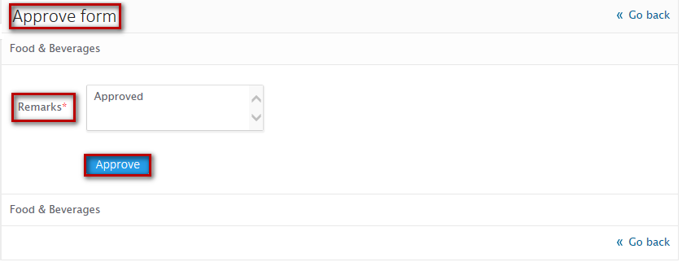

**3**

**2**



**Steps to approve master form:**

1. Click on Approve form from the master form library
2. Enter remarks
3. Click on Approve button

On successful approval of master form, you will be notified with a message as “**Form approved**” and you will be redirected to Master form library

## Create banner

Administrator can create banners to be displayed on home page of the domain and can also give link to the banner

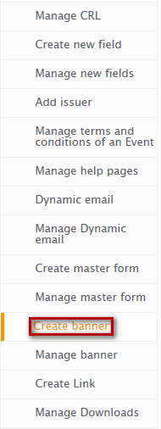

**1**

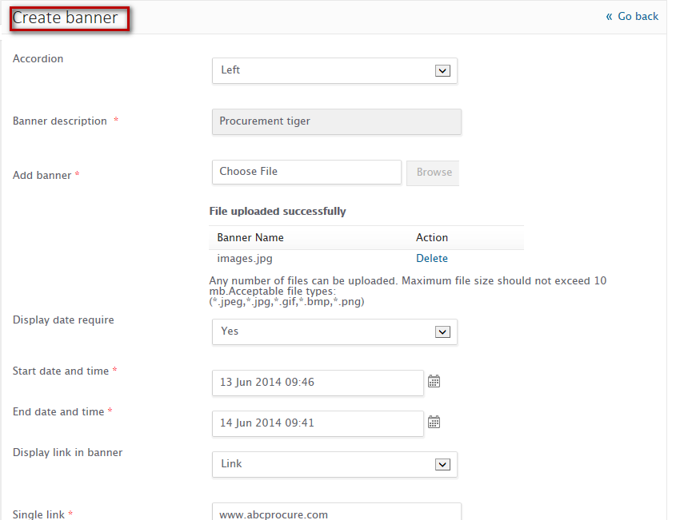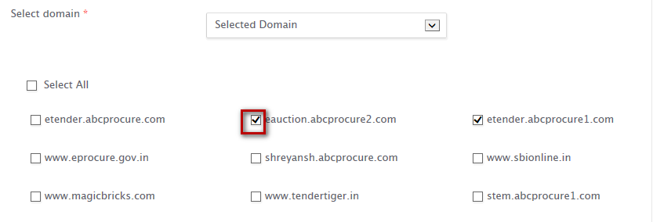

**3**

**2**

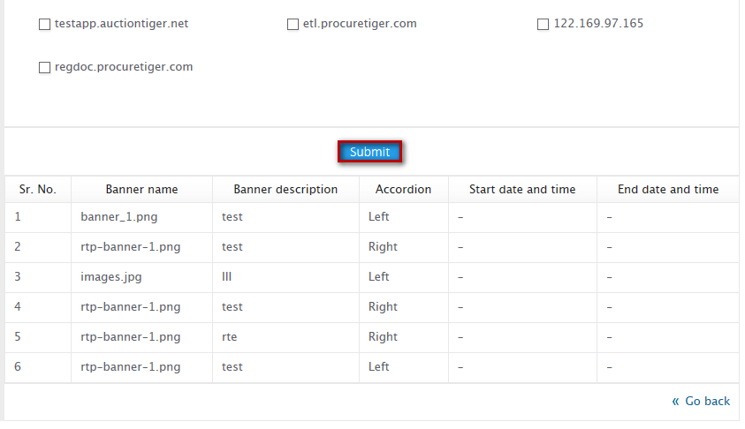

**4**

**Steps to create banner:**

1. Click on Create banner from manage content under administration panel from left accordion
2. Configure all the details required to create banner
3. Select domain on which you would like to display banner
4. Click on Submit button

On successful banner creation, you will be notified with a message as “**Banner created successfully**” and you can see the banner you created in the listing that lists following:

* **Banner name** – Shows name of the banner you created
* **Banner description** – Shows banner description
* **Accordion** – Shows whether you have configured banner to be displayed on left accordion or right accordion
* **Start date and time** – Displays start date and time configured to display banner on the respective sub domain
* **End date and time** - Displays end date and time configured to display banner on the respective sub domain

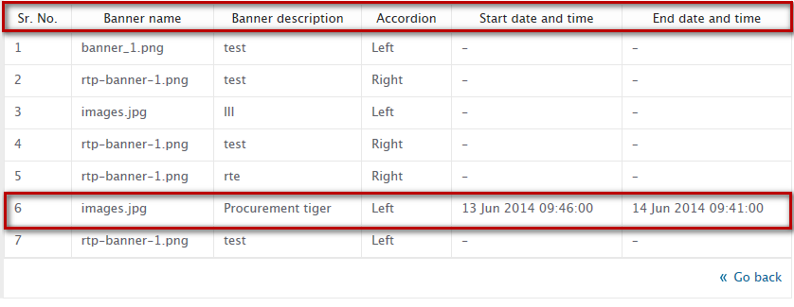

## Manage banner

Administrator can manage banner and can set the priority to display banner from the respective domain for which the banner has been created

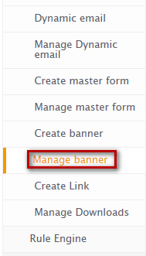

**1**

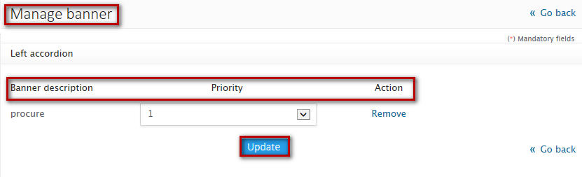

**3**

**2**



**Steps to manage banner:**

1. Click on Manage banner from manage content under administration panel from left accordion
2. Configure the priority
3. Click on Update button

On successful banner priority updation, you will be notified with a message as “**Priority updated successfully”**

Note

* + **Manage banner will list only those banner that belongs to the domain on which user is logged in.**
  + **Banner can be managed by login from the domain for which banner has been created**

## Create link

Administrator can create link and can display the link as per the configurations

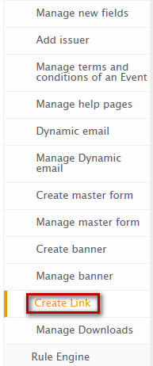

**1**

* **Link type – Upload document**

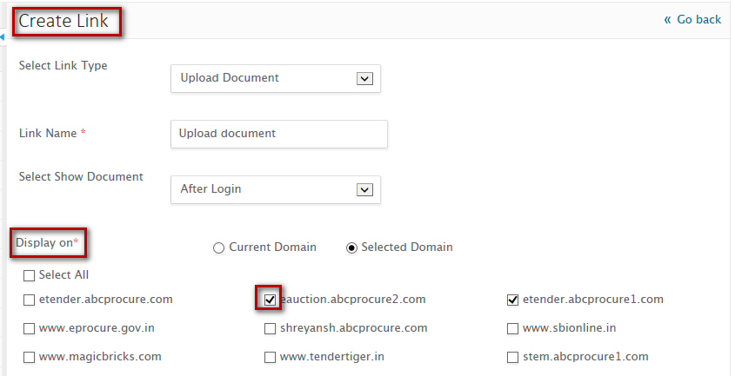

**3**

**2**

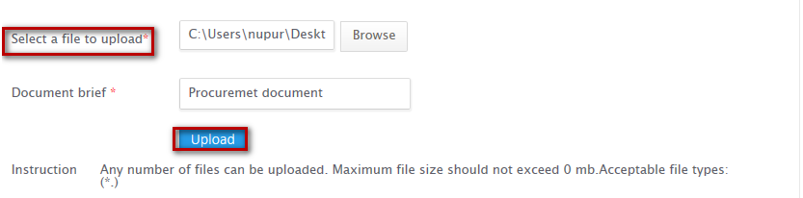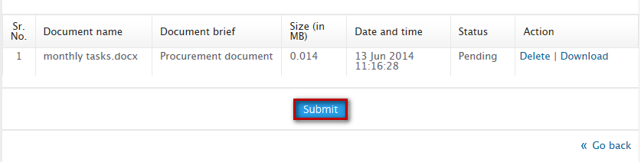

**5**

**4**

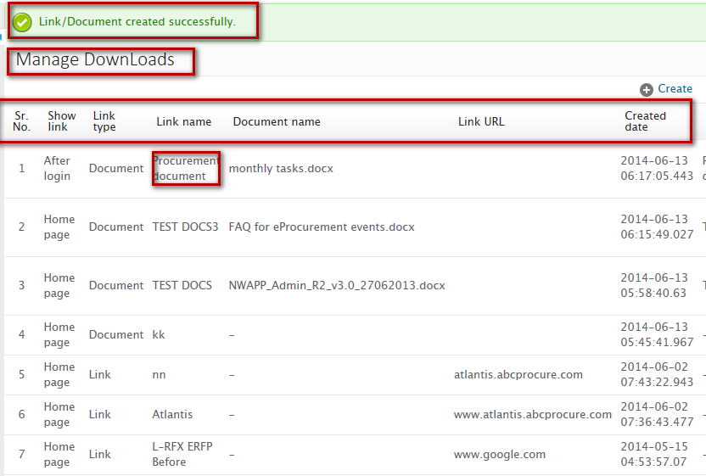

**Steps to create link for upload document:**

1. Click on create link from manage content under administration menu from left accordion
2. Configure link type as Upload document
3. Select the domain on which you want to display the link
4. Upload document
5. Click on Submit button

On successful deletion, you will be notified with a message as “**Link/Document created successfully”**

* **Link type - Provide link**



**1**

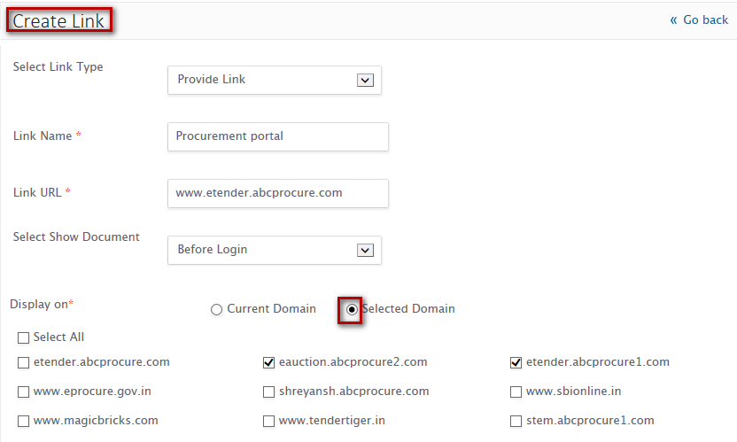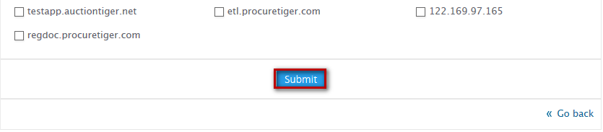

**5**

**4**

**3**

**2**

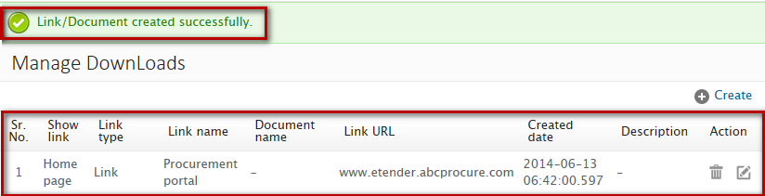

**Steps to provide link:**

1. Click on create link from manage content under administration menu from left accordion
2. Configure link type as Provide link
3. Specify link URL
4. Select the domain on which you want to display the link
5. Click on Submit button

On successful deletion, you will be notified with a message as “**Link/Document created successfully”**

## Manage downloads

Administrator can manage, edit, download and delete all the uploaded documents through manage downloads

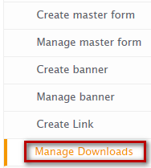

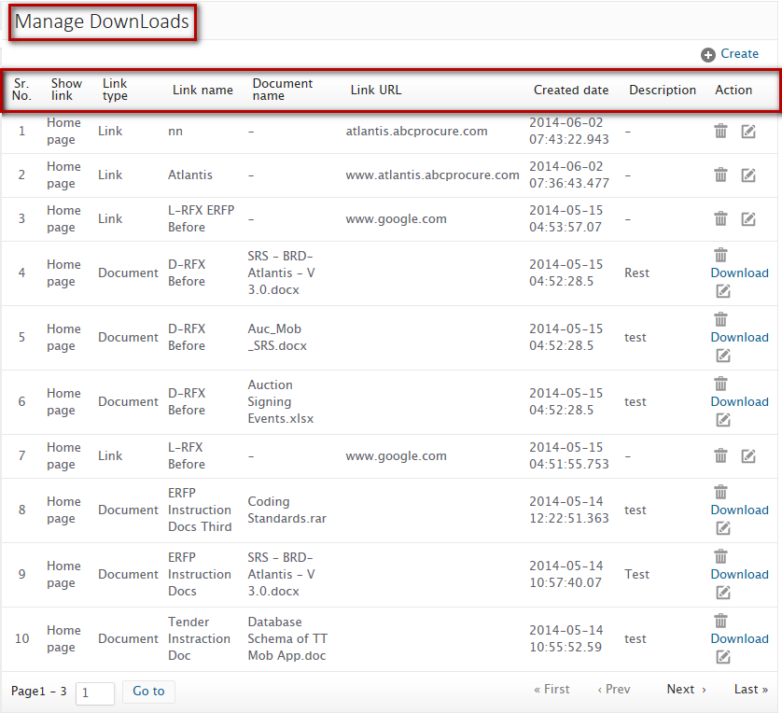

**Manage downloads listing** – Lists all the details configured while creating link

**Listing fields**:

* **Show link** – Shows location of link either on home page or after login
* **Link type** – Shows type of link configured
* **Link name** – Shows name of the link
* **Document name** – Shows name of the document being uploaded
* **Link URL** – Shows URL of the link
* **Created date** – Shows date and time on which link was created
* **Description** – Shows description of the link
* **Action** – Lists actions that can be performed on link created

### Edit link

Administrator can edit link details configured



**1**

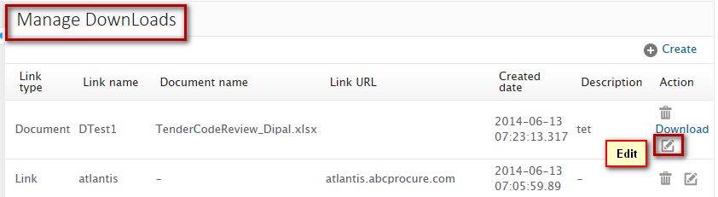

**2**

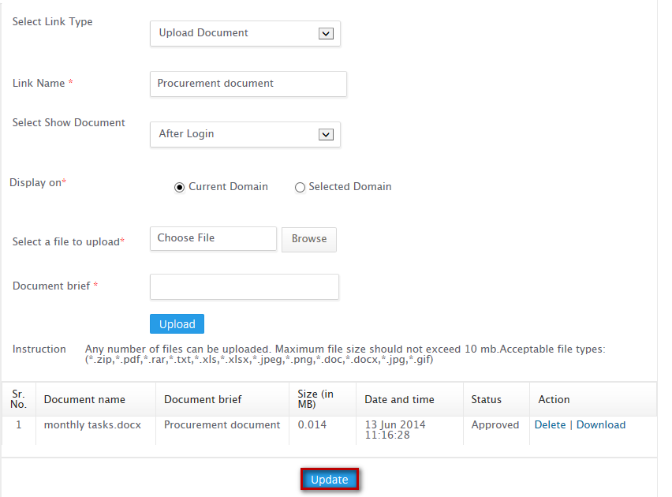

**3**

**Steps to edit link:**

1. Click on Manage downloads from manage content under administration menu from left accordion
2. Click on Edit icon from the manage downloads listing
3. Update the details as per your requirement
4. Click on Update button

On successful deletion, you will be notified with a message as “**Link/Document updated successfully”**

### Delete

Administrator can delete link created



**1**

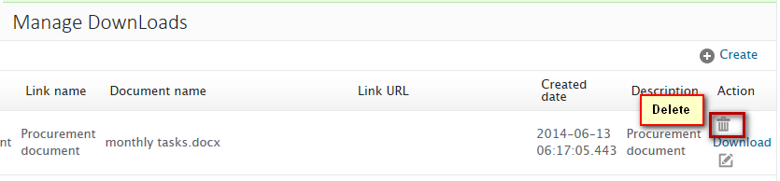

**2**



**Steps to delete link:**

1. Click on Manage downloads from manage content under administration menu from left accordion
2. Click on Delete icon from the manage downloads listing

On successful deletion, you will be notified with a message as “**Link/Document deleted successfully”**

### Download

Administrator can download the uploaded document from the listing



**1**

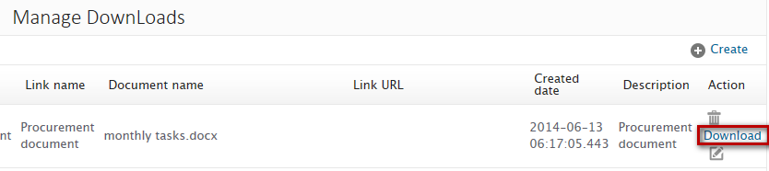

**2**



**3**



**4**

**Steps to download document:**

1. Click on Manage downloads from manage content under administration menu from left accordion
2. Click on Download icon from the manage downloads listing
3. Save the document from the pop-up message
4. View or open the downloaded document

On successful download, you will be notified with a message as “**The <document name> download has completed”** and you can open or view the downloads

## Rule engine

Administrator can configure certain rules to be applied on event

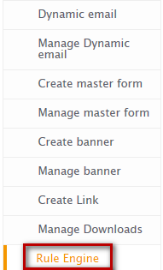

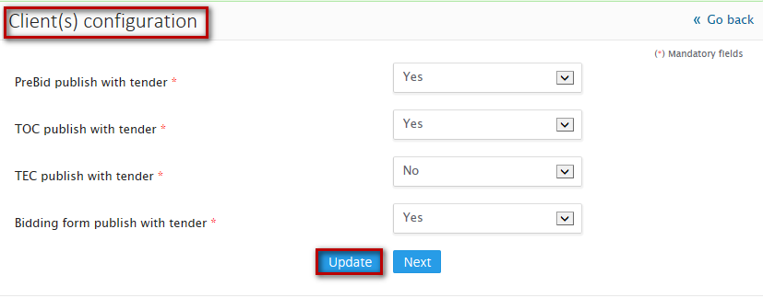



**Steps to configure rule engine:**

1. Click on Rule engine from manage content under administration menu from left accordion
2. Configure rules as per your requirement
3. Click on Update button

On successful configuration, you will be notified with a message as “**Client configuration updated successfully”.**

# Logout

You can logout from the system using this functionality.

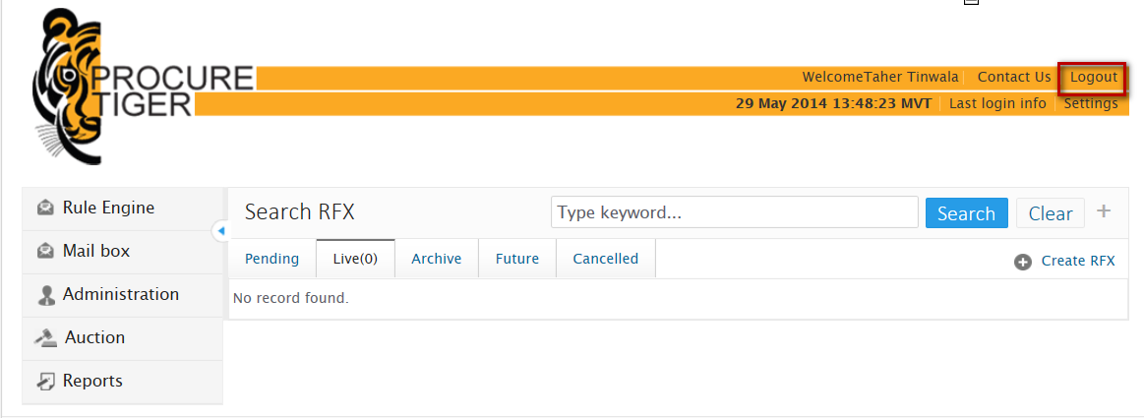

Figure

**Steps to logout:**

1. Click on **“Logout”** link from the menu panel

On successful logout, you would be redirected to the home page of the website.

# Do’s and Don’ts / Best practice

* Don’t wait till last minute for bid submission as you may encounter a problem of internet connection failure, hardware or power failure or you may not get good internet speed.
* Keep sufficient back up options such as PC, internet connection etc. so that in case of failure, you have an alternative option for bid submission
* Participate in a mock procurement event to understand the bid submission process thoroughly well in advance.